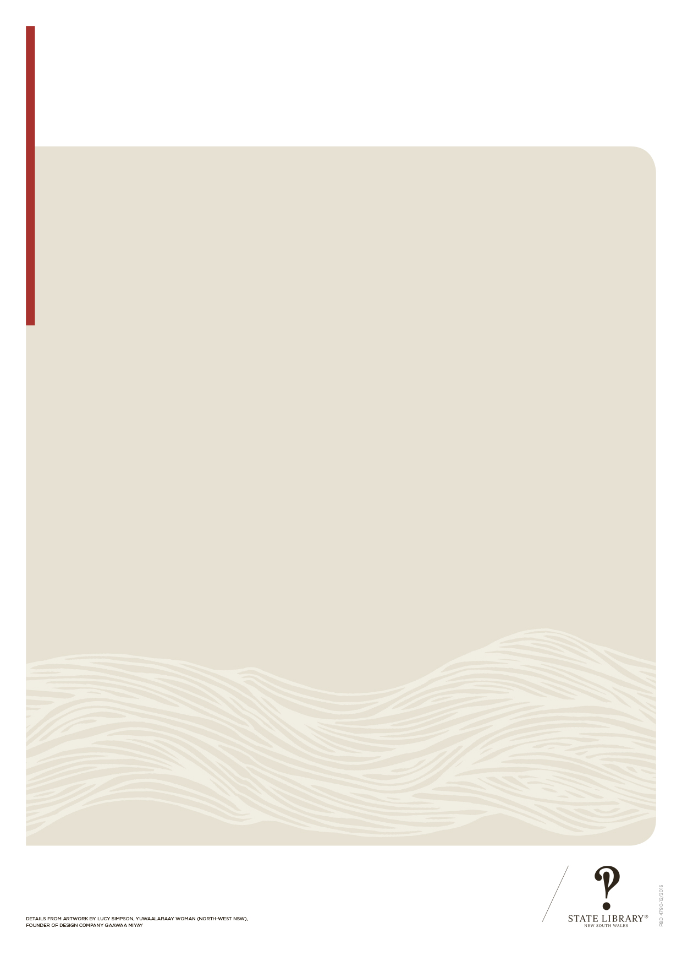
Key dates
Detail from artwork by Lucy Simpson, Yuwaalaraay woman (north-west NSW),
founder of design company Gaawaa Miyay
INSERT LOCAL COUNCIL LOGO HERE

INSERT LOCAL LIBRARY LOGO HERE
acknowledging Aboriginal and Torres Strait Islander history and culture

JANUARY
26 Survival Day

FEBRUARY
13 National Apology Day
21 Day of Mother Languages

MARCH
National Close the Gap Day
(third Thursday in March)
21 Harmony Day

APRIL
25 Anzac Day

MAY
26 National Sorry Day
27 Anniversary of 1967 Referendum
27 Reconciliation Week
(until 3 June)
29 Anniversary of Torres Strait Islander flag

JUNE
3 Mabo Day
JULY
1 Coming of the Light Festival (Torres Strait)
NAIDOC Week (from the first Sunday in July until the following Sunday)
12 Anniversary of
Aboriginal flag creation

AUGUST
9 UN International Day of World’s Indigenous Peoples

SEPTEMBER
7 Indigenous Literacy Day

OCTOBER
Koori Knockout
(October long weekend)

DECEMBER
10 Anniversary of Redfern Speech (1992)
24 Native Title passed in the Senate (1993)

