NSW Public Library Services
Guidelines for ecollections in NSW public libraries

Background
Ecollections are growing in public libraries. Some have turnover rates very similar to print publications, while others are substantially lower, sometimes even less than the collection size. Book turnover for 2013/2014 is 2.9, for ebooks it is 1.65 and for eaudio it is 1.72. Ereaders and tablets are available for loan in some public libraries. Some are well used, and others are never used.

Deeper analysis of data and understanding of collection promotion and development would enable public libraries to identify good practices ecollections and ereaders and enable NSW public libraries to maximise the benefits and reach of a significant investment.

What strategies work for training staff so they promote the use of ereaders/tablets to the community? Which libraries are the most effective in promoting ebook reader loans to their communities? Where have ebook readers not worked and why?

Objectives
- To identify the current ecollection usage patterns across NSW public libraries, by format – ebooks, eaudio, emagazines
- To identify factors which affect usage of ecollections in NSW public libraries
- Develop good practice guidelines for ecollection development, display, access and collection evaluation
- To identify current ereader/tablet usage patterns across NSW public libraries
- To identify factors which affect usage of ereaders/tablets in NSW public libraries
- Develop good practice guidelines for ereaders/tablets and their evaluation
- Undertake statistical analysis of ecollections and usage data to identify benchmarks for ecollection size and usage
- Undertake consultation with NSW public libraries on ecollection display, development, procurement and cataloguing
- Develop and publish good practice guidelines for ecollection development, display, access and collection evaluation

13 libraries were interviewed about the performance of their ebook or eaudio collection or both. The libraries all had turnover rates above the Living learning libraries baseline of 3.46 for these collections based on the 2012/2013 data. This is higher than many other libraries based on 2012/2013 data.

The factors which affect usage of ecollections in NSW public libraries for the libraries with the higher turnover rates:
- the collections are actively developed and tailored
- ebooks/eaudio are visible on the homepage of the library website
- the titles are accessible in the catalogue (in all but two instances)
- staff are trained in how to use and download ebooks/eaudio, and this training is updated
- staff actively promote ebooks in the library, and in many there are signs or other other ways to locate in the library
- training is provided to clients in how to use and download ebooks/eaudio

The above points hightlight good practice guidelines for ecollection development, display, access and collection evaluation

One person described it as “buy like you are building a book collection not subscribing to a database”.

Libraries interviewed have the following turnover rates for ebooks and eaudio

location | Ebook collection size | Ebook turnover | Eaudio collection size | Eaudio turnover
Country |  |  | 6126 | 4.7
Country |  |  | 487 | 3.1
Country | 4621 | 3.58 | 1467 | 6.35
Country | 1534 | 8 | 132 | 10
Country – collaboration * | 13666 | 4.8
Country* | 911 | 4.3
Metropolitan | 5482 | 9.7 | 2145 | 5.7
Metropolitan | 6899 | 4.13 | 1562 | 5.5
Metropolitan | 1257 | 3.7
Metropolitan | 507 | 4.05
Metropolitan | 5575 | 3.4
Metropolitan | 674 | 4.3
Metropolitan* | 5276 | 6.7
Note this figure combines ebooks and eaudio

From this table, collection size is a factor. There are three collections of less than one thousand items in this list, and they have smaller numbers of people using them. The largest collection size is from a collaboration, and this may be an area for more libraries to consider.

In libraries with high ebook/eaudio turnover staff received training in how to use ebooks, preferably also how to download to different tablets and other devices. Refresher training is often provided to staff as the technology to access ebooks keeps changing.

Training or trouble shooting is provided for the public. This is sometimes done in a small group or one on one bring your own device. Other times is it provided at need as someone brings their device to the library for some help in downloading ebooks. Device support is critical.

The ebook and eaudio collections are managed in line with other collections, and titles are selected based on the collection development strategies. Depending on the ebook provider and library policies additional copies may be purchased of high demand items.

Clients provide feedback via usual means, and these are considered in normal selection processes.

Ebooks are visible on the library home page and there are in-library promotions as well. Staff use word of mouth to promote ebooks.

Some library services also provide translations for help in languages other than English.

Ebook and eaudio collections are on the library management system. This was the situation for 12 out of the 13 libraries talked with. Ebooks and eaudio are usually mentioned as a format rather than a separate category in collection management documents. There is a launch to promote the ebooks/eaudio collection.

From the recent state wide survey of ereaders and tablets a few factors emerged as critical. Training for staff and the public. Making the staff training compulsory, rather than optional, appears effective. Providing library clients with introductory sessions on ereaders and tablets as well as training on their own devices are both points which are influential in encouraging use. Using statistics as well as structure discussions are important elements in effective evaluation. Using training such as Tech Savvy Seniors and tools like the NSW.Net ELK help in the understanding of newer devices.

The success factors for devices are similar to ebooks and eaudio
- the collections are actively developed and tailored
- that it is easy for devices to be located, signs in the library, or online (not many libraries have tablets and other devices on the catalogue – this needs to change)
- staff are trained in how to use tablets/other devices and this training is updated
- staff actively promote tablets/devices in the library, and in many there are signs
- training is provided to clients in how to use tablets/devices

The following information was provided as part of the state wide survey looking at ereaders, tablets and econtent.

Fifty seven libraries provided responses to a survey of ebooks, ereaders and tablets.

For clients
Of these 19, or 33.9% provided tablets or ebook readers for loan.

The number of devices for loan to the public are shown here
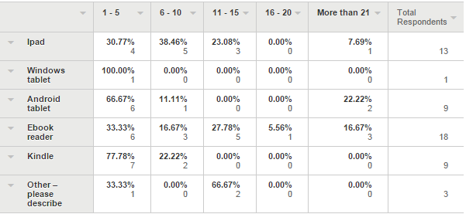

Other devices includes DAISY players, iPad minis, Sony ebook readers, and tablets targeting children.

Three libraries had devices available for in library use, twelve had devices which could be borrowed and taken home for two, three or four weeks. Five libraries had devices for use in the library and to borrow and take home. In library use time varies from 30 minutes to three hours.

12 libraries have their tablets and ebook readers listed in their catalogue with another three libraries planning to do this. The other libraries with these devices had no plans to list them in the catalogue.

Libraries were also asked what the clients used the devices for. The numbers for each of these categories were small. The main uses were learning how to use the device, closely followed by three separate ebook uses, preloaded, client selected and home library services.

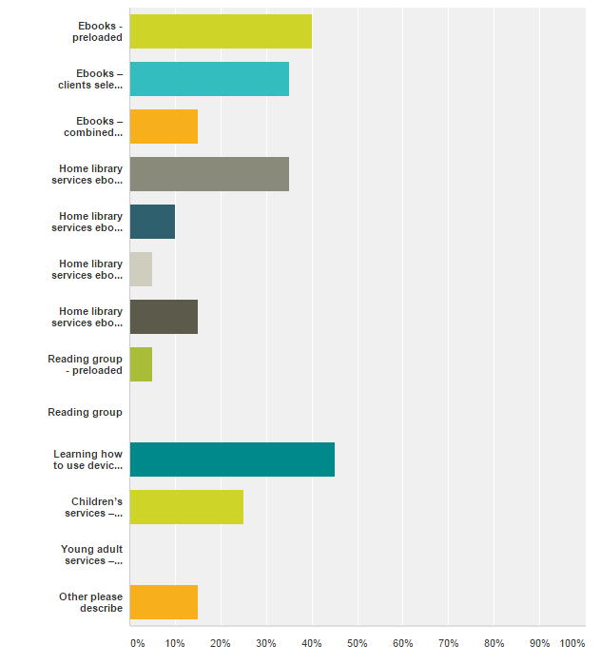

The comments for this question showed some other uses including:
- for exhibitions
- Ipads used in Lego club with Lego apps, iPads used by HACC group with brain training apps
- digital magazines preloaded

Training for the public
Libraries described the training they provided for the public
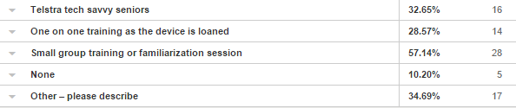

There were some other options included:
- Training is provided for clients on their own devices by several libraries, this may be small group or one on one. It may be as needed, or by appointment.
- Sessions run at local schools for classes
- Some of the training is provided by staff, some by volunteers. It varies according to individual library policy. By libraries which use staff this is viewed as a core service.
- Lessons are always in the context of library collections or finding information. Drop in sessions. One-to-one booked sessions (we are developing a Book A Librarian service to market opportunity).
- One on one training for showing how to borrow ebooks
- Plans to create web videos for assistance
- Staff provide one on one training with the public if they come in with a query on how to use their own tablets to access the library's online services (ie. BYO tablet).
- we provide a 2-5 minute familiarisation session as the device is loaned (all staff do this, whoever is rostered to Circulation and is loaning the device out).
- Although our library does not have tablets or eBook readers for loan or staff, we provide a Get Connected program which includes group and individual sessions based on Telstra's Tech Savvy seniors. We also provide one-on-one sessions for customers requesting help with their device.
- We are assisting customers with there own devices and deliver small group training with council purchased ipads. We are limited due to the fact we have limited It support from council. We are all self taught and have received training from NSW.net

Devices for staff
45 libraries provided tablets or ebook readers for staff use.

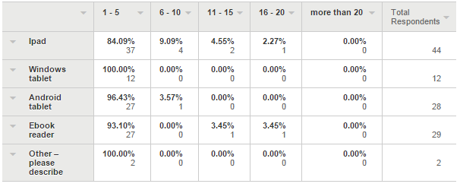

Some libraries described their collection focus, for example:
- Single collection of public-use e-readers & tablets: staff can borrow for the same period as the public.
- Each branch has it's own 'digital sandbox' toolkit featuring up to 5 devices that staff use to teach customers with.
- public tech bar used by staff when needed
- Windows tablets are used for concierge services, iPads and Android tablets are used for customer training and promotion
- Kindle Ipod touch

How staff use the devices
Library staff learning how to use tablets, and teaching clients about tablets tied as the top uses of the tablets by library staff.

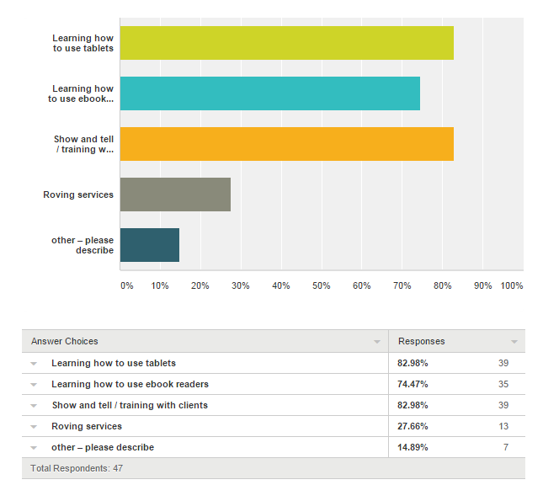

Roving services were supported by tablets in 13 libraries.

Other uses included meetings, conferences, training, surveys, outreach activities, learning how to use e-resource platforms, seminar/conference attendance note-taking, remote access to email, taking photos at events, promote the collections, staff training, both group and individual with ipads. pop-up library, and outreach at expos and shows.
Training for staff
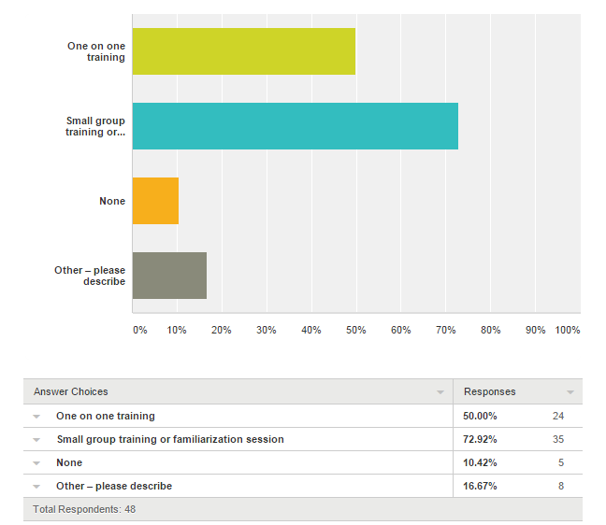

Kinds of training and familiarisation include:
- Training in conjunction with the State Library eLending Kit has been used by several libraries
- Continuing Education Courses from Sydney University - the IT Stream
- self help, sample equipment is loaned to staff with guides to work through. If need one on one this is provided, generally over the phone from Headquarters.
- staff encouraged to familiarize themselves; assistance given one-on-one as required
- Refresher training is important. Offer to train staff, don't wait for them to ask for it. Support with FAQ documents on staff server and website.
- Opportunity to borrow devices and take home to practise using notes
- Asked staff to help each other to learn, informal buddy training worked well. Some staff are very confident and helped several others. But we also had cases of staff only new themselves helping others who were right at the beginning…I admit we had to pull out a bit of a stick to get some of the staff to have a go. There were lots of opportunities, but some staff still had not got around to taking a device home etc. until we threatened testing of everyone to be sure they could do it.
- Staff were encouraged to purchase their own tablets using a salary sacrifice facility offered by Council.
- Vendor provided video training
- one on one training is on an ad hoc basis depending on availability of staff
- Shared experiences.
- Tech staff have also developed a suite of training sheets for staff to use for their own training at any time, or to refresh if they are to deliver a training session. There is also a set of training notes for staff to use with the public. The inhouse notes include training tips and possible scenarios.

Collection documents and econtent
Libraries were asked if their collection documents include sections for econtent

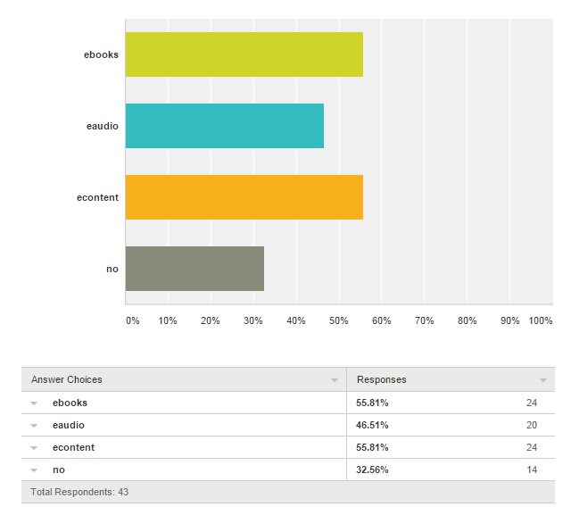

The next question explored if format was simply part of the general description in collection documents, for example, are ebooks/eaudio and other econtent described as part of the collections they relate to (fiction/non-fiction and so on) within the collection development policy/collection management policy/content strategy?

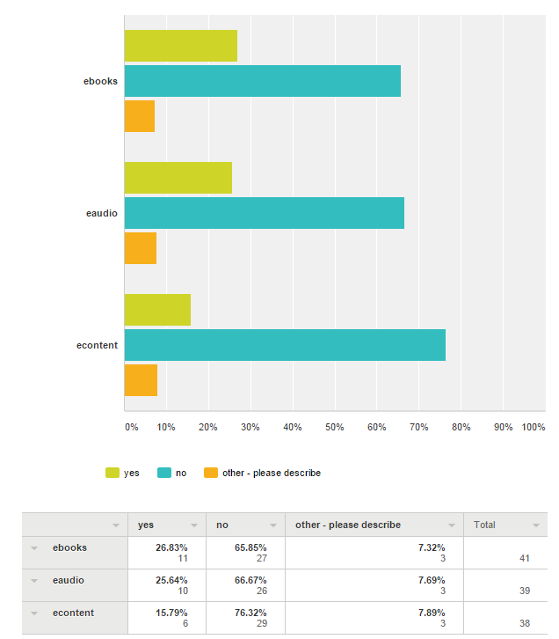

The same number of libraries used patron driven acquisition for econtent as did not. The count was 22 libraries each.

Licensing models
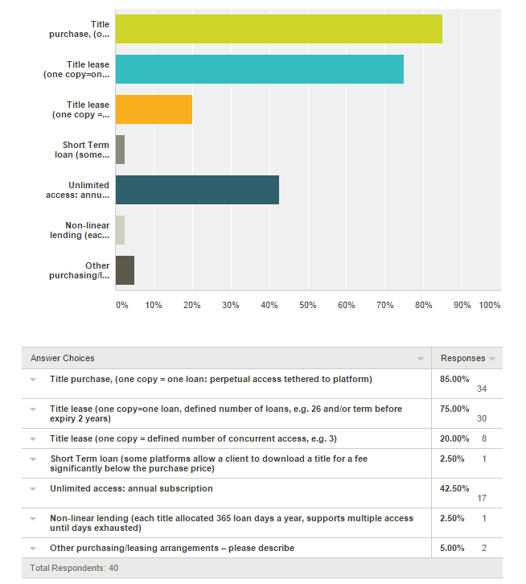

Other models included
- We owning all ebooks with unlimited concurrent users - number of uses per year is sometimes limited.
- Non-linear lending of 325 loan days per year.
- some e-audio titles are unlimited concurrent users, ownership for 7 years. same platform has some titles with one copy = one loan and 7 year ownership. Conditions depend on title
- Our eAudiobook titles have a capped (100 loans) concurrent access per title

Econtent and library catalogues
Libraries were asked if their ebooks were searchable in the library catalogue.
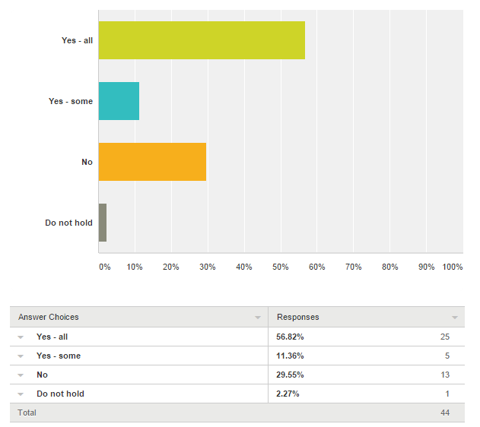

They were also asked about their eaudio being searchable on the library catalogue

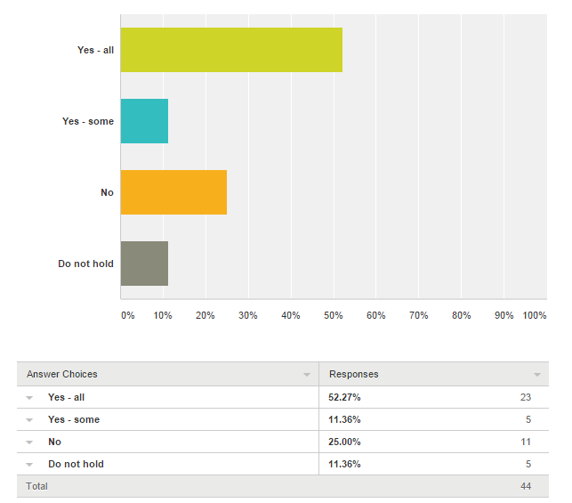

From separate information obtained from libraries with high turnover rates for ebooks and eaudio good practice, and higher loans, are aided by clients finding ebooks and eaudio in the catalogue as well as in the separate platform access.

Zineo
Thirty three libraries provided some Zineo data. Between these libraries there were more than 3140 titles (some libraries did not provide exact numbers). There were at least 204,120 downloads over 12 months. This means that each title averaged 65 downloads. The largest collection size was 240 titles, the smallest 12. The most downloads were 38,539, the fewest 337.

Freegal
Freegal had 10 libraries provide data on use. Others mentioned that the service was too new for useable data. The total downloads from the 10 libraries was 104 683. The highest was 25,773, and the lowest 1609.

Is Zineo searchable on the library catalogue?
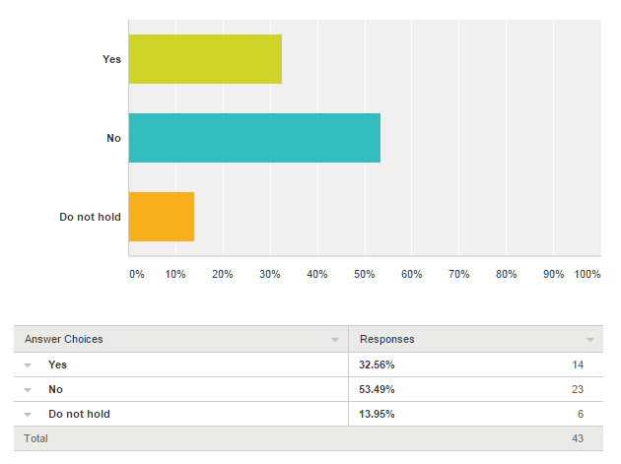

Are any of the eContent platforms utilised by your library service deeply integrated into your library management service? If so what functionality is offered:

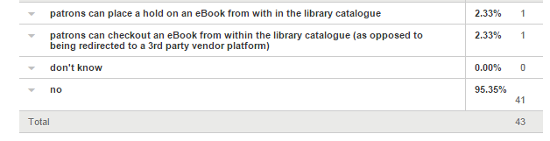

What in promotion has been done for econtent held by your library?

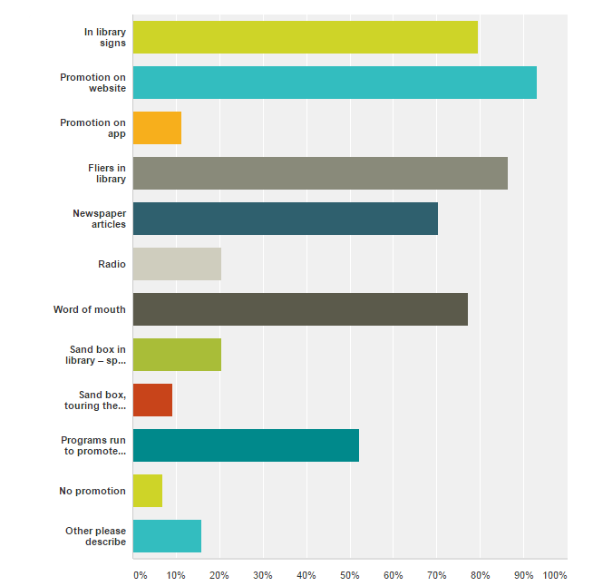

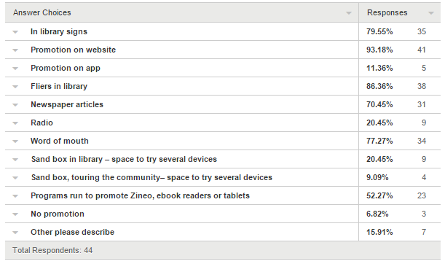

Comments provided a few other examples including:
- At events such as seniors weeks, community events and bookfairs.
- enewsletter, TV screens
- In Library Newsletter - emailed to 22,000 plus borrowers
- Promoted on library blog via articles and eBook specific reviews.
- Outreach to Seniors group in Neighborhood Centres
- Monthly eNewsletter, visits to Retirement homes
- Info stalls at council organised community events
- eNewsletter, Social Media, Training sessions for devices
- competitions, regular articles in eNewsletter, promo in qtly hardcopy library magazine
- Lots of staff training.
- Tech Table events for council staff
- Library eNewsletter articles

Social media promotion
Libraries were asked if they used social media to promote the econtent collections. Of the libraries which did, Facebook was the most used method.
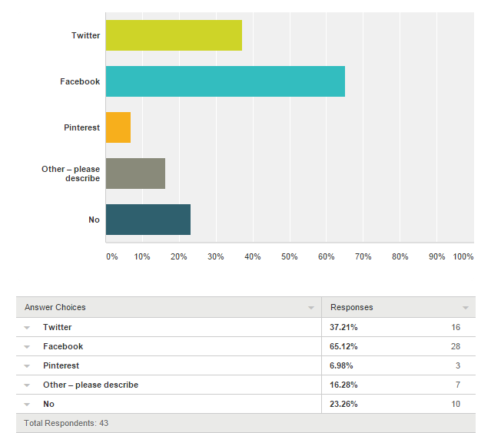

Other methods of promotion include library enewsletters, blogs and online reading groups.

Evaluation
Most libraries used loan/download/access statistics as part of their evaluation. Some use informal feedback, others data from customer satisfaction survey,

Some libraries have been interviewing clients about the services, this seems to happen more frequently when home library clients are loaned ereaders/tablets.

The informal feedback helps staff learn idiosyncrasies of different devices clients are using are readers. It has helped at least one library see the importance of having devices to demonstrate ebook loading.

Please comment about ease or difficulty of use of tablets and ebook readers. Please include as much information as possible as we need to know what works and what doesn’t.
- Introductory devices purchased were from the lower end of the market in terms of cost for ereader and tablet as a trial. These gave people the general idea but weren't as efficient as more popular models so patrons generally had this explained.
- The problem is the speed of the wifi at the Library
- experience problems with ipads for use in library with customers locking them out, using them for purposes other than that intended. In most instances devices have to be reset or restored which is very time intensive for staff.
- Once learnt all ok - depends on what the reader wants
- encouraging staff to make best use of tablets for roving is a challenge.
- Patrons found setting up an eReader device from scratch was challenging, time consuming and at times confusing. We went through numerous cheat sheet versions for Sony Readers and supported more frustrated patrons. Most in the end asked for preloaded ebooks. They found Overdrive difficult to setup and use, BorrowBox has been easier. Tablets and apps for Overdrive and BorrowBox has been far simpler for patrons and less troublesome. With the added functionality of a tablet they have been received much better than Sony Readers - our stats reflected this, despite illuminated versus backlit argument.
- DRM causes problems with pre-loading, as the ebooks expire regularly. Investigating setting up a special collection with the maximum 60-day loan period, reserved for e-readers only.
- All ok once you learn
- We chose to use Surface Pros in our Tech Savvy Seniors session however we are getting feedback that some people feel they are too small and a bit too overwhelming for beginners. However some have gone out and purchased their own. We chose them over a laptop because they can be used as a tablet or as a PC which gave us more options for training.
- eReaders are much more cumbersome compared to tablets. We find the majority of our customers are using mobile devices.
- explaining the different file formats and why our collection is not compatible with Kindle.
- Main issue with HLS use is availability of wifi to download and high demand for content via our eBook platforms (which makes selection difficult). We have purchased titles commercially instead of trying to use titles from our 2 ebook platforms for Home Library Clients. Lots of training / ongoing support needs to be given to both staff and clients in use of tablets, troubleshooting and operating eBook apps. Clients so far VERY happy with the content we are able to provide by buying commercially. Much quicker and newer and bigger range that library platforms. Elderly customers difficulty in managing screen and app options. One elderly client found the tablet heavy to hold. Still no solution for clients with significant vision impairment who are unable to use any device with a screen.
- We have Ipads and Galaxy Tablets and staff have had no problems using these.
- Highly dependent on not only the skills of the staff, but their motivation in learning new technology. As staff learning these is optional, there has been a low takeup on staff testing themselves.
- we have stopped using the ereaders - harder to use and less popular with customers. Tablets is a matter of practice - some staff were reluctant to try with devices and needed more help. We had to insist that all staff could do the basics of downloading and returning each of our resource collections Customers are more motivated - a lot have already bought the device and come to us for help setting up. It's becoming easier all the time to use the devices, as app improve. Once we set people up and show them the first time, they are generally comfortable. We do have some come back for multiple training sessions.
- Registering devices can be difficult as they sometimes require separate email accounts, etc.
- the great variety of readers and tablets makes it difficult to be fully aware of how each work. Staff tend to assist with devices that they are familiar with.
- Staff find the tablets easy to use. There is a high take up of tablets by the community (both IPad and Android) so staff find it useful using them with the public.
- Problem is the wide variety of tablets and eBook readers that people present with. They do all have similar structures but it does take time to find the various functions. Also, the often very low skills levels of the patrons. Generally speaking people are presenting more and more often with tablets. Very few eReaders presenting (especially as kindle owners are aware that the library can't help them with lending eBooks).
- The Sony eReaders we selected to lend with preloaded content are easy and straightforward to use. They have wifi access but are a dedicated eReader rather than a multifunctional tablet - this is a huge benefit when introducing borrowers to how the device works. Selecting preloaded content allows for borrowers to learn how to navigate the device rather than be distracted with selecting and ownloading hassles so are great as an introductory eReader device. We have had to replace some stylii but have been able to source some 3D printed ones at reasonable cost. Key drawback for some borrowers is the need for the device to be charged via PC rather than powerpoint - not everyone who borrows an eReader has access to a PC/laptop. eReaders and tablets for staff use are primarily to familiarise staff with various devices so they are more capable of helping patrons but a key difficulty here is in the wide variety of devices and the way their software constantly changes - as does the eBook lending services which we subscribe to. App development has not been in line with product enhancement and this has led to confusion on both sides of the library counter. As eReaders though, the Sony is a solid device which is easy to use; the Kindle is the winner of these type of devices but is not compatible with our Wheelers eBooks which is unfortunate; the Kobo is another good device and also easy to use while being reasonably priced. You get what you pay for though and it is well worth investing in a decent device, steer clear of cheap devices, they are more hassle than they are worth. This goes for eReaders and tablets etc - the ability of some cheaper tablets to intergrate with our eBook and eAudiobook collections is limited. That said, developers struggle to keep up with tablet development, most notably Samwung, Windows Surface, and the latest iOS.
- the Sony eReader for Book clubs has been a disaster. The devices are simple to use but the eBooks themselves have been the hassle. To buy 12 and then sort with the supplier a 12 month loan was terrible.... the first time we loaned them (actually the only time) we didn't realise that by the time we preloaded the book for them, that the expiry on the title would mean that half the book club couldn't read the item because it had expired. Since we got the 12 month loan we haven't put a new version of the book on their, mainly laziness and a lack of time, as 12 devices can take almost a day to preload.
- Adobe Digital Editions causes a lot of problems with customers as it adds difficulty to the process of borrowing eBooks. Many compatible devices perform slightly different which in turn makes it more complicated to explain to customers. Tablets are much easier to demonstrate than eReaders due to the simplicity of apps which outweigh the benefits of e-ink screens and the steps to transfer from a computer.
- iPad much easier to use for Zinio. Kindles are 5 years old so fairly clunky, Home Library clients sometimes have trouble navigating. Have to pre-load titles as the purchase function is not locked down.
- ipads have worked well as they have the same characteristics across each type of device. Androids have proven slightly more difficult for staff to learn as each device uses the android operating system slightly differently, and it can take time to work out how a particular device will work. The e-reader only devices first purchased at the beginning of the popularity of e-readers, have very quickly become redundant, and this is something of a n ongoing problem, as early tablet devices can very quickly become obsolete, especially with regard to their software and availability of apps.
- the tablet is easy to use - The suppliers App is what makes using a tablet easy or difficult preloaded eReaders have been easy for the community - just takes staff time to load titles and keep updating To have an ereader for borrower ILL can be time consuming for staff
- Our library uses ipads and Samsung tablets for staff training in eproducts and for public training in our eproducts, as well as using them for general tech lessons for the public. Having eproducts that are app based has made training much easier. Our tech team has developed lesson plans that are very simple and allow any staff member to provide a basic lesson in tablets. More advanced lessons are booked as one-on-one sessions with the most suitable staff member to deliver.
- Ease of use of ipads / tablets is very much dependent on staff members individual level of skill and comfort - generally find ipads easier to use, android a bit harder, very limited experience with windows tablets. Most staff a cormortable with using / demonstrating pre-loaded kindles (Kindles were deliberately chosen over generic e-readers for patron use, due to ease of use)
- Most customers have ipads, we have had difficulties troubleshooting KOBO e readers. The high demand is from seniors who predominately have ipads or iphones and require help downloading e-audio and e-books form the catalogue.
- Kindles don't work with our ebook suppliers
- We purchased 15 e-readers, 3 different types so that our staff and clients could trial and familiarise themselves with the devices. We provided basic written instruction and staff would assist our clients with issues. The devices are easy to catalogue and use with our LMS, HLS clients are using them so they need to be easy to operate for our seniors as well (in particular, changing the font size for visually impaired clients.
- iPads require resetting after each return. Only certain staff are trained in how to do this. Kobos have regular software updates which change how users interact with them. This makes troubleshooting difficult over the phone if customers are on a different software release. However we get very few phone calls asking for troubleshooting help.
- ipad is easiest as all of the required apps, licences, etc can be managed on one device. WE have also purchased a third party system to manage the software and security. We have not used android devices.

Comments about ebooks in libraries
- eBooks and Audiobooks have been slower to take off than expected. We have had for over 18 months and we thought due to our demographics, they would be more popular. The usage has been slow but steady, although increasing.
- Frustration with different procurement models from publishers. unavailability of titles from publishers
- Ebooks are increasing in popularity, with over 1,000 loans per month and climbing. Attendance at e-info sessions is also rising.
- We are in the process of making our ebooks and audio books searchable through our library catalogue. To download the ebook the patron will still need to leave the catalogue but at least they do not have to search on a separate website.
- A lot relies on staff education, confidence and enthusiasm for promoting the service. I have found this to be a long, slow, ongoing process :-)
- We keep away from purchasing titles that we don't own. Anything that has a limit of 26 loans or 2 years is ignored. Unless it is essential to have, we boycott these publishers
- They remain a niche collection, despite being pushed for as a solution by management. Collection development issues (expiry by loans, 1 year leases, bulk purchases, increasing platform fees, limitation of publishers, terrestrial publishing rights, DRM, 3rd party privacy issues) mean small collections and even smaller user bases, when compared to lending patterns compared to print collections.
- biggest issue is keeping up, with so many platforms and devices. Much easier if you are using personally, but even I only use apple devices at home, so keeping up with android is hard work.
- We've focused on BYO technology classes and providing content rather then lending devices to customers. We are concerned that devices have a short lifespan which may make a lending service difficult to sustain. Our Online library loans are growing
- Setting up our lending eReaders has a very targeted methodology - we determined specific genres to allocate to each eReader, allocated budget funds for each eReader (for titles), were very targeted in our purchasing of titles and careful to check lending rights etc, we used a multitude of eBook vendors (big and little - the quality varies accordingly), various staff (with particular genre reading strengths) were tasked with selecting titles for our eReaders, each eReader (except for Contemporary Fiction) include a selection of Gutenberg titles (ie, free, out of copyright restrictions, classic titles), each eReader is catalogued listing contents but the individual titles on each eReader are not catalogued. Our eBook service is provide via Wheelers and we have allocated specific funds to allow for the ongoing development of this service. We are restricted in this though by Publisher restrictions whcihw e continue to negotiate through Wheelers with. While loan limits can be worked around (ie, 26 or 52 loans and then the title must be bought again) we struggle with publisher-set purchase limits (ie, Pan Macmillan insists on 500 titles must be bought by public libraries in order to buy just one title, this equates to approx $15,500 which we simply do not have and becomes restrictive for us to provide titles to our patrons). Our eBook take up has been strong and ongoing, recent app development from Wheelers is good but still a little clunky in some areas but the help desk and feedback has been great. They are good to work with. Purchasing titles and incorporating them into our LMS (Spydus) has become easier and they have recently responded to a suggestion to tailor our skinny marc records more responsively which is great. Our eAudiobook collection is a whole different ball game and has recently become more challenging to develop through decisions by the vendor to change the way they do business.
- at the moment the services/products offered by suppliers don't meet the needs of our users. For example, Borrowbox won't allow you to return an item early, a reservation counts as a loan at the time of placing, reducing what you can borrow at the specific time, etc etc.
- Best sellers are more readily available than they used to be. Profiled standing orders are not currently an option with our suppliers Sometimes suppler curated selection lists are long and not appropriate. As a selector it is required that we go through all these lists just to obtain a few titles. Supplier platforms vary with respect to how items are accessed and downloaded. We have marc records within the catalogue however the customers still need to go into the supplier platform which hinders discovery across collections Waiting lists are a problem with customers as there is an expectation that items will be available when they want them. This is especially problematic if items are unable to be returned early
- We need to promote eCollections more widely and more actively
- Lots of confusion amongst customers over how to download to their particular device. Zinio is problematic for many clients, logging in twice puts many off. Freegal and Zinio can be quite slow. Huge problems with collection development, customers expect to have access to every bestseller, various models for different publishers and vendors. Difficulty integrating different platforms.
- the uptake has been slow but is starting to increase
- Content is still much less that print. Subscription models mean lots of back list to get newer listings. Best sellers not available to libraries. Borrowers can not really requests titles due to these restrictions. New titles that are available can be 4-5 times the cost of the print version, so quite prohibitive when we are still in the building phase of the collection. Not able to manage or develop the collection as you can any print collection because of these factors. The borrowers are happy that the digital collection exists for them to borrow, but as Collection Development Librarian, it is very unsatisfying to have such restricted content. The borrowers who only use the digital ebook collection have a much poorer collection than the print borrowers.
- Difficult to source popular titles at affordable cost, especially with unreasonable publisher limitations. Big gap between customer expectations and what we can afford to offer
- Fist platform integrated into catalogue was Overdrive, and it had @80% of our loans. Pickup of eBook loans a bit slow (Romance going well).

