Background information
This teachers’ guide accompanies My Weekend with Pop a short illustrated bilingual story on the State Library’s My Weekend with Pop – stories in Aboriginal Languages website. You and your students can read the story in English and listen to it in several NSW Aboriginal languages: Dharawal, Gumbaynggirr, Gamilaraay-Yuwaalaraay, Paakantyi and Wiradjuri. In recent decades people in these communities have been involved in reviving their languages. They have worked with linguists to reconstruct and re-learn their languages, using a combination of archival/historical materials and orally-held community knowledge of the languages. Following detrimental treatment from colonial through to recent decades, policies for Aboriginal languages have only recently become supportive. The NSW State Library project is part of a fabric of support now available through several government and non-government organisations, working alongside communities to strengthen their languages.
Schools have begun to play a key role in supporting local communities who want their languages to be taught in schools. An Aboriginal languages syllabus has been available in NSW since 2003. Aboriginal communities, linguists and schools have worked together to develop teaching programs for local languages. As clearly stated at the front of the syllabus, it can only be implemented in collaboration with communities, ensuring local Aboriginal community control of the development and delivery of the school program. Implementation of the Aboriginal languages syllabus to date has been highly successful. In effective school-community partnerships, the programs have demonstrated that learning Aboriginal languages is important for both Aboriginal and non-Aboriginal students.
The people who have recorded My Weekend with Pop want to share their languages with you and your students. My Weekend with Pop is a taster. It provides an opportunity for students to listen to, read and write in Aboriginal languages. However, teachers and students will only be able to speak in an Aboriginal language if they have a speaker of that language and from that community working closely with them.
The teaching and learning sequence below has been approved by the people who recorded My Weekend with Pop in their languages. The activities are designed for Stage 2, and teachers could adjust them for Stage 1 or Stage 3 learners. Reading the English sentences in this bilingual story is well within the capabilities of Stage 2 learners. The more cognitively challenging aspect for the students will be learning about the revitalisation of Aboriginal languages and cultures. This will require them to develop interpretive skills and their ability to express insights into people’s experiences represented in the text and images in the story.
The My Weekend with Pop story facilitates integration of key learning areas (KLAs). Each activity in the teaching sequence below is matched to learning outcomes and content in relevant NSW syllabuses, especially History, English and Creative Arts. Alternatively, teachers could select particular activities from the ones below, and embed them in their own existing KLA-specific units of work, as a way of including Aboriginal perspectives. The resource list at the end of this guide includes print and multi-media materials that are suitable for teachers of Early Stage 1 through to Stage 6.
STAGE 2 OUTCOMES AND CONTENT | TEACHING AND LEARNING ACTIVITIES FOR MY WEEKEND WITH POP
Community and remembrance.  The importance of Country and Place to Aboriginal and/or Torres Strait Islander peoples who belong to a local area. (This is intended to be a local area study with a focus on one Language group; however, if information or sources are not readily available, another representative area may be studied) (ACHHK060)  Students:  - identify the original Aboriginal languages spoken in the local or regional area  - identify the special relationship that Aboriginal and/or Torres Strait Islander peoples have to Country and Place  - respond to Aboriginal stories told about Country presented in texts or by a guest speaker.  First contacts  The diversity and longevity of Australia's first peoples and the ways Aboriginal and/or Torres Strait Islander peoples are connected to Country and Place (land, sea, waterways and skies) and the implications for their daily lives (ACHHK077)  Students:  - investigate, drawing on Aboriginal and Torres Strait Islander community representatives (where possible) and other sources, the traditional Aboriginal way of life, focusing on people, their beliefs, food, shelter, tools and weapons, customs and ceremonies, art works, dance, music, and relationship to Country | Activity set 1 (History K-6)  Class discussion before introducing the My Weekend with Pop story:  - What is an Acknowledgement of Country?  - What is a Welcome to Country?  - Who can give an Acknowledgement?  - Who can give a Welcome?  - Why are Acknowledgments and Welcomes important?  You and your school might already have a positive relationship with the local community and knowledge of many details about the local country. On the other hand this might be an area that your school needs to work on. If Acknowledgements/Welcomes are already a regular part of proceedings in your school, you could skip straight to the next activity. Or you could work with your class to research and write your own original and unique Acknowledgement/Welcome speech.  As a class, begin a research project to investigate questions such as:  - Where is our school located?  - Which Aboriginal country are we living and learning on?  - What are some of the unique geographical features of this Aboriginal country?  - Are there special Aboriginal places in this area?  - Which Aboriginal language belongs here?  - Are Aboriginal languages written down?  - Are there any Aboriginal placenames in our area?  - Which Aboriginal organisations are in our area?  - What can we respectfully find out about Aboriginal people in our local area?  Build up a wall display of information. Each child contributes an image and a sentence to demonstrate something they have learned as part of the class research project. The class could organise and display information on the wall according to themes that anticipate the My Weekend with Pop story, e.g. things we have learned about language, country and culture.  Aboriginal children in the class may be able to contribute deeper information from their own knowledge and experience, if they feel comfortable doing so. This should be encouraged sensitively, with the teacher being guided by adults who know the children well, e.g. parents, caregivers, an Aboriginal Education Officer or Aboriginal Education Consultant from your school’s regional/diocesan office.  With the new knowledge compiled in the wall display, the class can now create an Acknowledgement which is well-informed and unique, rather than standard or formulaic. The jointly constructed Acknowledgement can be added to form the centre-piece of the class display. (Joint/collaborative construction. Board of Studies, 2010, Dictionary of Classroom Strategies K-6, p23).  For information for the above activities, teachers can refer to various sources, e.g.:  - Brochures and advice about Acknowledgement of Country and Welcome to Country are available online from the NSW Department of Education and Museums and Galleries NSW.  - Search the ABC splash page and/or YouTube for clips showing Acknowledgments and Welcomes to Country in various places and languages.  - Contact the local or regional Aboriginal Education Consultative Group closest to your school for advice.  - Explore maps such as the map of Indigenous Australia published by AIATSIS (the Australian Institute for Aboriginal and Torres Strait Islander Studies in Canberra), also available in an interactive format through ABC online.  - Explore publishers which specialise in Aboriginal languages, e.g. Magabala books, Batchelor press, Aboriginal Studies Press, IAD press.  - Information about local Aboriginal people and knowledge can often be found in the Culture & Heritage section of the NSW Parks and Wildlife website and on your Local Government/Shire Council website.  - Where possible the teacher could invite a guest speaker from a local Aboriginal community organisation, or take the students there for an excursion. To do this well, the teacher needs to have an established relationship with the guest speaker. The topics for the talk/visit need to be negotiated so that the teacher and guest speaker are comfortable with the teaching and learning plan for the talk/visit. Teachers are advised to follow the Board of Studies (2008) Working with Aboriginal Communities Guide to Community Consultation and Protocols which is available online.
Thinks imaginatively, creatively and interpretively about information, ideas and texts when responding to and composing texts EN2-10C  Students:  - respond to a range of texts and express thoughtful conclusions about those texts  Responds to and composes a range of texts that express viewpoints of the world similar to and different from their own EN2-11D  Students:  - identify and compare differences between texts from a range of cultures, languages and times. | Activity set 2 (English K-6)  Introduce the State Library of NSW My Weekend with Pop – stories in Aboriginal Languages website. Background information for teachers and topics for class discussion:  - Before invasion and colonisation, Aboriginal languages were orally transmitted and had a rich oral tradition. Those traditions continue. Aboriginal languages also now have writing systems. Most use the same writing system as English, i.e. the Roman alphabet.  - In the early days of colonisation, it was mostly non-Aboriginal people who wrote down Aboriginal languages. These days Aboriginal people themselves are writing and publishing in their own languages.  - In recent decades people in Aboriginal communities have been involved in reviving their languages. They have worked with linguists to reconstruct and re-learn their languages, using a combination of archival/historical materials and community-held language knowledge which has survived orally.  - Prepare a selection of short examples to enable the class to compare and contrast:  - archival/historical records made by non-Aboriginal people who wrote down languages provided orally by speakers. Class views examples of archival/historical records for Dharawal, Gumbaynggirr, Gamilaraay-Yuwaalaraay, Paakantyi or Wiradjuri, available on the NSW State Library Rediscovering Languages website.  - present day examples of text in Aboriginal languages made by people from those communities. Teachers might access current publications for Dharawal, Gumbaynggirr, Gamilaraay-Yuwaalaraay, Paakantyi or Wiradjuri in the resource list at the end of this Guide. Alternatively, teachers can just show the My Weekend with Pop story.  - Possible discussion questions to compare and contrast (1) and (2): Who do you think wrote the old records of the languages? Who spoke the words and who wrote them down? Why do you think they wanted them to be written down? When do you think they were written?  Introduce My Weekend with Pop on the State Library of NSW My Weekend with Pop – stories in Aboriginal Languages website:  - Show that the website includes a story that has been recorded and written in Dharawal, Gumbaynggirr, Gamilaraay-Yuwaalaraay, Paakantyi, Wiradjuri. The website has a location map for each recording.  - Which one is closest to our school? Which one is furthest from our school?
Thinks imaginatively, creatively and interpretively about information, ideas and texts when responding to and composing texts EN2-10C  Students:  - respond to a range of texts for pleasure and enjoyment, and express thoughtful conclusions about those texts.  Responds to and composes a range of texts that express viewpoints of the world similar to and different from their own EN2-11D  Students:  - make connections between students' own experiences and those of characters and events represented in texts  - discuss aspects of literature from a range of cultures to explore common experiences and ideas as well as recognising difference. | Activity set 3 (English K-6)  Introduce the story My Weekend with Pop in English (Guided reading. Board of Studies, 2010, Dictionary of Classroom Strategies K-6, p15-16).  - Pre-reading discussion:  - What kinds of things do you do with your grandparents? Which places do you go to together?  - Tell the class the story is about an Aboriginal grandfather and grandchild, who do special things together on country.  - Post-reading discussion:  - How are the characters in the story connected to country? What activities do they do together?  - In what ways is your time with your grandparents similar to the Aboriginal child in this story?  - In what ways is your time with your grandparents different from the child in this story?  Introduce the story My Weekend with Pop in an Aboriginal language.  - Listen to the story in an Aboriginal language, e.g. you could select the language of the land on which your school is located or the nearest one or the one that Aboriginal students in your class identify with.  - Listen to the recording for each page a few times.  - Try to follow each written sentence as you listen.  - Can you hear/pick out a key word in each sentence and point to it?  - Have you ever heard an Aboriginal language before? How would you describe this experience?  Place the images from the story out of order, e.g. projected on an interactive whiteboard. Class drags each page into the correct sequence, and retells the story in English. (Retelling. Board of Studies, 2010, Dictionary of Classroom Strategies K-6, p36).  Each student brings a photo of him/herself with a grandparent or grandparents. Compose a text to accompany the photo, which captures similarities and differences and makes connections between their own experiences and those of the Aboriginal grandparent and grandchild in My Weekend With Pop.
Making and Appreciating are the two main aspects of Visual Arts in the Creative Arts K-6 Syllabus.  Appreciating  VAS2.4 Identifies connections between subject matter in artworks and what they refer to, and appreciates the use of particular techniques.  Learn to: interpret the meaning of artworks by taking into account relationships between the artwork, the world and the artist.  Learn about: how pictures and other artworks invite interpretations from audiences. | Activity set 3 (Creative Arts K-6)  The Creative Arts K-6 Syllabus recommends students be: exposed to a wide range of artists, artworks and artistic practices in Australian cultures. These include Aboriginal and Torres Strait Islander peoples where the visual arts are integral to the expression of cultural identity and contemporary interpretations of experience.  The illustrations for the My Weekend with Pop story were created by a well-known Aboriginal artist and designer, Lucy Simpson. A lot of images and information about her and her work is available on the internet. Individually, or as a class, students could talk about and then write a short biography of Lucy Simpson, including information and images such as:  - examples of her art and design work  - things she makes and creates  - materials she uses  - techniques she uses  - places her work has been exhibited  - her Aboriginal language and country  - concepts from her culture that are represented in her art and design work  - items from her country that are represented in her art and design work.  Look at the images created by Lucy Simpson for the My Weekend with Pop story:  - How has she created them?  - What materials has she used?  - What techniques has she used?  - How would you describe the images?  - What kind of feelings do they give you?  - What kind of ideas do they communicate?  - Aboriginal cultures are living. They are both past and present, both traditional and continuing. How does the artist show us this through her images?

Making  VAS2.1 Represents the qualities of experiences and things that are interesting or beautiful by choosing among aspects of subject matter.  Learn to: select and explore different aspects of subject matter in particular ways in their making of artworks  Learn about: how artists, including themselves, can interpret the world in particular ways in their artmaking.  Learn to: use a particular artistic traditions guided by the teacher’s instruction in artmaking and experiment with techniques, tools and graphic schema  Learn about: traditions associated with different forms such as drawing, painting, sculpture, printmaking and digital works. | Activity set 4 (Creative Arts K-6)  2D word art. Choose a word from the My Weekend with Pop story, and design a version of it where the letters connect together using solid block letters. Design the word on thin cardboard and cut it out. Trace the word repeatedly in various positions, e.g. overlaps, spirals. Make artworks of the words depicting the shape of the object or meaning of the word, e.g. bullowa (flower) and gooralang (bush potato).  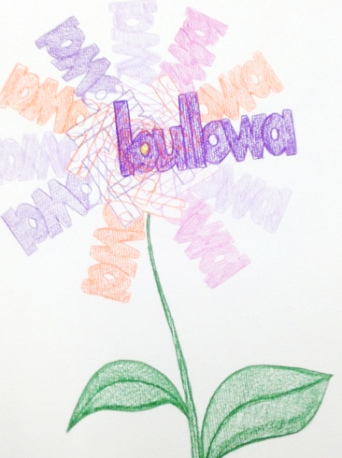  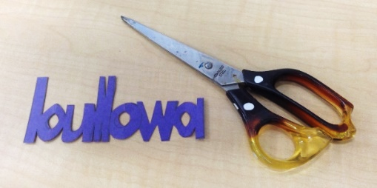  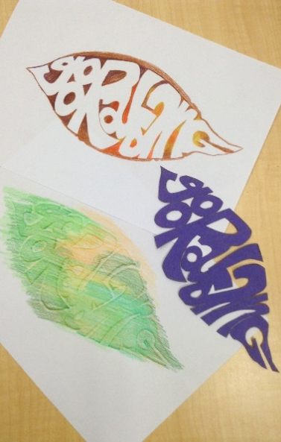  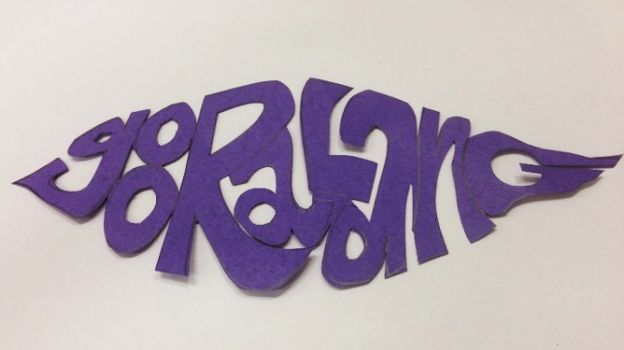  2D plant art. Search your local area for seeds and seedpods. Look at them under a magnifying glass and draw them in giant size. Include details like bumps and ridges, hairs and spiky bits. Use charcoal or heavy black pencils (3B or 4B) to draw these and experiment with the full range of tones from light to dark in your drawings. Display them all together in a line as a wall frieze with some black paper as backing.  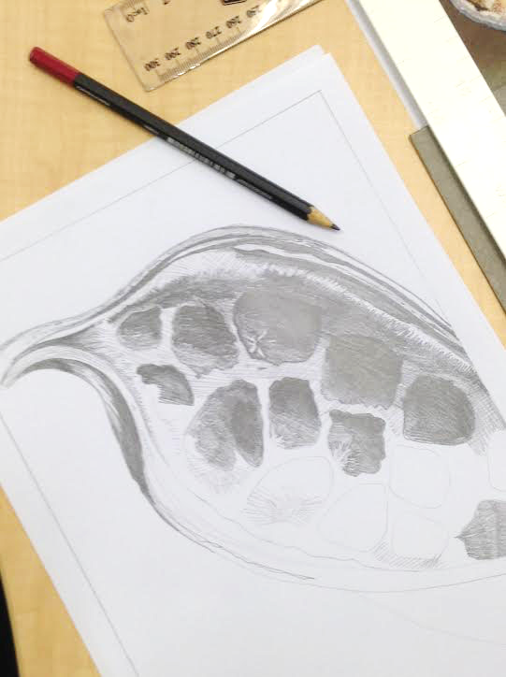  3D word art. Use the same words cut out of thick or corrugated cardboard and slot together to create sculptural forms of words. These could be painted and spray-varnished to give them a longer life.  3D giant seeds. Use wire and crepe paper, or fabric and papier-mache, to create supersized 3D models of the seeds/plants in the My Weekend with Pop story or seeds/plants from your local area.  Lucy Simpson is a Yuwaalaraay woman. Her language is from north-western NSW and is closely related to Gamilaraay language. Here are some Gamilaraay-Yuwaalaraay words that you could use to make 2D or 3D art, or a bilingual class mural: mirii (star), burrulaa mirii (a lot of stars), mandaymanday (string of stars), Maliyan.gaalay (morning star / Venus), Yarraan (Southern Cross), Warrambul (Milky Way), Birraybirraay (Orion’s belt), Miyaymiyaay (Pleiades), buluuy (dark, night), baaluu / gilay (moon).

Additional resources and reading for teachers
The following list of resources is for background reading for teachers. Some of the resources will be suitable for your students too, e.g. links to video clips of children across NSW who are learning Aboriginal languages. The resources are grouped according to languages represented on the NSW State Library My Weekend with Pop – stories in Aboriginal Languages website, and the list starts with some maps and general information about keeping languages strong throughout Australia. Some of the resources in the list are books which may only be available through specialised libraries. Some are more easily accessible. Teachers do not need to read all of these books to be able to implement the Stage 2 teaching and learning activities suggested in this guide.

Maps and keeping languages strong
- ABC online. Indigenous languages map. Available: http://www.abc.net.au/indigenous/map/
- ABC Radio National. (2009). Holding Our Tongues website has information about several languages across the continent and includes some audio recordings of speakers and songs. Available http://www.abc.net.au/rn/legacy/features/holdingourtongues/
- ABC Splash. Indigenous resources page. http://splash.abc.net.au/home#!/topic/494038/aboriginal-and-torres-strait-islander-histories-and-cultures
- Nathan, David (Ed). (updated 2017). Aboriginal and Torres Strait Islander Languages of Australia virtual library. Available http://www.dnathan.com/VL/
- Museums and Galleries NSW. Aboriginal languages map of Australia. Available https://mgnsw.org.au/sector/aboriginal/aboriginal-language-map/

Bundjalung
- ABC Open. (2016). A conversation in Bundjalung. https://open.abc.net.au/explore/139619
- ABC Open. (2016). Aboriginal language detectives. https://open.abc.net.au/explore/138717
- ABC Open. (2014). Sharing Bundjalung mother tongue. https://open.abc.net.au/explore/74602
- ABC Open. (2014). Sharing Bundjalaung language through photographs. https://open.abc.net.au/explore/74677
- Sharpe, Margaret. (2001). An introduction to the Yugambeh-Bundjalung language and its dialects. An introduction to the Yugambeh-Bundjalung language and its dialects. Revised (3rd) edition with chapters by Marjorie Oaks, Terry Crowley and Jill Fraser-Knowles. Armidale, NSW: University of New England.
- Sharpe, Margaret. (2005). Grammar and texts of the Yugambeh-Bundjalung dialect chain in Eastern Australia (Vol. 370). Munich, Germany: Lincom.
- Sharpe, Margaret. (2002). Dictionary of coastal Bundjalung including Bundjalung, Wiyabal, Minyangbal and Ngahnduwal: Unpublished manuscript.
- Sharpe, Margaret. (1995). Dictionary of Western Bundjalung, including, Gidhabal and Tabulam Bundjalung. Armidale: M. Sharpe.

Dharawal and Dhurga
- ABC Open. (2014). Let's rejoice in Dharawal. Tahlia King sings the National Anthem in Dharawal. https://open.abc.net.au/explore/77790 or https://vimeo.com/104576601
- ABC Open. (2014). Reclaiming the Dhurga language. https://open.abc.net.au/explore/94548
- Besold, Jutta. (2013). Language Recovery of the New South Wales South Coast Aboriginal Languages. (PhD), Australian National University.
- Eades, Diana. (1976). The Dharawal and Dhurga languages of the New South Wales South Coast. Canberra: Institute of Aboriginal Studies.
- NITV (National Indigenous Television). (2017). Around The Campfire, Series 3 Episode 13. Dhurga Language With Kerry Boyenga and Trish Ellis. Available http://www.sbs.com.au/nitv/video/554997315553/Around-The-Campfire-S3-Ep13-Dhurga-Language-With-K

Gamilaraay and Yuwaalaraay
- ABC Open. (2015). Near or far, a poem by A Gamilaraay woman, Suellyn Tighe, for her grandchildren. You can view it in English https://open.abc.net.au/explore/93771 and in Gamilaraay https://vimeo.com/126769095
- ABC Open. (2015). Give me five in Gamilaraay. https://open.abc.net.au/explore/112156
- ABC Open. (2015). Count to ten in Gomeroi. https://open.abc.net.au/explore/92371
- ABC Open. (2015). Master of ceremonies, Len Waters. https://open.abc.net.au/explore/108145
- ABC Splash. (2015). Yaama Ghubhii: Indigenous Connect Song. http://splash.abc.net.au/home#!/media/2394462/yaama-ghubhii-indigenous-connect-song
- ABC Open and First Languages Australia. Language legends series: Kate Munro. https://gambay.com.au/profiles/89
- Chandler, Karen, & Giacon, John. (2006). Dhiirrala Gamilaraay! Teach Gamilaraay: A resource book for teachers of Gamilaraay. Armidale, NSW: Yuwaalaraay Language Program.
- Giacon, John. (2002). Gamilaraay, Yuwaalaraay, guwaaldanha ngiyani: We are speaking Gamilaraay and Yuwaalaraay. Tamworth, NSW: Coolabah Publishing.
- Giacon, John. (2003). Yugal: Gamilaraay & Yuwaalaraay songs. Tamworth, NSW: Coolabah Publishing.
- Giacon, John. (2006). Gaay garay dhadhin: Gamilaraay & Yuwaalaraay picture dictionary. Alice Springs, NT: Institute for Aboriginal Development Press.
- Giacon, John & Betts, Marianne. (1999). Yaama maliyaa. An Aboriginal languages textbook. Walgett, NSW: Walgett High School, Yuwaalaraay Gamilaraay Program.
- Giacon, John, & Nathan, David. (2009). Gayarragi winangali (find and hear): An interactive multimedia resource for Gamilaraay and Yuwaalaraay [CD-ROM]: Catholic Schools Office, Armidale, NSW & The Hans Rausing Endangered Languages Project. Available http://lah.soas.ac.uk/projects/gw/
- Ma Gamilaraay. (2015). Gamilaraay dictionary app. Available https://itunes.apple.com/au/app/ma-gamilaraay/id935546616?mt=8
- Yuwaalaraay gaay Gamilaraay garay website http://yuwaalaraay.org/

Gumbaynggirr
- ABC Coffs Coast. (2013). Gumbaynggirr in song. Gary Williams and Dallas Walker singing the song Baabaga Birruganba Bularri http://www.abc.net.au/local/stories/2013/11/27/3899985.htm
- ABC Coffs Coast. (2011). Gumbaynggirr language, with Fiona Poole and Gary Williams. http://www.abc.net.au/local/stories/2010/07/02/2943206.htm
- ABC Open. (2015). Plus 20: Gumbaynggirr Language Teacher Michael Jarrett https://open.abc.net.au/explore/112354
- ABC Open and First Languages Australia. Language legends series: Michael Jarrett. https://gambay.com.au/profiles/92
- ABC Open and First Languages Australia. Language legends series: Virginia Jarrett. https://gambay.com.au/profiles/93
- Long, Julie. (2007). Barriyala: Let’s Work – Gumbaynggirr language student workbook 1, 2, 3. Nambucca Heads, NSW: Muurrbay Aboriginal Language and Culture Co-operative.
- Mayalambala teaching resource http://www.muurrbay.org.au/muurrbay-resources/courses/
- Morelli, Steve. (2015). Gumbaynggir dictionary and learner's grammar. Bijaarr jandaygam, ngawa gugaarrigam. Nambucca Heads, NSW: Muurrbay Aboriginal Language and Culture Co-operative.
- Muurrbay Aboriginal language and culture co-operative http://www.muurrbay.org.au/.
- NITV (National Indigenous Television). (2015). Indigenous rangers revitalise language and culture. http://www.sbs.com.au/nitv/nitv-news/article/2015/09/23/indigenous-rangers-revitalise-language-and-culture
- Senator Aden Ridgeway’s speech in parliament in 2009 in Gumbaynggirr language http://www.smh.com.au/federal-politics/language-is-power-let-us-have-ours-20091125-jrsb.html
- SBS TV, Custodians program, Season 1, Episode 14, Nambucca Heads, Gumbaynggirr Country (5mins 54 secs) http://www.sbs.com.au/ondemand/video/353160771753/custodians-gumbaynggirr-nambucca-heads

Paakantyi
- Butcher Murray, Kayleen Kirwin, Robert Lindsay, Wilcannia Central School and Board of Studies NSW. (2009). Paakantyi teaching and learning samples. Available https://ab-ed.bostes.nsw.edu.au/go/aboriginal-languages/learning/lower-darling/teaching-learning
- Butcher, Murray & Wilcannia Central School. (2011). Kilampa wura Kaani. Galah and bearded dragon. A Paakantyi story. Available https://www.youtube.com/watch?v=Lbc_b2S_3ws and https://wn.com/kilampa_wura_kaani__a_paakantyi_story
- Butcher, Murray, Wilcannia Community, and Sharing Stories. (2017). The moon and the gecko. Available http://www.pearsonplaces.com.au/Places/Primary_Places/Indigenous_Place.aspx
- Butcher, Murray and Faith Baisden. (2012). Picture books in Paakantyi and English. Available http://www.binabar.com/paakantyi-and-english-books-launched-in-wilcannia-and-menindee/
- Kirwin, Kayleen. (2012). Nhiki manhu. Making Johnny Cakes in Paakantyi. Available https://www.youtube.com/watch?v=3wvIzQPZiGE
- Kirwin, Kayleen. (2013). Teaching Paakantyi at Meninindee Cenral School. Availbale https://www.youtube.com/watch?v=LDvcvVZswCQ
- Paul, Margaret & ABC radio. (2013). Learning Paakantyi with Isobel Bennett. https://www.youtube.com/watch?v=-NwpXm_T0gY
- Hercus, Luise. (1982). The Bāgandji language. Pacific Linguistics Series B, No. 67. Canberra: Research School of Pacific Studies, Australian National University.
- Hercus, Luise. (1993). Paakantyi dictionary. Canberra: Australian Institute of Aboriginal and Torres Strait Islander Studies.
- Hercus, Luise. (1999). Paakantyi. In W. McGregor & N. Thieberger (Eds.), Macquarie Aboriginal words: a dictionary of words from Australian Aboriginal and Torres Strait Islander languages (pp. 41-60). North Ryde, NSW: Macquarie Library.
- Hercus, Luise, & Nathan, David. (2002). Paakantyi [CD-ROM of texts, stories, songs, grammar, dictionary, games]. Canberra, ACT: Australian Institute of Aboriginal and Torres Strait Islander Studies & Aboriginal and Torres Strait Islander Commission.

Wiradjuri
- ABC Open. (2012). Our Mother Tongue: Wiradjuri. https://open.abc.net.au/explore/22207
- ABC Open and First Languages Australia. Language legends series: Geoff Anderson. https://gambay.com.au/profiles/21
- ABC Open and First Languages Australia. Language legends series: Lionel Lovett. https://gambay.com.au/profiles/24
- ABC Open and First Languages Australia. Language legends series: Diane McNaboe. https://languagesmap.com/profiles/120
- Anderson, Geoff; Lovett, Lionel; Towney, Tiyana; and the Parkes Wiradjuri Language group. I am my Elders' blood. Song arrangement and mixing: Sunfield Records. (2015). https://soundcloud.com/ub-ubbo-exchange/i-am-my-elders-blood
- Bundyi cultural tours, cultural awareness and school programs in Wiradjuri country http://www.bundyiculture.com.au/
- Grant, Stan, & Rudder, John. (2001). Learning Wiradjuri book 1 (place and direction) & book 2 (about actions) [with audio CD]. Canberra: Restoration House.
- Grant, Stan, & Rudder, John. (2001). Wiradjuri language – how it works. Canberra: Restoration House.
- Grant, Stan, & Rudder, John. (2001). Wiradjuri language song book 1 & book 2 [with audio CD]. Canberra: Restoration House.
- Grant, Stan, & Rudder, John. (2001). Introducing Wiradjuri sentences. Canberra: Restoration House.
- Grant, Stan, & Rudder, John. (2001). Wiradjuri language colouring-in book 2. Canberra: Restoration House.
- Grant, Stan, & Rudder, John. (2005). Wiradjuri dictionary (2nd ed.). Canberra: Restoration House.
- McNicol, S., & Hosking, D. (1999). Wiradjuri. In W. McGregor & N. Thieberger (Eds.), Macquarie Aboriginal words: a dictionary of words from Australian Aboriginal and Torres Strait Islander languages (pp. 79-99). North Ryde, NSW: Macquarie Library.
- Wiradjuri Condobolin Corporation. (2016). Wiradjuri dictionary app. Available http://www.wiradjuricondocorp.com/
- Wiradjuri songs and animations:
- http://sharingandlearning.com.au/animation/
- https://www.youtube.com/watch?v=PcPP1eeBvDE
- https://vimeo.com/140564543
- https://vimeo.com/140564544
- Wiradjuri Educators Network. (2016). Wiradjuri for everyone website. http://www.wiradjuri-language.com/
- Wiradjuri Kids http://www.wiradjurikids.com.au/

