NSW Public Library Services
Nonfiction collections in NSW public libraries

Background
Over the last decade patterns in nonfiction development and usage have changed significantly. Anecdotally NSW public libraries have observed a shift to internet sources for nonfiction information and a significant reduction in reference and lending adult nonfiction collection sizes and usage and even more significant decreases in junior nonfiction collection size and usage.

However preliminary analysis of nonfiction collection data across NSW public libraries indicates that this decrease in size and demand for nonfiction varies dramatically across different library services. Variation in collection sizes and patterns of usage suggests that factors affecting on fiction collections are more complex than access to alternative sources on the internet.

Deeper analysis of data and understanding of collection housing, display, promotion and collection development would enable public libraries to identify good practices for nonfiction collections and enable NSW public libraries to maximise the benefits and reach of a significant investment.
,
Objectives
- To identify the current nonfiction usage patterns across NSW public libraries
- To identify factors which affect usage of nonfiction collections in NSW public libraries
- Develop good practice guidelines for nonfiction collection development, display, access and collection evaluation

Project description
The elements of the project would include:
- Analysis of overall trends in NSW public library nonfiction collections and usage data
- Identify benchmarks for good practice in nonfiction collection usage
- Consultation with NSW libraries achieving high levels of nonfiction usage and satisfaction. Factors for consideration include:
  - Collection display and housing
  - Collection signage
  - Collection development policy and selection
  - Collection budget
  - Procurement models for nonfiction collections
  - Weeding practices
  - Collection promotion
  - Nonfiction cataloguing practices and policies
- Publication of good practice guidelines for nonfiction collection development, display, access and evaluation in NSW library

To identify the current nonfiction usage patterns across NSW public libraries has proved challenging. When the research started there were a small number of libraries which showed increasing loans in non-fiction. Some of these have maintained this increase. Some of these increased their collection size, some descreased it. The initial scoping report (not published) still contains the current state of information about non-fiction collections, because the most recent Bibliostat data shows eight libraries where their non-fiction loans have increased from 2004 and 2014, and their overall loans have increased. One of these had council amalgamations or and another had several libraries joining one regional library which would bias these statistics.

From the state wide survey of genre rooms, it has not been possible to identify factors which affect usage of nonfiction collections in NSW public libraries. There are too many variable which took place at the one time. Not all genre arrangements increased loans. Many genre arrangements were across entire collections. Detailed discussions would need to take place with individual libraries to be able to attempt to locate possible factors.

It is not possible to develop good practice guidelines for nonfiction collection development, display, access and collection evaluation at this time. There are some indicators which could be considered. Collection HQ , from anecdotal evidence appears to be assisting in collection maintenance. Highly managed collections, designed to be responsive to the community contribute to loans.

Survey Results

41 libraries provided information about their use of using themes, genres or rooms for non-fiction. Adult non-fiction had twelve examples, junior nine and young adult six.
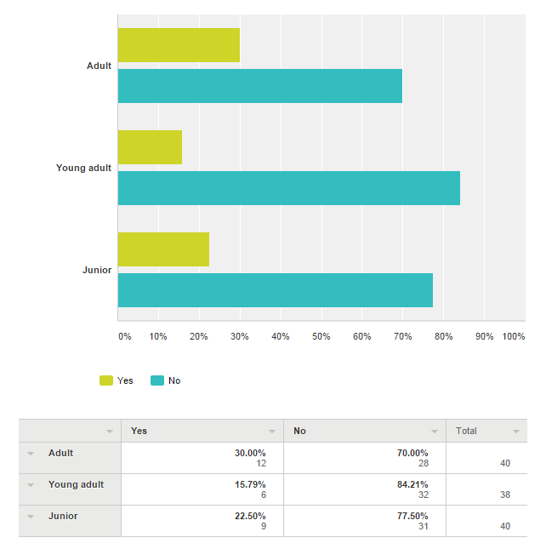

For some of the libraries which responded, it was at one of their branches, for others it was some or all.

For the fifteen libraries who responded to a question about floating collection, only five had one.

Libraries were asked about some specific features of their catalogues, to help with online collection discovery.

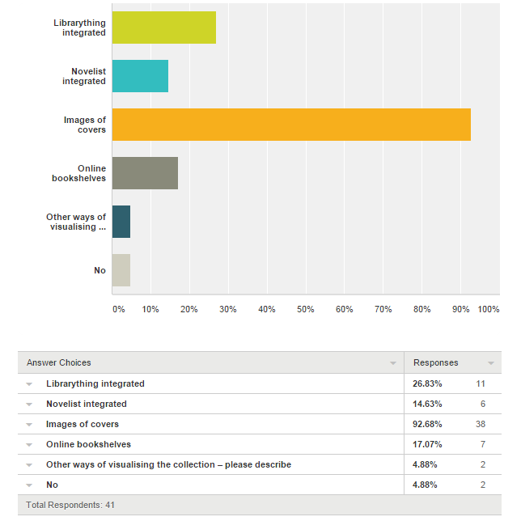

Images of covers was the most common. Some libraries also had:
- gallery displays for similar titles
- OPAC featuring containers which can feature either collection specific or subject specific titles (with covers) Various pages on website have 'latest releases' covers lists for Adult Fiction, DVDs, Magazines, and Music CDs. The OPAC also features links to lists of titles added to the collection within the last 2 months (from our Acquisitions module)
- QR codes
- Some images of covers. Google Books record for some items. Both are courtesy of the Libero WEBOPAC module, not created inhouse.
- Integration of Wheelers and Overdrive into catalogue (OCLC WorldShare).
Libraries were asked if they used social media to promote non-fiction collections
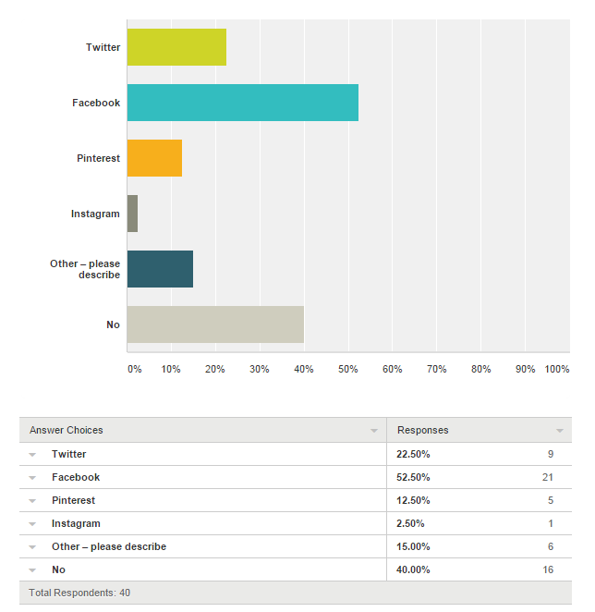
Other social media used include:
- Pinterest
- Library blog/s
- Flickr
- Weekly newspaper column
- Online bookclub
- Email newsletter

When was the non-fiction component of the collection policy updated?
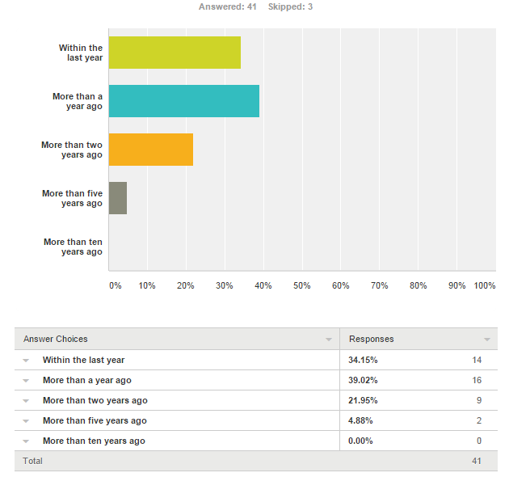

What collections are in genre/subject rooms?
- Non-Fiction Junior Non-Fiction
- biographies separate to nonfiction
- Subjects are most popular but separated by Dewey Numbers and customers often have to go to different shelves to find similar subjects; books that has significance in cultural regards, eg Aboriginal collection.
- English Adult Non Fiction English Junior not fiction
- LIAC, Local Studies, and English Workshop are shelved with but separate to the Non Fiction collection; Biographies are identified but shelved in the non fiction collection according to their appropriate Dewey.
- Parenting Indigenous Better Reading Military Genealogy
- All adult non-fiction is divided into shelf locations, of which there are 37 and then within the shelf location are arranged in Dewey order, Junior non-fiction is divided into 4 areas (Things to do, people and places, How things work and Animals and plants. We shelve the following genres separately Mystery, Science Fiction, Paranormal Fiction and Classic Fiction
- We use a straight Dewey sequence, with Biographies in a separate Dewey run as they are very popular
- Indigenous, HSC, Biography
- Gardening, cooking, interior design, DIY, Health, Business and Management, parenting, art and music, craft and leisure, computing, biography
- Non-fiction at small branch with adult, teen and junior interfiled
- in the one branch that we have moved to genre based shelving, the whole collection is divided
- Biography / Indigenous / Mental health & wellness / Parenting / Literacy / Junior Literacy
- Art and Crafts, Gardening, DIY, Parenting

What words are used to describe the themed areas (for example health and wellness, walk on the wild side, travel etc)? What kinds of signs are used?
- Jnr (About Me, Animals & Plants, Doing Things, Fun Facts, Machines & Computers, People & Places) Adult (Beliefs, Biography, Business, Family History, Food & Wine, Health, History, House & Garden, Knowledge, Language, Legal Information, Local History, Military, Parenting, Reference, Relationships, Sciences, The Arts, Travel, True Crime)
- Biographies
- there are few subject zones for AN, biography, Aboriginal & Torres Strait Islander, Home & Garden, Cooking, Parenting, Craft, Health & Wellbeing, Environment & Sustainability, Computers & Technology. So far signages are not great as they're temporary due to the uncertainty of the new library building.
- Family & relationships home and garden body, mind and spirit arts and crafts music, movies and theatre paranormal and mythology sport and recreation countries and cultures food and cooking computers and technology literature, language and facts business and education animals industry, mechanics and engineering science local and family history true crime
- Hone& garden, Arts & literature, Science & technology, People & society, Business & finance, Health & family, The world, Past & present, Local studies & family history, Learning English, HSC parent and teacher, Biographies Spine labels and location guides are colour coded
- ceiling sign for Legal Information bayend label for Local Studies and English Workshop
- Parenting Indigenous Better Reading Military Genealogy Sticky labels Signage with words and images
- We don't actually have "Themed areas" the entire non-fiction area is set out according to shelf locations, each shelf location has signage above it e.g. Adventure & Travel, Crime, Style & Fashion, Art, Biography, Sport 7 Fitness
- Simply a sign on the top of the shelves 'Biographies' black printing on yellow A4 paper, laminated, with arrows pointing down to the shelves
- Home & Garden, Health and Wellbeing, Business and Management, Computing, Parenting, Art and Music, Craft, Sport & Travel, biography
- popular headings from BISAC
- Business & Computing; Home & Lifestyle; Family & Wellbeing; Arts & Crafts; Life & Times; Travel; Science & Technology. We have also the following junior categories: That's amazing; People & places; How things work; Animals & nature; Things to do. We also have a :Study Help area that covers curriculum support.
- subject areas as above are separately shelved from general non-fiction run, with themed spine labels, bay end or overhead signage.
- Art and Crafts, Gardening, DIY, Parenting Shelf top signs - they are shelved on lower shelves

How are the adult non-fiction genres shown on catalogue?
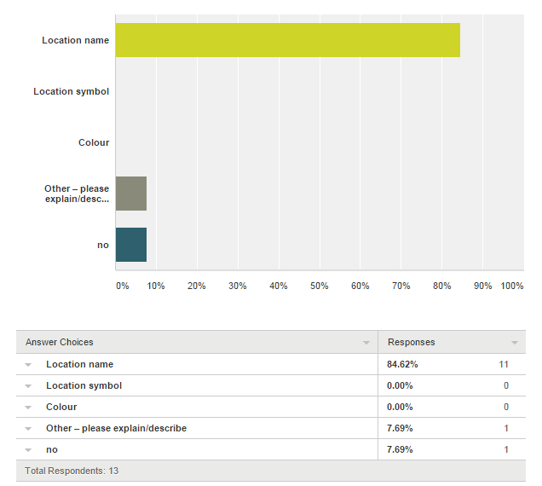

The comments had two libraries which provided call numbers, so the usual method of identification. The other comments combined collection and branch name for greater precision.

In the themed areas, are all formats shelved together?
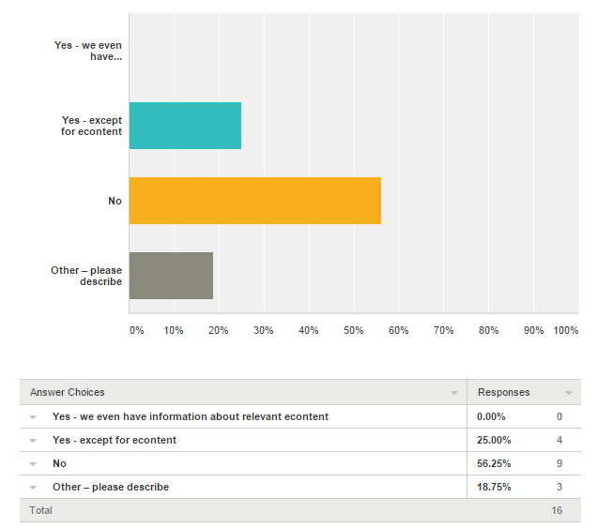

It was interesting to see only a few libraries bringing all formats together. The comments highlighted separation of collections. One library has posters about eContent in the area as a way to help people be aware of relevant content online.

What percentage of your non-fiction collection is arranged this way?
For the small number of libraries which have genre or theme approaches, only a few have all their non-fiction collection available this way. For the remaining libraries using this approach most had less than 20% of their non-fiction collection arranged this way.

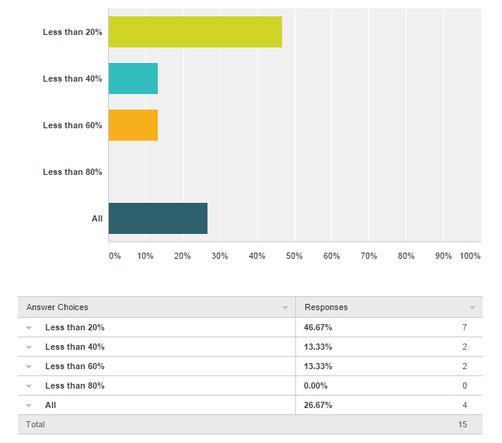

Shelving and arrangement
We asked libraries to tell us about their collection. How is the shelving arranged? What kind of shelving is used? What percentage are face out? Are there genre rooms?

- 2 zigzag shelves items selected from the bay that have appeal no particular order and 2 flat shelves in dewey order per bay for each genre approx. 40% would be face out. shelves are arranged in a u formation creating a room feel
- regular shelving with one display shelf every 2 bays
- All AN shelves are on one side of the library and all in angles. Standard metal shelving is used but some display books are on face out shelves (less than 10%) amongst its allocated subjects. We don't have genre rooms.
- At the moment - normal rows of shelving, but this will chance once the collection has been re-classified.
- Standard shelving at [branch]. Shelving arranged into subject rooms at [other library]. Face out shelving approximately 1:8 ratio
- standard flat library shelving; quite tall; arranged 000-999 from the centre/front of the library to the side/back We do not have space for the face-out display of non fiction items but we do have some book display holders among the shelves which are used
- Standard shelving. Problem for us is space. When we get a larger library we will create more defined areas.
- The shelving is just conventional library shelving 5 bays high the top 1 or 2 shelves (usually 2) are face out.
- The non fiction is arranged in a straight Dewey sequence. Just normal library shelving, four shelves, with a roof on the top shelf on which we place directional signs telling users what materials are shelved in that bay. The Indigenous books are shelved separately in a Dewey sequence and have a separate signage.
- Dewey - regular shelving, Very little face out. No genre rooms!
- All attempts are made to have as much face on display as possible. Staff are trained in merchandising principles and are alert to displaying items. Some branches have genre rooms for Zones, some branches have slat wall displays for all new items (including ANF), all effort is made to showcase content. Within the ANF sequence effort is made to have one display shelf per bay of books.
- Small branch, regular shelving. Subject signs on top of shelves and as dividers. 1% face out-space at an absolute premium
- The shelving is straightforward, mostly 1500 high with some zig zag and display shelves included. the display shelving is face out. Space constraints limit this to about 25%. Space constraints mean there aren't genre 'rooms', but there is a flow from one genre to the next.
- Most of the shelving is in standard straight runs, with smaller / specialist collections tucked into various nooks or short runs. Shelving is standard metal shelving, slatwall bayend panels. No face out shelving, nor "rooms" as such
- The genre collections are on lower shelving but still "roughly" in the same Dewey sequence as the overall collection with the exception of the "Parenting" collection which is housed in the Junior area. Around 10 percent would be face out.

What preparation did you do before moving the collection?
Weeding was a key starting point for all the libraries before moving the non-fiction collection. Even in one of the libraries which returned their collection to Dewey order, weeding was done prior to moving most of the collection back to Dewey.

After the weeding, items had genres assigned, and catalogue records were updated. Where needed (and this was not in every library), spine labels were changed to reflect new categories.

Some libraries consulted with a range of staff and the community about the changes, most did not. One library looked at examples from bookshops, and the categories they use as a guide to how to arrange the collection.

After changing the layout, if floor plans existed showing the collection layout, these were updated. One library had a series of talks in the library to target the different zones and to build community awareness about the content of the different zones. They also included some new furniture in the zones as the layout was a big change and they wanted people to be able to read in the new areas.

What kind of feedback have you received from clients about this kind of layout?
Feedback from the communities has been mixed, some have been very happy because things are easier to find, others aren’t because things don’t seem easy to find. There is not sufficient information to determine if this has been influenced by library staff.

Comments include:
- Majority of feedback has been positive, some people did not like the change, a period of adjustment was required
- So far all feedback is positive, because it's easy to find what they want and also make it more convenient for browsing.
- Nothing at this stage, as it's very early stages.
- Mixed feedback. Most of the formal feedback received has been negative. Some of this was from people who identified themselves as librarians or long term library users. Survey comments about collection and finding material in the new library are positive. People familiar with the Dewey system find it more difficult to find items.
- Limited response. Generally, though, people like it. Not sure about genre approach for all the non-fiction.
- The public tend to love this arrangement, for those who don’t use libraries often or who only use this library service it is intuitive. Once clients who are used to a different system get to understand what we do and why we have this layout, they seem happy with it. Librarians (those who don’t work here) tend to find it a bit confronting.
- All positive. Members of our Indigenous community loved this specific collection. And HSC students love going to the HSC shelves - all in one - makes it easy.
- Positive
- Positive from staff and borrowers, especially in the junior areas. Our Biographies have always been shelved in a single alphabetical run, so it hasn't appeared to be a big leap for the borrowers to move to grouping like material together.
- More positive, as the "special" collections make sense, and are readily located by clients
- Very little. It confuses some.

What has been the effect on loans with this change? Please describe and include details of statistics if they are available.
- Initial changes evident at the end of the introductory financial year period 13/14 showed a 2.97% increase
- sorry cannot provide relevant information Anecdotally this collection seems to be popular
- Will send this separately as it's not available so far. However it certainly seems increase in hours usage when doing morning tidy and by observation.
- Inconclusive. there was big an increase in non fiction loans at the [ ] library (35%) between 2010 and 2012 but the change to the collection coincided with the opening of the new [ ] library. [Branch library] experienced a more modest 3% increase in loans after the switch to subject rooms but again the coincided with a renovation which raised loans across all collections.
- Loans have declined, but it is due to other factors, including a shift from a two-week to a three-week loan.
- The loans increased…
- We have had these collections separated for over 10 years, so it is hard to gauge.
- We created these Zones in 2004. Response was positive and the loans from the Zones exceeded loans from the titles left in the ANF Dewey sequence. This pattern is still prevalent today. We are currently reviewing some of our Zones (Art and Music, Computing) as loans are not as anticipated
- Increase in loans, difficult to tell if result of rearrangement of collection because the branch had a complete refurbishment at the same time
- The junior statistics have been remarkable, with a 374% increase from November 2013 to November 2014
- Uncertain
- Loans have remained relatively the same

From reading the survey results, genre rooms and themes are interpreted very differently across libraries. It has been helpful to see this. For some libraries it is separating a single collection, like biographies, for easier access for clients. Four libraries had their entire non-fiction collection divided by genre, but for most of the libraries who responded it was some of the non-fiction collection, not all. Within these spaces few libraries bring all formats together, mostly leaving magazines and dvds in separate runs or locations.

It could help clients if more on site promotion of econtent takes place, highlighting the ebooks, eaudio, magazines and databases of relevance to a specific genre area or room. There also needs to be a similar online discovery space, reflecting the genre area or rooms, so that the items can be browsed, or at least their covers browsed, online. With continued improvements to library management systems and discovery layers, this should be possible. It would also be an effective way to highlight online content to the community in the same kind of browsing clusters as in the library.

This comment
The public tend to love this arrangement, for those who don’t use libraries often or who only use this library service it is intuitive. Once clients who are used to a different system get to understand what we do and why we have this layout, they seem happy with it. Librarians (those who don’t work here) tend to find it a bit confronting.
is a strong reminder that how the library is arranged should be to serve the clients. It also highlights the important role library staff play in assisting clients to navigate the space, and this is true however the library is arranged as each structure needs some explanation.

