75th Anniversary of the NSW Library Act 1939
3 November 2014

Information and resources for NSW public libraries

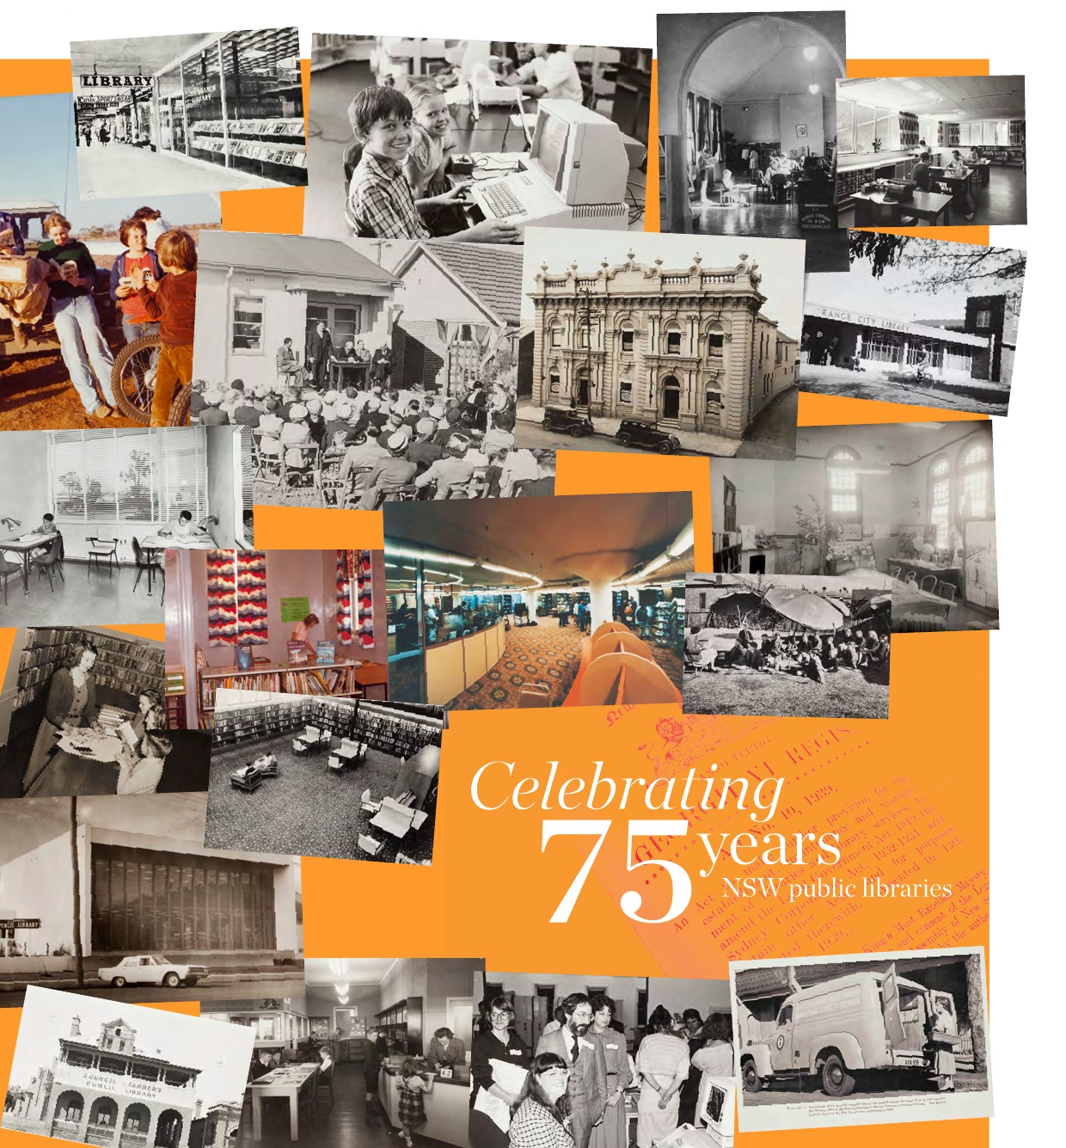

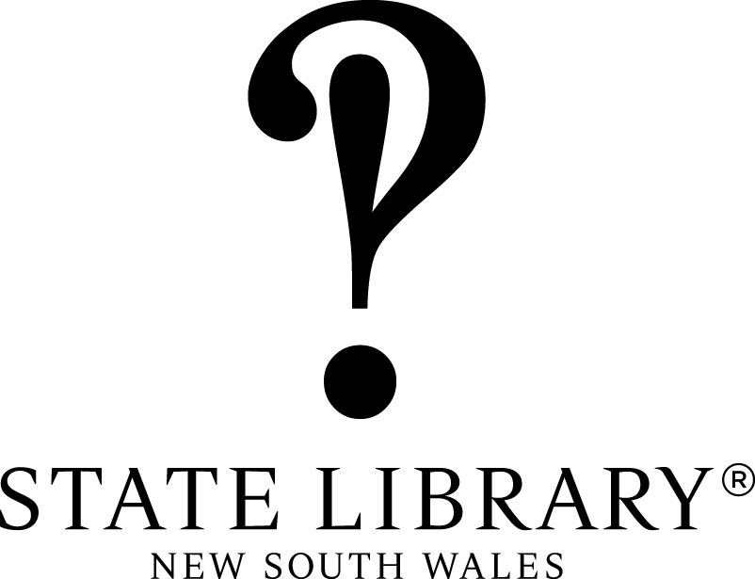

Produced by the State Library of NSW August 2014

Overview

2014 marks the 75th anniversary of the NSW Library Act 1939 and we are encouraging public libraries across the state to celebrate.

The 75th anniversary of the NSW Library Act falls on Monday 3 November 2014.

The NSW Library Act was passed by State Parliament on 3 November 1939 with bipartisan support. This landmark legislation led to the provision of free public library services for the people of NSW.

In 2014 public libraries are going strong, with over 368 libraries across the state, 3.2 million members (that’s 44% of the population), 46 million loans per annum and over 35 million visits to libraries each year.

The 75th anniversary of the NSW Library Act 1939 provides an opportunity to celebrate the growth of public libraries over the last 75 years, promote the strong position of NSW public libraries today and look towards the future of the public library network.

We encourage each library service in NSW to get involved in the celebrations by hosting an event on 3 November and participating in social media activities.

This is a great opportunity to promote your library in the context of state-wide celebrations.

This information pack includes a brief history of the Library Act, some suggested activities you can do to celebrate the 75th anniversary of the Library Act and promotional materials you can use as part of your celebrations.

For more information about the 75th anniversary of the NSW Library Act 1939:

- Visit our libraryact75th blog at www.libraryact75th.tumblr.com
- Visit our Celebrating 75 years Pinterest board at www.pinterest.com/slnswpls/celebrating-75-years
- Visit the State Library of NSW website at www.sl.nsw.gov.au/libraryact75th
- Follow the conversation on social media #libraryact75th
- Contact Edwina Duffy, Project Officer Public Library Services, on (02) 9273 1526 or edwina.duffy@sl.nsw.gov.au
Brief history of the NSW Library Act 1939

NSW public libraries: “A never failing spring....”

The passage of the NSW Library Act enabled the provision of free public libraries in NSW. It provided for State Government subsidies to local councils as an incentive to set up free public library services; and instituted the Library Board of New South Wales, one of the predecessor bodies of the Library Council of NSW.

Free Library Movement

NSW was the Australian frontrunner in the Free Library Movement. Prominent solicitor and businessman Geoffrey Remington founded the Free Library Movement in 1935 and became its chief spokesperson and Executive Chairman in 1936. His activities were stimulated by the Munn-Pitt report, which criticised the state of public libraries in Australia and received extensive exposure when it was published in 1935.

In the mid-1930s, there were only two free public libraries in NSW operated by local authorities: Broken Hill Public Library, established in 1906, and the Sydney Municipal Library (now City of Sydney Library), which commenced operations in 1909.

In 1935 on Sydney’s lower north shore, a meeting of parents and citizens groups and progress associations met at the Chatswood-Willoughby School of the Arts and established the Free Library Movement. The Free Library Movement’s objects were to establish free public libraries in NSW and persuade government to complete the building that housed the Public Library of NSW. Public Library of NSW Principal Librarian WH Ifould and Deputy Principal Librarian John Metcalfe were unofficial advisors and supporters to the Free Library Movement.

This group was broadly based and comprised of people of all political views; from local councillors to business groups to teachers; together with the returned services movement, service clubs, trade unions and parent and citizen associations. Geoffrey Remington was the layperson with great lobbying skills behind the group. He was well connected, with a gift for public relations and a good understanding of influence. The group was well organised in its communications: speakers were trained and put their case on radio, locally and nationally; pamphlets were circulated; school children were invited to participate through writing essays and winning prizes – the topic was the benefits of free public libraries.

Remington together with John Metcalfe toured the state by train and branches of the Free Library Movement sprang up in regional areas as well as suburban Sydney by the end of 1938. It was essentially a laypersons’ movement – the librarians took care to be involved more informally.

The Government acts

The Education Minister DH (David) Drummond, who was keen to see public libraries improved, set up a Libraries Advisory Committee in June 1937 to recommend improvements to library services and draft legislation.

Remington was appointed to the Libraries Advisory Committee by the Minister for Education in 1937. Ifould and Metcalfe were also appointed members of this Committee together with an under-secretary from Department of Education. This committee developed a plan for public libraries in NSW via a report and drafted the bill that became the Library Act 1939.

In early 1939, NSW cabinet agreed in principle to the establishment of a Library School at the Public Library of NSW and adopted in principle the report of the Libraries Advisory Committee. The draft bill was sent to the Parliamentary Counsel for finalisation. Copies of the Libraries Advisory Committee report were sent out to every institute and school of arts in NSW; to the returned services branches; the Country Women’s Associations; all town clerks and elected members; relevant librarians; NSW parliamentarians; various government departments and a number to each Apex and Rotary club.

Various activities, lobbying, and refinements continued as matters progressed with the Government. For example, the Inverell area continued to be interested in establishing provision of library services through the Library Bill though the fine details including financial assistance had not yet been worked out. World War II broke out and at the end of September 1939 Cabinet decided to defer the introduction of the Library Bill. Much further behind the scenes lobbying took place, which included Principal Librarian Ifould threatening to resign if the Bill did not progress. In the end a compromise was found - the Bill had support but the financial clauses would be delayed.

The Bill was passed in the early morning of 3 November 1939; proclaimed 22 December 1939 and would take effect, apart from financial clauses from 1 June 1940.

The Public Library continued to be extended and the great reading room (now Mitchell Reading Room) was open from June 1942. Its official opening occurred in November 1943 and included the announcement that the Library Act including its financial provisions would be effected 1 January 1944.

Growth of the network

Within 18 months of the Act being passed, 32 NSW councils had adopted the Act, seven were already providing library services and 16 councils planned to begin in 1945. By the end of 1946, a quarter of the people of NSW were being served by a free public library service.

The last council to adopt the Act and establish a public library was Junee in 1992. Today Central Darling Shire is the last council in NSW that does not provide a library service, although it has adopted the Act. The Library Council of NSW supports library services to the people of Central Darling Shire and the unincorporated area of NSW through an annual grant to Broken Hill Council for their operation of the Outback Letterbox Library for these isolated residents.

The Library Act 1939 must rank as one of the great achievements of the NSW Government through its creation of a network now numbering over 369 public libraries for the people of NSW.
There was also a national impact. Across Australia, the success of the Free Library Movement following the Munn-Pitt report of 1935 brought about a turning point for libraries. Legislation was passed in every state between 1939 and 1951 resulting in the establishment of Library Boards, whose chief purposes were to develop local public library services.

75th Anniversary

The 75th anniversary of the passage of the NSW Library Act in 1939 is a great opportunity to celebrate the history of NSW public libraries, their achievements and their future.

Library philanthropist and industrialist Andrew Carnegie was of the view that it was imperative that local citizens embraced their local libraries to ensure their ongoing funding and upkeep from their local authorities. Carnegie also said: “A library outranks any other one thing a community can do to benefit its people. It is a never failing spring in the desert.”

Today, NSW public libraries are vibrant community spaces, with services beyond book lending and story-time. While the services offered, the technology employed and the types of building and spaces are beyond that dreamt of by the architects of the NSW Library Act, the bedrock public library principles of benefiting and strengthening communities though free library services remains as strong as ever.

Anne Doherty, Consultant, State Library of NSW. This article was first published in Public Library News, August 2014.

Useful links

Munn, Ralph (1935) Australian Libraries: a survey of conditions and suggestions for their improvement by Ralph Munn and Ernest R Pitt, Australian Council for Educational Research, Melbourne.
You can view this item online at the State Library of NSW

NSW Libraries Advisory Committee (1939) Public library services: a report of the Libraries Advisory Committee to the Honourable D.H. Drummond (Minister for Education in NSW), Government Printer, Sydney.
You can view this item online at the State Library of NSW

Library Act, 1939, No. 40 (1945)
You can view this item online at the State Library of NSW

When did your council adopt the Library Act? Visit www.sl.nsw.gov.au/libraryact75th to find out when your council adopted the Library Act and started a library service.

Ideas for activities

Here is a list of suggested activities to help you celebrate and promote your library for the 75th anniversary of the Library Act. We encourage you to participate in at least one activity.

These are intended to be suggestions and starting points, please be as creative and colourful as you like.

Host a celebration event on 3 November
The NSW Library Act was passed by State Parliament on 3 November 1939. The Library Act turns 75 today! Host a celebration event in your library, it could be as simple as hosting a cake or morning tea. Use the poster templates and balloons to promote your event. Take photos of your event and share them on social media.

Create a display about the history of your library
Create a display about the history of your library. Was there was a branch of the Free Library
Movement in your local area? When did your council adopt the Library Act and start a library service? How has your library changed over time? Have there been any significant events, such as new buildings or natural disasters? You could look up newspaper articles on Trove and include old photographs. Use the poster templates to promote your display. Take photos of your display and share them on social media.

Participate in social media activities
Participate in social media activities that will help celebrate and promote your library. Just to make it easy, we have made a list of suggested activities for you.

Share your photos
Take photos of your activities and share them on social media. You could post them on our libraryact75th blog or on your library’s Facebook, Twitter, Flickr, Instagram or Pinterest accounts.

Use hashtags
If you are using Twitter or sharing photos of your activities on social media, use the following hashtags:
#libraryact75th
#nswpubliclibraries
#(name of your library or council)

If you use the hashtags other people can follow and share what you are doing to celebrate the 75th anniversary of the Library Act.

Post on our libraryact75th blog
You can submit your own photos and stories on our libraryact75th blog at www.libraryact75th.tumblr.com - simply use the “submit” button!

Share your old library photos on Pinterest
Do you have any historical photos of your library? You can pin them on our Celebrating 75 Years Pinterest board at www.pinterest.com/slnswpls/celebrating-75-years

To do this you will need to have a Pinterest account and follow the board, and then we will invite you to pin. We will be inviting NSW libraries, councils and individuals to pin.

What do you love about your library?
Use the “Celebrating 75 years of NSW public libraries” poster template to create a poster with one of the following questions:
What do you love about your library?
What does the library mean to you?
Why did you come to the library today?

Print the poster and display it in the library. Invite members of the public use post-it notes to write and stick their responses around the poster. You could leave it up for a day or a week.

Here is a nice example of what it might look like: https://www.flickr.com/photos/hennepincountylibrary/14106788177/
Take a photo of the poster and the comments and share them on social media.

What is your library memory?
Ask members of the public to share their favourite library memory. It might be the first time they went to a library, a special event they attended, or when a funny thing happened at the library.

Use the “Celebrating 75 years of NSW public libraries” poster template to create a poster with the question: What is your library memory?

Print the poster and display it in the library. Invite members of the public to share their responses. You could use post-it notes or larger pieces of paper for more detailed responses. You could leave it up for a day or a week.

Ask key figures in your local community, such as MPs, councillors, celebrities, writers, sportspeople or businesspeople, to share their library memories.

Share the responses on social media, you could post them on your library’s Facebook page or Twitter account. Use the hashtag #librarymemories

30 things you can do at the library
Every day for the month of November share something special or unique about your library. You could use Facebook, Twitter or whichever social media platform your library already uses. You could post photos, fun facts or information about your collection, services, programs or statistics. Be creative!

You can plan your 30 things in advance, using a social media scheduling tool, like Hootsuite or Tweetdeck for Twitter, or even just a simple Word document.

If 30 things sounds a bit daunting you could try seven things to do at your library over one week.
#30librarythings

Where does your library card take you?
Encourage your members to take photos of their library card in different locations. They could be everyday places, like going shopping, or special places, like on holiday.

Ask members to share their photos. You could create an album on Facebook or Flickr, or a Pinterest board. You could Tweet the best photos.

Depending which social media platform you use, members might be able to share their photos directly with you, or they might have to email photos for inclusion on your social media account.
This activity could take place over a few months. You could print out the photos and have a display at your library.

Day in the life of a library
On a chosen day - it could be 3 November or another date that suits your library - showcase what happens during a day at your library. You could share photos, statistics, give a virtual tour, or include comments from members. You could use Facebook, Twitter, Instagram, Pinterest, Flickr or whichever social media platform your library uses. You could choose 10 things and post them throughout the day.

Promotional materials

Media release template – use the media release template to promote events at your library.

Poster template – use the template to create a poster to promote your event or display.
You can add your library or council logo.

Balloons and bookmarks – we will send each library service a promotional kit containing balloons and bookmarks. Extra balloons and bookmarks are available on request by emailing edwina.duffy@sl.nsw.gov.au

MEDIA RELEASE TEMPLATE

Public libraries celebrate 75 years

On Monday 3 November [Insert library name] will join public libraries across the state to celebrate the birth of free public libraries in New South Wales.

[Insert library name] will be hosting a celebration event with [insert description of event] to mark the 75th anniversary of the NSW Library Act, the landmark legislation that led to the provision of free public library services for the people of NSW. [Call to action/indication of how to participate for members of the public.]

The celebrations are part of a state-wide program of events led by the State Library of NSW to commemorate this historic milestone and to recognise the important role public libraries play in the community.

Since the passage of the Act in 1939 the number of public libraries in New South Wales has grown from two – Broken Hill and Sydney – to over 360, with 3.2 million members and more than 35 million people visiting libraries each year.

[Insert council area name] adopted the Act in [year] and its first branch opened in [year]. Today the [Insert library name] sees over [Insert service/membership stat] through its doors each year, taking part in a range of programs from [highlight library programs].

“Insert quote from Library Manager or Council representative” says [insert name and title].

“This November we celebrate the 75th anniversary of the NSW Library Act, which led to the network of free public libraries we all enjoy today.

“The Act was supported by both sides of politics, and was passed two months after the outbreak of WWII, which shows just how important the establishment of free public library services was to the people of NSW. Councils quickly adopted the Act and the number of NSW public libraries has now grown to over 360.

“Today, public libraries are going strong and play a vital role in their communities. As State Librarian I have visited many from Waverley to Wentworth and enjoyed seeing them in their diversity, meeting their staff and council colleagues and talking to their readers. It is striking to see how much they contribute to their communities,” says Alex Byrne, NSW State Librarian & Chief Executive.

[Option to list additional event/program details or include quote.]

For more information about the anniversary of the Library Act 1939 please contact
Edwina Duffy, State Library of NSW, (02) 9273 1526, edwina.duffy@sl.nsw.gov.au

Media contact: Vanessa Bond, Media & Communications Manager, State Library of NSW, (02) 9273 1566, vanessa.bond@sl.nsw.gov.au

POSTER TEMPLATE
Library NAME

Celebration Event
Date to be confirmed

Text inviting everyone to be part of a wonderful experience
Text inviting everyone to be part of a wonderful experience
Text inviting everyone to be part of a wonderful experience
Text inviting everyone to be part of a wonderful experience
Text inviting everyone to be part of a wonderful experience

Library name
address
contact details
website

