Dear [participant name or Sir/Madam],

Thank you for agreeing to be interviewed by [Name of Library] for an oral history recording. This form explains how we intend to obtain and use the material you provide as part of this interview.

The library may create the following items from your interview:
- An audio and or video recording
- An edited transcript and summary
- A photograph of you

In addition, if you agree, we would also be grateful for any personal documents, photographs, or materials that you might like to share as part of the Interview. We may accept these items in original form, or we can make copies if that is preferred.

Your contribution is very important to us, and we wish to make sure that you are properly acknowledged for it. While the Council will own the copyright in the items that the library creates during the interview, we would like to invite you to license any personal documents or materials (or copies thereof) that you choose to share with us, under a licence called the Creative Commons Attribution 4.0 Licence. This licence ensures that we have your permission to share this material with the public in the same way that we intend to be able to publicly share the other items we create.

All you need to do is complete and sign the attached consent form. The plain English version of the licence is attached for your perusal, and a copy can also be found online at https://creativecommons.org/licenses/by/4.0/.

The licence also requires us to associate your name with the material that you contribute. We can do so by prominently displaying your full name, first and or surname, or any other name that you wish to be known by, with the material. If you do not wish to be attributed, that’s ok. Just place an ‘N/A’ on the attribution line on the attached form.

To thank you for your participation we will provide you with a copy of the interview recording, transcript and any related items that are created from your interview, which we will forward to your nominated address on the attached form.

Once again, thank you for agreeing to participate in an oral history interview, and for your important contribution to our library. It is greatly appreciated by us, and will be of considerable benefit to the wider community for years to come.

Yours sincerely,
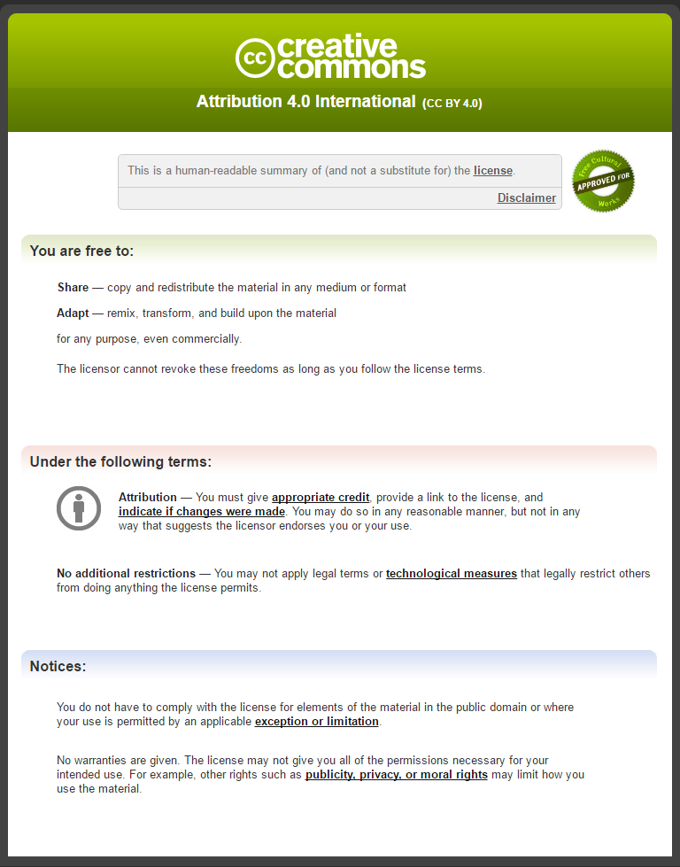

NAME:

ADDRESS:

PHONE AND/OR EMAIL:

I agree to be interviewed for an oral history recording by the [Name of Library]. I understand that the library may create the following items from my interview:
- an audio or video recording
- an edited transcript and summary
- a photograph of me

If I have provided personal documents, photograph’s, or other materials, or permitted the library to make copies of same, I make them available to the library under the Creative Commons Attribution 4.0 Licence.

Please attribute me as: _______________________________________
(if you do not wish to be attributed, please insert NA above.)

A copy of the Creative Commons Licence Deed was attached to this form for my perusal.

I understand that the library may make all of the materials created or provided as a result of this interview available to the public.

Interviewee’s Signature: ________________________________

Interviewer’s Signature: ________________________________

Date: ________________________________

