Community information audit

The NSW public library network plays a key role in connecting their communities to a range of local services. Many do this through use of online databases such as LINCS which is an online community information directory provided by a partnership of more than 30 local councils, state government departments and community organisations.

In light of freely available information on community services online and a growing presence of community information agencies on the web the value and role of libraries in the provision in community information needs to be critically considered.

Collection of data on community information provision via an audit would provide information to inform the planning, provision and allocation of resources to community information provision.

This audit was initiated after a submission to the Public Library Network Research Committee, and has been auspiced by this Committee.

Objectives
- To explore the current role of libraries in providing community information
- To identify the number of NSW public libraries generating and providing access to community information.
- To identify the resources required to provide community information in libraries
- To identify current service models for community information in libraries
- To explore the value of community information provisions provided by public libraries

The project undertook research to identify current trends in community information and the future role of libraries in the provision of information. It looked at how libraries are currently providing community information, service models and sources –online, print, LINCS, social media.

The next stage is for the State Library of NSW to
- Develop recommendations on the viability of community information in libraries
- Develop and publish a discussion paper on the future role of community information in NSW public libraries

Summary of results
This audit was completed in 2014 by 61 libraries or councils in New South Wales. While not every library service is represented in the survey responses, the information obtained highlights the importance of community information, and the importance of libraries and councils providing the information in different ways for their communities. In many instances both the library and the council collect and manage community information, although only a small number of organisations include community information in either a collection development policy or a council policy. Almost half the responding organisations have no written policies about parameters about the kinds of community information which can be displayed on council or library noticeboards (electronically or in print). This could be an area of risk for organisations as there could be the perception of arbitrary or biased decisions.

Databases of community information are still an important way to bring local services together and to make this information available and searchable, with more than half the organisations responding having database for community information. Of the libraries using a community information database, 88% were using LINCS. More sophisticated community information databases would appear timely, and something like Trove for community information would have a place. LINCS has strengths in being able to search a dataset which is maintained by many people which provides access to community information maintained by different organisations, so that if there is not a service locally, there may be one nearby which someone else provides the updates for.

Printed directories are still produced, but often are done as print on demand, or printing of a specific subject range of information, rather than using a more formal printing process.

Community information noticeboards are still popular, with many being paper based, and a smaller number electronic. Most are in libraries, but there are significant numbers in the main council office or customer service center. There are also small numbers of community information noticeboards in the street or outside community centres.

As well as having a community information database and some in library display of community information, using social media to advise people of community information events and updates appears to be beneficial. This may take the form of notifications of floods and fires, or local street closures, regional grants which the community can apply for or many other kinds of community information which are appropriate for library and council social media streams. They can also be a critical way for the community to be kept informed of what their library and council are doing.

The main community information database uses by public libraries in NSW is LINCS by Datadiction. It is used by 38 metropolitan libraries and 10 country services. From the survey responses 57% of the libraries completing this survey are using LINCS, so there would appear to be a slightly higher response rate by libraries which are using this database.

Almost half of the libraries, or their councils used social media for local emergencies. This was for a range events including stoppage of garbage collection, fires, flooding and other weather warnings, if the library is closed due to an emergency. Some of the use is as one off announcements, others take the form of regular posts during heavy rain to advise of road closures due to flooding.

Social media may also be providing some community information as libraries tweet/retweet, share on facebook and other social tools, however, from a brief look at the use, it looks like little community information is available in non-database format, and that much of it is inconsistent. Staff from the Blue Mountains Library reported at the ALIA National conference on how they used twitter and facebook to provide reliable and accurate information to the community during the 2013 bushfires. There are also some excellent examples of other uses of social media to provide information during emergencies which are includes in this paper.

Some additional examples of community information, and considerations are included later in this report.

From the objectives of the research, libraries still have a key role in providing community information. It may be in the form of using social media during local emergencies and to provide information about community events and services. It may also be in the form of a structured community information database to provide information about service providers which is not available in other ways.

A high percentage of public libraries continue to provide community information as part of their information service provision.

The resources required to provide community information vary from council to council. Some of the database maintenance may done by council staff not in the library, or it may be done in the library. Generally it is part of a position, or done in small chunks by several people in an organisation.

The current service model is mixed, and generally includes a community information database, some website information and for more responsive community information, some social media, and not just at times of emergency.

From the research it was not possible to obtain a value as many libraries and councils record inadequate data about the use of community information resources or the number of community information enquiries

Question 1
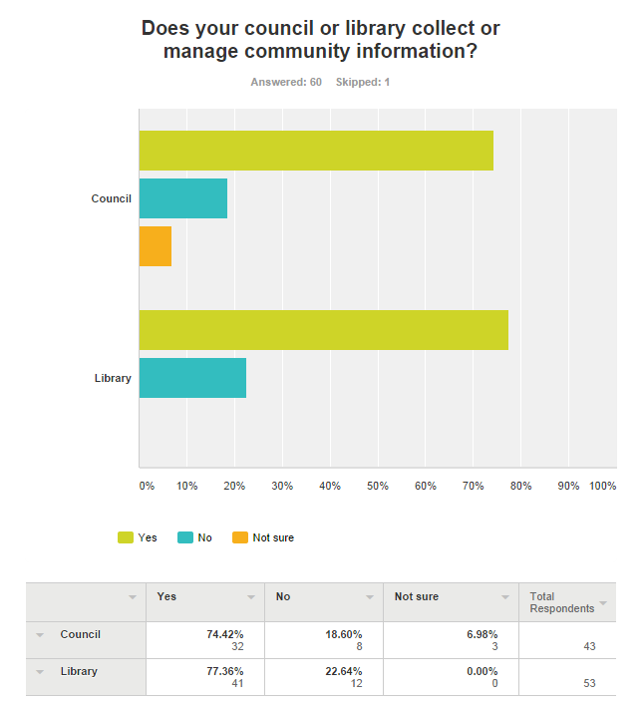

Comments included:
- Register of community groups for consultations
- Council via webpage… Library via display boards only
- Visitor Information Centre
- We did have a database but due to lack of staff to keep it up to date and lack of responses we closed it to the public but still have the base on our LMS for staff to access if the need arose
- Our library displays some community information but does not specifically collect or manage it.
- The Library sort-of does in the sense of displaying some posters/notices on the front desk but most of the role is undertaken by another Council officer who manages the Community Information Window which is quite independent of the library
- Council has recently overtaken this role that was previously the responsibility of the library

Question 2
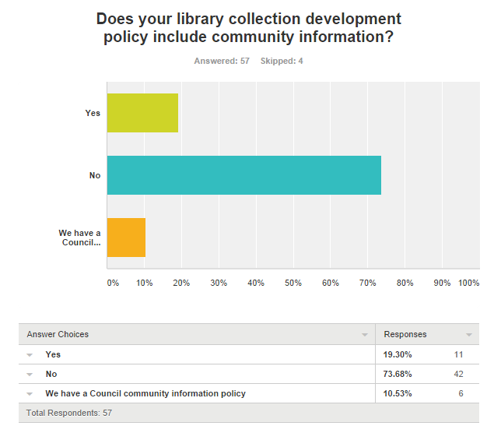
Comments included
- We have a separate Community Information policy from the Library Collection Development policy.
- We have a Library policy on Community Information Display Council staff member in charge of community information webpages is on extended leave - won't return until after survey closure
- We did have comm info up until last year when we closed the database. Previously the coll dev policy stated that the database was under review
- We have a separate Library policy for the collection of community information
- We have a" Use of Noticeboards" section in our Library Services Determination
- The Library has collection development guidelines which includes a section on Community Information.

Question 3
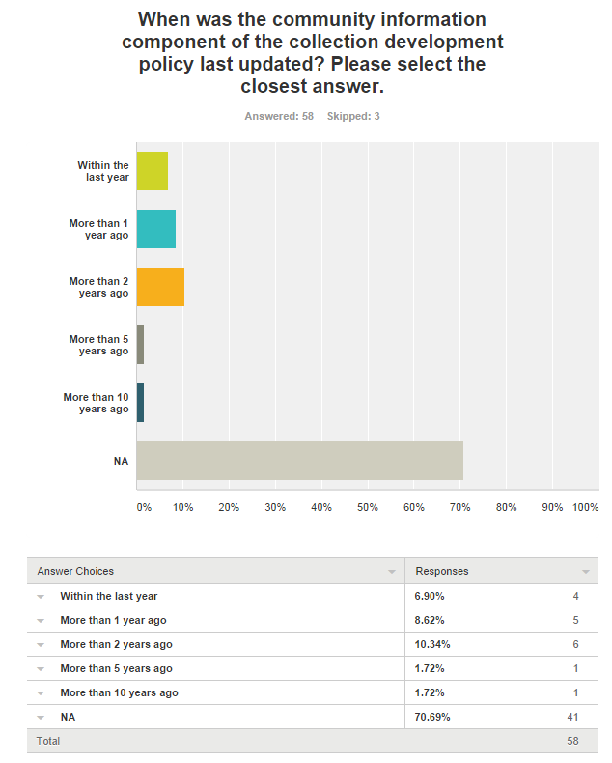
Question 4
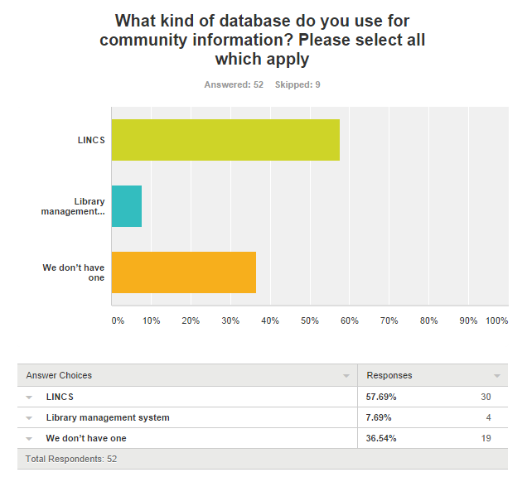

Comments include:
- Component of our website CMS. It has facility to create multiple directories. I used the LINCS/Community directory subject heading list & classification scheme to create the structure
- purpose built system
- Community Connect website (purpose built website)
- TRIM
- Council and Library Service distribute not-for-profit community information but do not currently have a formal policy. Facebook and Shire Web page distribute community information regularly and library display and give-out flyers etc.
- Council uses SQUIZ
- The Library doesn't have one. There is one on Council's own website
- Council online database

Question 5
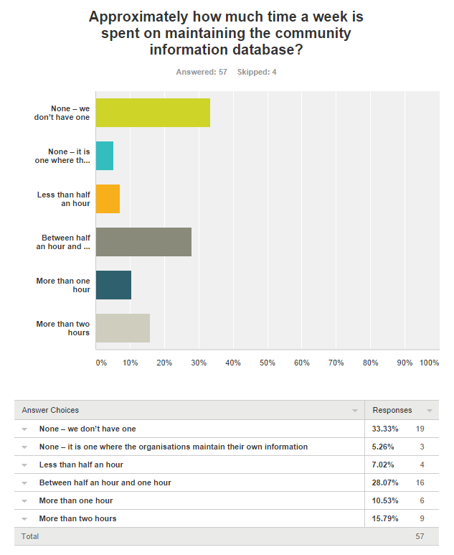

Question 6
Does your library or your council produce a printed directory?
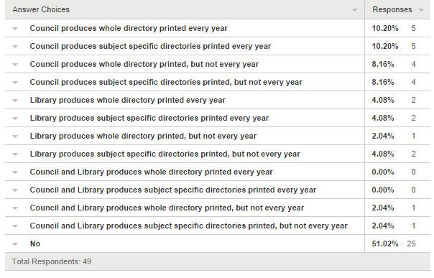
Comments included:
- We used to publish annual directories (last ed. 2010) with support from our local newspaper, but this relationship has lapsed. The CMS allows printing on demand so we have done this when requested.
- Provides online version of a printed Directory and specific subject directories for downloading and printing every year
- Used to publish jointly with [other local] Councils - now only available online
- Library produces subject specific directories in short print runs when requested (few times a year) for council use. LINCS directory builder used to harvest current records at time of request.
- Produce printed subject lists tailored to suit specific enquiries
- Library produces special directories e.g. CALD Communities in LGA
- Online webpage can be downloaded as a PDF directory
- Council produces a City Guide each year, and some departments in Council produce their own annual directory (e.g child services)
- Council produces a published Youth Directory
- Library produces subject 2 specific directories (Older Residents; Children & Families) - printed as required - usually 2-3 times p.a. for each
- Council partners with local organisations to print and distribute community information but not on a regular basis.
- Information is downloadable from the LINCs database and we produce specific sections upon request.
- Directory is online
- Council produces subject specific sections of the directory which are available for download and printing from the website. These can be printed on demand. they are updated at least once a year, more if demand requires,
- Strictly online only.
- We only produce a printed directory if requested. Sometimes these are specific directories and often only single copies. This is done for internal and external customers.
- The Library produces subject lists tailored to Library or Council requested needs
- There is some community information kept on the council website and each branch library keeps brochures and directories that have been put together by chambers of commerce or other community groups.
- Council contributes to a publication on community information produced by the local newspaper once a year.

Question 7
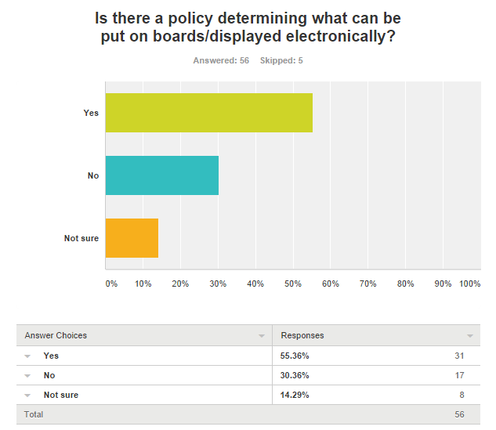

Comments include:
- OBJECTIVE To facilitate a free flow of information and ideas in the community, in accordance with Council’s Adopted Policy 137-Corporate on Library Collection Development POLICY The general principle of upholding intellectual freedom, by facilitating access to expressions of knowledge and intellectual activity, shall apply in the [ ] Library. Only those materials which are in breach of legislation relating to discrimination, racial vilification, offensive behaviour, defamation and elections will be unacceptable. The display and distribution of leaflets and notices in the Library will be managed and maintained by Library staff. The materials will be monitored regularly for neatness and currency in a similar manner to the Library Collection…
- There seems to be an unwritten policy where unsuitable items are taken down e.g. car sale brochures are removed. But community event notices are fine both within the library and on the large community noticeboard in the Civic Centre (council building which also houses the library )
- Guidelines only
- Not for the Library.
- Not an official policy but library branches are not allowed to display commercial notices or FOR SALE notices.
- No but the library tries to promote community events mainly and no commercial ventures.
- Informal policy within Library - only non-for-profit related posters etc can be displayed.
- Not a Policy. Generally, any free community event. Fees for service are vetted.

Question 8
What are the key points of any policy determining what can be put on boards/displayed electronically?

Comments include:
- Must be not for profit and open to all community members
- Must be a free community service
- Notices from community organisations in the region are given the highest priority. Individuals and organisations must ask permission to have notice displayed. Commercial notices including, but not limited to, offers of tutoring, courses, items for sale or accommodation advertisements are not permitted.
- Free or low cost service, Service benefitting community
- Not for profit community organisations only
- Must be for community information and or benefit
- Not for profit only
- It’s within the LGA, community service and it’s not a pure profit organisation.
- Activities from local non profit community groups. Council and library activities
- nothing which is of religious, political, discriminatory or commercial content.
- Library community info display guidelines include: First priority given to Library and Council events/services; high priority given to non-profit orgs, clubs, groups or societies, with preference to those in our LGA; items of commercial, religious or political nature are not displayed.
- Non- profit making community based groups.
- Noticeboards - restricted to Council events Electronically - Events Calendar –[conditions listed on website]
- Community engagement Policy
- Not to be commercial community information only non profit
- Not for profit only is included.
- #nothing of a commercial nature #must be relevant to our LGA
- There is not a written library policy but the library can only display information that is council, government or charity related. The library will not advertise anything for private businesses.
- direct benefit to the community via social &educational programs. Not for profit , self help support group, health, childcare , carers info .
- local information, non commercial, non offensive,
- Only information about local non-profit community groups, organisations, services, courses, facilities and events provided by community based and government organisations may be displayed or included in the community information database
- Non-profit only, no political material.
- With limited display space priority is given to Library and Council information Local Community events
- Not for profits only.
- NFP community organisations only. No commercial organisations will be displayed. Items of a commercial religions or political nature will not be displayed unless they are considered by the library to be of community benefit (eg. child care, concerts, public seminars)
- Local non-profit clubs, societies, Library and Council activities
- What can and can't be displayed and how long for.
- Informal policy - Manager decides - usually only non-profit / charity / arts related events
- Only Library/Council info on screens. Only Library/Council/ Not for profits in posters and brochures

Question 9
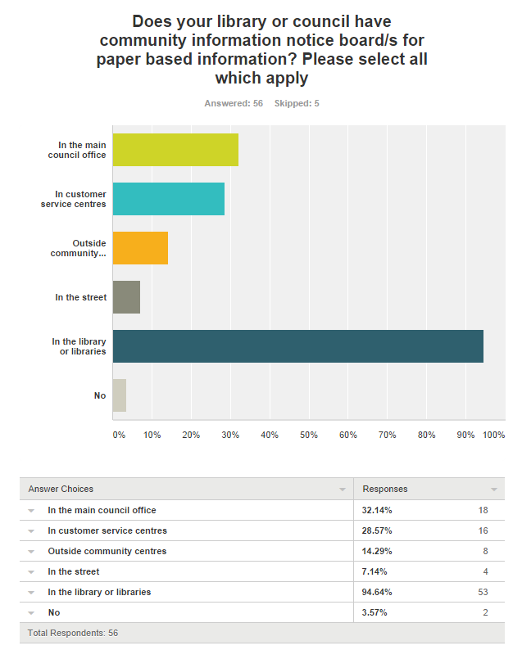

Question 10
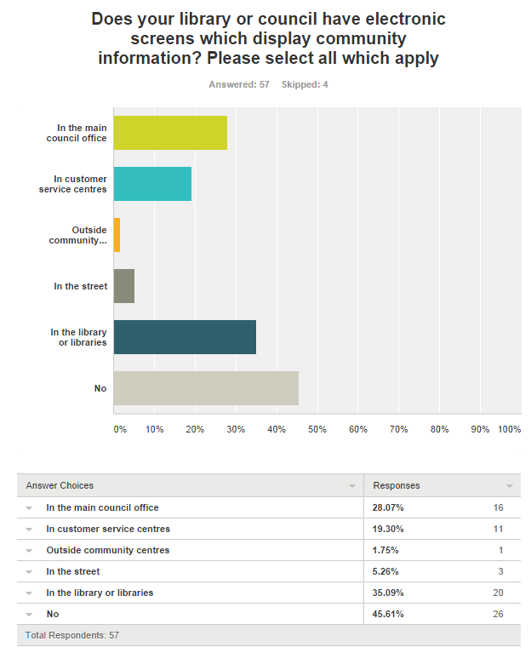

Comments include:
- various businesses around town
- Airport, Council's cultural services and tourism sites
- …central library and [one] branch library
- For Library and Council related information

Question 11
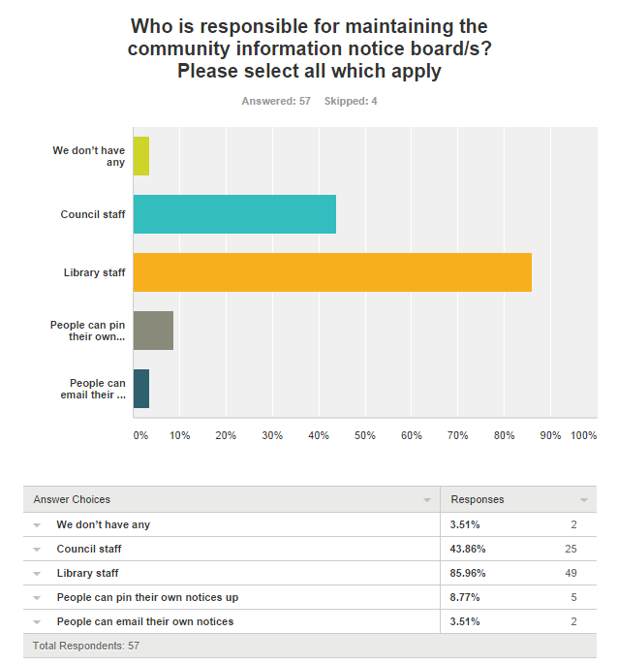

Question 12
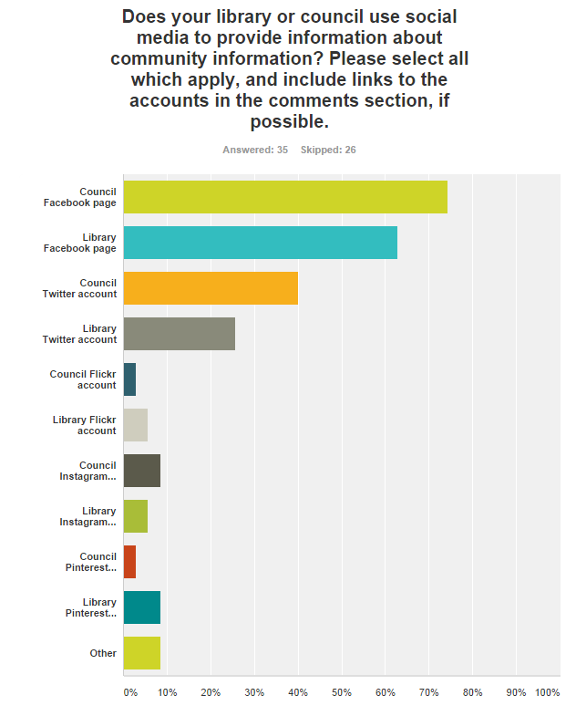

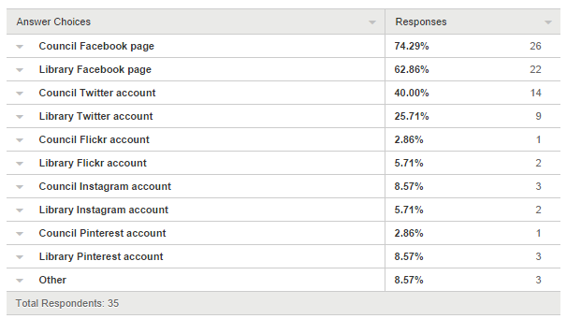

Question 13
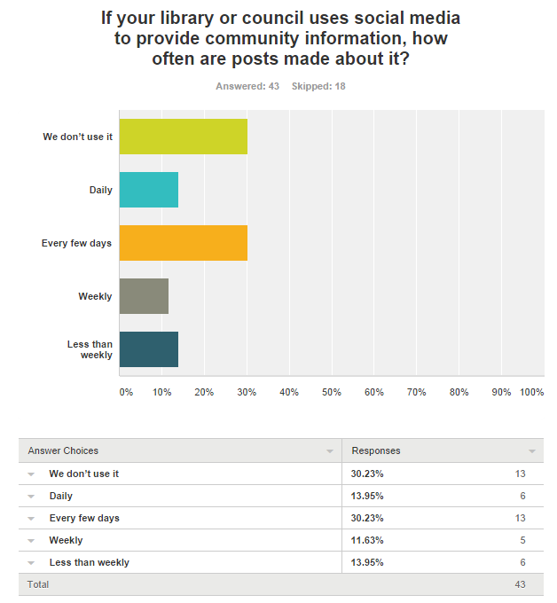
Comments include:
- as needed
- Used mainly by the Library to promote events, programs
- Tourism Website
- eg: Community events running in libraries, council activities etc will be shared.
- As required
- Only during natural disasters or when road closures are happening
- Sporadically

Question 14
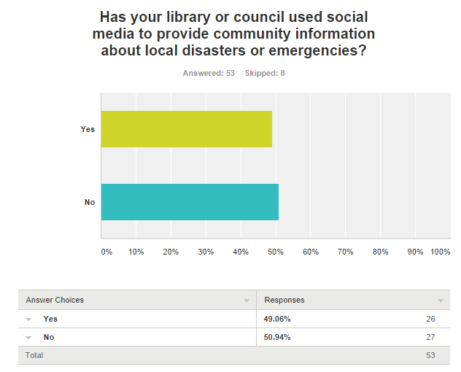

Comments include:
- Recently Council provided information via Facebook and Twitter on stoppage of garbage collection
- Council has used social media for flooding and weather warnings
- Library uses the social media to inform if the library is closed due to an emergency, e.g. during an episode when the library was closed due to smoke or paint fumes.
- Yes we have. These tend to disappear after the event e.g. Twitter feeds and are always housed on the council's homepage. An example would be the floods in 2012 and 2013. The library also does the same thing where appropriate.
- During local floods in 2012 we passed on information, warnings and reports through the library facebook page.
- via council's facebook page
- Power outages.
- Facebook was utilised to explain a water mains problem [after] after pipes burst.
- Not as yet, but it will do so in future. This would come from the corporate communications area.
- Either fire or flooding announcements
- website, twitter, facebook
- websites, facebook, eNewsletter - eg. during bush fires
- Council Media team uses Social media to do this. Sometimes library may share Council posts if appropriate
- As soon as Council's media section is informed
- regular posts during heavy rain to advise of road closures due to flooding. During the recent garbage issue advising residents what action they should take. Notices are posted by Council's media section
- Earlier this month information about a fire at the waste depot was provided via Facebook.
- During flood events and road closure information is provided by one person - unsure the job title of this person in council.
- Council alerts customers through social media about weather and road conditions as well as other sudden local issues.

Question 15
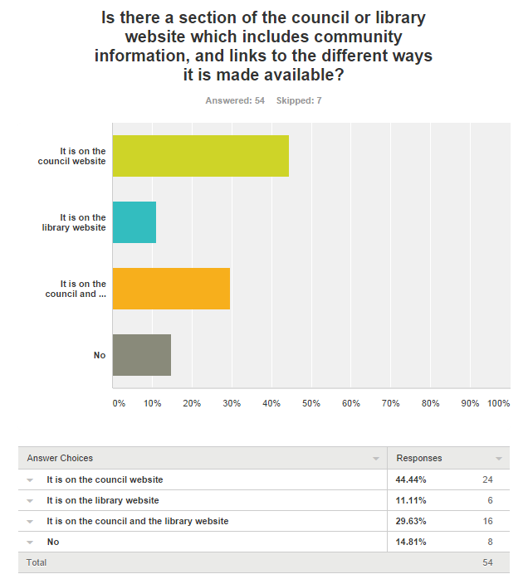

Question 16
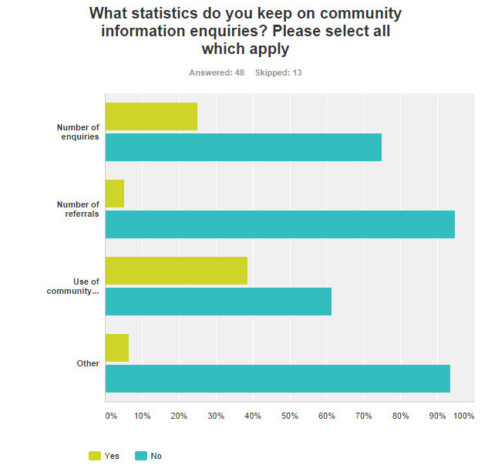
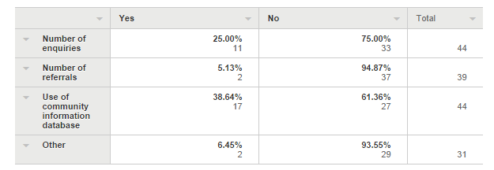

Comments include:
- Statistics are available through the LINCs database but we don't keep stats for library enquiries
- Daily, monthly enquiries, most requested subjects, Approx 40,000 per month. We collect information through the use of LINCS or PLEG.
- Report on number of searches in LINCS database. During quarterly statistical gathering, community information has its own field.
- Record no of enquires - in person & by phone No. of searches on Lincs database
- The enquiries would not be separated from other types of enquiries.
- Staff member who is responsible for the LINCS database keeps referral statistics only. Number of enquiries collected at the end of each month from LINCS.
- Stats are collected from LINCs databases quarterly. Includes number of organisations and number of enquiries.
- Most popular searches and records assist evaluation of service and administrative requirements

Question 17
Is the overall provision of community information the responsibility of one person in the council or the library, or is the work shared? Please describe and provide job titles for staff involved

- Library Staff including - Community Information Officer & Administration staff
- Information Services Librarian. Customer service staff may refer requests for updates and email/letters to council are sent to ISL for data entry etc.
- Library staff member - Collection Services Officer in library manages LINCS database. Other library staff manage notice boards.
- One staff member responsible but can be done by many staff
- Shared
- Work shared by Customer Service Officers and Library Assistants
- One person in the library Not sure about Council
- Shared between library and council staff at various locations
- Library staff generally refer to specific council staff
- Shared
- Community Development officer
- Managed by Community Information Manager
- website & community information updated by executive assistant of general manager
- Unsure of Council responsibility sharing. Library display boards are part of one Library Assistant position's responsibilities.
- The library staff
- Two positions in the Library: Community Information & Promotions Librarian Community Information Library Assistant
- Work is shared - Information Services Librarian and Library Assistant
- unsure, each council would be different
- The Tourism department undertake this role.
- One Library staff member (Library Officer Information & Lending Services) is responsible for updating the Lincs database, noticeboards, production of directories etc.
- One person responsible for updating the LINCS database. Library Technician
- Administration Officer has main Facebook entry job and requests all staff provide her with any upcoming community events, Library attractions, local history and any Council problems which may be encountered by residents. Several other staff have administration rights which are utilised when [name of staff member] is not available. It comes within the responsibility of the Librarian, Information Services currently.
- community planning section
- IT Support (at Council) and the Library Technical Administrator
- All notices that are displayed in the library are to be approved by the Library Manager.
- one person to manage the community information. But all staff share the information provision for library users.
- Library Assistant
- Customer Service Staff Community Development Officer
- currently assigned to Library Assistant for updates but reviewing for handover to Council's Community Planning and Development Team.
- Shared between Library Community Information Officer, Digital Services Team and miscellaneous Council staff
- LINCS is managed by one staff part time staff members. Noticeboards are the responsibility of staff at each Branch.
- Mainly the Reference & Community Information Librarian
- shared: library Development Officer promotions and projects Council Community Services Officer Council Media Officer
- Shared
- All community flyers/information is first approved by a senior staff member, usually Client Services, and a Library Assist maintains the board so the information is always current.
- Community Info is overseen by Info Services Librarian, data entry and updates are done by Library Admin Assistant.
- Community Information Technical Specialist with assistance from a Team Member Services.
- Community Information Officer
- Promotions Facilitator looks after community info board Technology Trainee updates LINCs
- Information Services Librarian
- The council website coordinator
- Work is shared Community Development Officer Customer Service Officers Library Manager
- Branch Officers. Monitor and vet Community Information put up on walls and brochure holders. Main Branch Officer maintains LINCS.
- One staff member at Council
- All library staff.
- Staff in Council's Community Services department - rotated responsibility
- Shared across libraries by branch staff

Question 18
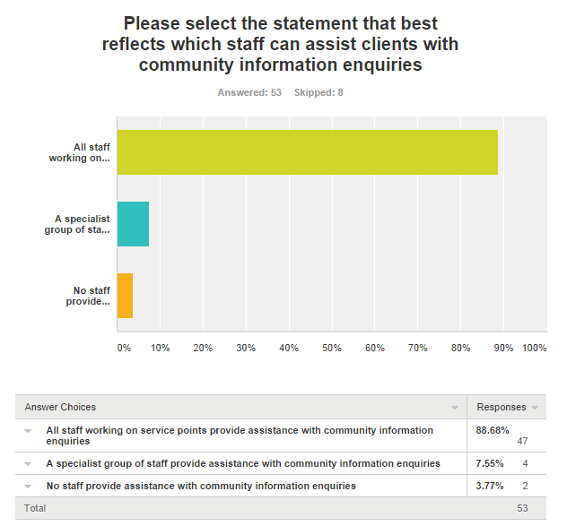

Further examples and ideas for community information.
New York Public Library has set up a list about community information in their local government area. The list follows providers of community information and services. Police are contributing to community information on social media, with examples from the Garda in Ireland and the Queensland and NSW Police. Recent analysis by Craig Thomler shows, that for Australian government twitter accounts the NSW and Queensland Police twitter accounts are in the top ten for tweets, followers and tweets per day.

Some South Australian community information is provided by a dedicated twitter stream and this is run by SAcommunity which manages a state wide community information database. This opens the question of could the Datadiction information, or other database community information be streamed through a twitter or facebook account in a way which was relevant.
There are very limited examples of libraries providing community information though their library management system. Of the libraries responding to the survey, there were three libraries making community information available this way, two with purpose built systems and one each using TRIM and a wesite CMS.. In NSW this could be because of the long standing status of Datadiction. Topeka and Shawnee County Public Library in Kansas has their searchable community information as a module of their library management system. It is searchable in a similar way.

Another access route for community information is via map, such as the emergency maps in the ACT and the NSW state wide live traffic, which include floods, fires, and other incidents.

As well as the Facebook example provided by the Blue Mountains Libraries, and there is some community information in other library and council Facebook pages, Community information in Hamilton, Canada has a Facebook page for community information which links to their searchable community information database.

From the survey responses, about half of the libraries, or their councils, or both sue social media as part of their local community information strategy. A small number of these examples will be highlighted.

Other social media examples include:
- Townsville has a dedicated community information Facebook page. It contains a mix of reporting on events and some advance notice.
- Horsham Floods which appears to be active only during flood times
- Bankstown Community Information, this community run community information site is mostly about photographs of events and businesses, with some other community information included as well.
- Waltham, MA provides links to local obituaries on facebook.
- Fremantle, with some local programs and services
- City of Sydney with reports and advertises local events on facebook, and twitter
- Cairns Regional Council provides links to their twitter and Facebook pages which are specifically set up for use during disasters. They use other accounts for the day to day social media
- #ifitsfloodedforgetit is a hashtag largely used in Queensland, but with some other states using it as well. This is tweeted by emergency services in flood and cyclone conditions some images included too
- Brisbane City library has set up a list for people to follow for crisis communication and for city floods
- There is a twitter account for maps of where disasters are, called Disaster chart and another called Disaster report which covers disasters occurring all around the world.
- Community information and support Victoria covers broader areas of community information rather than local programs and services.
- Community reference is a linked idea see
http://www.americanlibrariesmagazine.org/article/community-reference-making-libraries-indispensable-new-way

Appendix
Social media mentioned in the survey
- Berrigan Shire – social media links http://www.berriganshire.nsw.gov.au/ https://www.facebook.com/berriganshire https://twitter.com/berriganshire http://instagram.com/berriganshire
- Pittwater Council – social media links http://www.pittwater.nsw.gov.au/ and Pittwater Library – social media links are hidden
- Willoughby Council – social media links http://www.willoughby.nsw.gov.au/
- Clarence Regional Library https://www.facebook.com/clarence.regional.library?ref=hl
- Rockdale Council - https://www.facebook.com/RockdaleCityCouncil
- Penrith Council - https://www.facebook.com/penrith.city.council and https://twitter.com/penrithcouncil
- Parkes Library https://www.facebook.com/KidsReadFunPSL and https://twitter.com/ParkesLibrary
- Shoalhaven Library https://www.facebook.com/ShoalhavenLibraries and https://twitter.com/shoallibraries and http://www.pinterest.com/shoallibraries/
- Shoalhaven Council https://www.facebook.com/shoalhavencitycouncil and https://twitter.com/shoalhavencc
- Burwood Library https://twitter.com/burwoodlibrary
- Burwood Council https://www.facebook.com/burwoodcouncil and https://twitter.com/BurwoodCouncil
- Corowa – Vic example via tourist information https://twitter.com/corowavic and https://www.facebook.com/CorowaVisitorInformationCentre
- City of Canada Bay twitter https://twitter.com/CanadaBay facebook https://www.facebook.com/pages/City-of-Canada-Bay/139811752755560 City of Canada Bay Library twitter https://twitter.com/canbaylibraries
- Willoughby City Council facebook https://www.facebook.com/WilloughbyCityCouncil twitter https://twitter.com/willoughbycity
- Wagga Wagga Council - tourism facebook https://www.facebook.com/VisitWaggaWagga and twitter https://twitter.com/VisitWaggaWagga Wagga Wagga Library on facebook https://www.facebook.com/waggalibrary?ref=ts twitter https://twitter.com/WaggaLibrary pinterest http://www.pinterest.com/waggalibrary/
- Temora Shire facebook https://www.facebook.com/temorashire twitter https://twitter.com/temorashire library facebook https://www.facebook.com/TemoraShireLibrary
- Richmond Tweed Regional Library facebook https://www.facebook.com/pages/Richmond-Tweed-Regional-Library/174275235999409?sk=wall
- Leeton Library facebook https://www.facebook.com/pages/Leeton-Shire-Library/54713201103
- Mosman Council twitter https://twitter.com/MosmanCouncil facebook https://www.facebook.com/mosmancouncil flickr https://www.flickr.com/photos/mosmancouncil/ Mosman Library facebook https://www.facebook.com/mosmanlibrary twitter https://twitter.com/mosmanlibrary flickr https://www.flickr.com/photos/mosmanlibrary/ instagram?
- Cooma Monaro Council on facebook? Cooma-Monaro Library on facebook https://www.facebook.com/MonaroRegionalLibraries pinterest http://www.pinterest.com/monaroreads/ flickr https://www.flickr.com/photos/monarolibraries/
- Bega Valley Shire Council facebook https://www.facebook.com/begavalley.shirecouncil library facebook ???
- Parramatta Library twitter https://twitter.com/parralibrary facebook https://www.facebook.com/ParraLibrary
- Coolamon Library on facebook https://www.facebook.com/coolamonlibrary
- Corowa Visitor Information Centre https://www.facebook.com/CorowaVisitorInformationCentre
- Camden Library on facebook https://www.facebook.com/camdenlibraries
- Wollongong City Council on facebook https://www.facebook.com/wollongongcitycouncil twitter https://twitter.com/Wollongong_City library on facebook https://www.facebook.com/wollongongcitylibraries
- Hornsby Council facebook https://www.facebook.com/HornsbyCouncil
- The Hills Council twitter https://twitter.com/TheHillsCouncil facebook https://www.facebook.com/TheHillsShireCouncil instagram http://instagram.com/thesydneyhills The Hills Library on twitter https://twitter.com/HillsLibrary facebook https://www.facebook.com/thehillsshirelibraryservice
- Holroyd City Council facebook https://www.facebook.com/holroydcity library facebook https://www.facebook.com/holroydlibrary
- Ku-ring-gai Council on twitter https://twitter.com/krgcouncil facebook https://www.facebook.com/kuringgai library facebook https://www.facebook.com/krglibrary
- Singleton Council facebook https://www.facebook.com/SingletonCouncil twitter https://twitter.com/Singleton_NSW Singleton Library facebook https://www.facebook.com/SingletonLibrary twitter https://twitter.com/Singleton_Lib
- Bellingen Shire Council https://twitter.com/BellingenShire good use for community information but not updated since 2013
- Carathool Shire – tourism facebook https://www.facebook.com/carrathoolshire.tourism#!/carrathoolshire.tourism
- Auburn Council on facebook https://www.facebook.com/pages/Auburn-City-Council-Sydney/270154639689109

LINCS by Datadiction http://www.datadiction.com.au/lincs/ [accessed 26 September 2014]
Clerc, Patou, From leisurely posts to urgent tweets: what can we learn from using social media in an emergency? ALIA National Conference, Melbourne, 16 – 18 September 2014 http://nationalconference2014.alia.org.au/content/leisurely-posts-urgent-tweets-what-can-we-learn-using-social-media-emergency [accessed 26 September 2014]
NYC community information twitter list https://twitter.com/asknypl/lists/nyc-community-information [accessed 26 September 2014]
Garda info on twitter https://twitter.com/gardainfo [accessed 26 September 2014]
QPS Media on twitter https://twitter.com/QPSmedia [accessed 26 September 2014]
NSW Police on twitter https://twitter.com/nswpolice [accessed 26 September 2014]
Thomler, Craig Infographic: Australian government agencies and councils have now sent 2 million tweets and have 3.9 million followers, eGov AU 24 September 2014, http://egovau.blogspot.com.au/2014/09/infographic-australian-government.html [accessed 26 September 2014]
SA community on twitter https://twitter.com/SAcommunity [accessed 26 September 2014]
Topeka and Shawnee County Library community information on library management system http://catalog.tscpl.org/polaris/search/communityinformation.aspx?ctx=1.1033.0.0.6 [accessed 26 September 2014]
ACT Emergency Services Agency incidents map http://esa.act.gov.au/community-information/incidents-map/ [accessed 26 September 2014]
Live traffic NSW https://www.livetraffic.com/desktop.html [accessed 26 September 2014]
InfoHam on Facebook https://www.facebook.com/InfoHam [accessed 26 September 2014]
Information Hamilton http://informationhamilton.ca/redbook [accessed 26 September 2014]
Community Information Centre Townsville on Facebook https://www.facebook.com/CICTownsville [accessed 26 September 2014]
Wimmera floods on Facebook https://www.facebook.com/wimmerafloods [accessed 26 September 2014]
Bankstown Community Information on Facebook https://www.facebook.com/pages/Bankstown-Community-Information/192683100741883 [accessed 26 September 2014]
Waltham, Massachusetts community information https://www.facebook.com/YourTownWaltham [accessed 26 September 2014]
Freo-info community information service on Facebook https://www.facebook.com/pages/Fre-info-Community-Information-Service/179284198780254 [accessed 26 September 2014]
City of Sydney Facebook https://www.facebook.com/cityofsydney [accessed 26 September 2014]
City of Sydney Twitter https://twitter.com/cityofsydney [accessed 26 September 2014]
Cairns Regional Council cyclone and flood emergency information http://www.cairns.qld.gov.au/cyclone-emergency-information [accessed 29 September 2014]
Cairns Regional Council on facebook https://www.facebook.com/CairnsRegionalCouncil [accessed 29 September 2014]
Twitter search results for #ifitsfloodedforgetit https://twitter.com/search?q=%23ifitsfloodedforgetit&src=hash&f=realtime [accessed 26 September 2014]
Example of an image used for #ifitsfloodedforgetit https://twitter.com/QPSmedia/status/297150625890832387/photo/1
Brisbane City Crisis communication twitter list https://twitter.com/brisbanecityqld/lists/crisis-communications [accessed 29 September 2014]
Brisbane City Qld floods twitter list https://twitter.com/brisbanecityqld/lists/qldfloods [accessed 29 September2014]
Disaster chart twitter account https://twitter.com/DisastersChart [accessed 29 September 2014]
Disaster report twitter account https://twitter.com/Disaster_Update [accessed 29 September 2014]
Community information and support, Victoria on Facebook https://www.facebook.com/pages/Community-Information-Support-Victoria/132951903439264 [accessed 29 September 2014]

