NSW Public Libraries Local Studies audit 2013

Both the State Library of NSW and the NSW public library network play a key role in developing, maintaining and providing access to collections that document the history and development of local communities across NSW. The scope and management of local history collections across the state is not well documented. A shared understanding between public libraries and the State Library would support collaboration to develop future local history collections and services which complement each other and combine to build a statewide local history approach.

In 2004 the State Library of NSW commissioned an audit of local history collections across the NSW public library network which led to the publication of the Digital Practice Guidelines for NSW public libraries (guidelines updated in 2011).

While the Digital Practice Guidelines provide guidelines for public libraries that are involved in digitisation projects, there are currently no broad guidelines or standards for developing and managing local history collections and services.

In 2012 the State Library’s Public Library Services and Library Services Divisions held preliminary discussions to develop the concept of a shared local history shared strategy. Representative from Public Library Services, Collection Services, Original Materials and Collection Preservation and Storage met in September 2012 to develop a discussion paper on the shared strategy concept. The discussion paper and concept of a shared strategy have since been supported by key stakeholder groups across the network including the Public Library Network Research Committee, Public Libraries Consultative Committee and the NSW public libraries local studies working group.

Collection of data on local history collections and services via an audit provides information to inform the planning and provision of local history collections and services. The development of guidelines and a shared strategy for NSW public libraries and the State Library of NSW would build capacity across NSW to develop quality local history collections and services.

This project is being undertaken in three stages:
- An audit of local history collections (digital, published and original) in or managed by NSW public libraries, together with an understanding of the management and services around these collections.
- Development of best practice guidelines for collection development, managing collections including reformatting, providing access and service delivery.
- State Library of NSW and the NSW public Library network collaborate to develop a statewide strategy for local history collections, which would include pathways for referral from public libraries to State Library collections and vice versa.

This audit was completed in late 2013 and early 2014 by 116 of the 152 councils in NSW. This means that the data for the audit is for 76% of the state. Although not every council answered every question the results provide broad indicative data and suggest areas which are priorities across New South Wales.

The combined collection of local studies material across the state is at least 2.9 million items and over 21 329 metres. For the libraries which hold this, almost 50% have no records on Trove, with less than 16% of local studies collections being fully searchable on Trove. Over 40% of the council surveyed have no digitisation program, and there is very limited digital original content being collected.

There are several issues which are raised by the responses to these surveys:
- Access to the collection for clients
  - Is it catalogued?
  - Can you search online for it?
  - Is it digitised and available online in a format which can be enlarged and viewed in detail?
  - Is it findable on Trove? If it is a digitised image, is it viewable on Trove?
  - Are the rights to re-use the collection clear? How is the copyright information being made available?
  - How can clients add information/tags to the content?

- Collection content
  - Is it catalogued? What is the plan for cataloguing the collection and adding the material to Trove?
  - When will the holdings be added to Trove if they are already catalogued?
  - Can you search for it online?
  - Is it digitised? What is the plan for digitising the collection and adding the material to Trove?
  - How is digital content being collected?
  - What methods are being used to source new digital content?
  - What methods are being using to create new digital content? What methods are being used to ensure accurate rights management? For Council/library created digital content is consideration being given to the use of Creative Commons licensing?
  - Is the cataloguing and management of local studies material receiving the same priority as that of other collections?

- Collection management and access
  - How recently was the significance assessment of the collection made?
  - Is there a plan of management for the local studies collection?
  - Is there a plan for preserving and conserving the collection?
  - Is there a business continuity/disaster recovery plan?
  - How easy is it to access the collection? Is it available all hours the library is open?
  - How are all staff trained to provide a high quality local studies service?

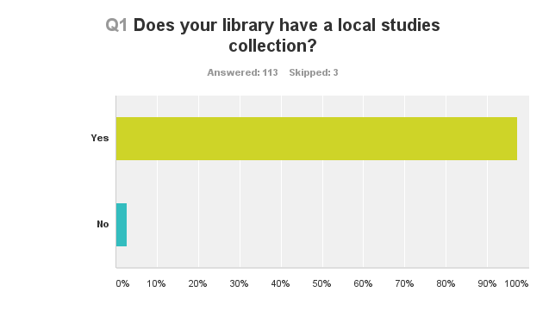
94.8% of the libraries represented in the survey have a local studies collection
2.5% of the libraries represented in the survey do not have a local studies collection
2.5% of the libraries represented in the survey did not answer this question

Looking at the three council who skipped this question, two of them “actively seek and purchase local studies material” and the third is known to have an extensive local studies collection, so there may be been some misunderstanding with in this description.

It is possible speculate that this number could actually be 113 councils out of 152, or 74% having local studies collections, but there is insufficient data to confirm this.
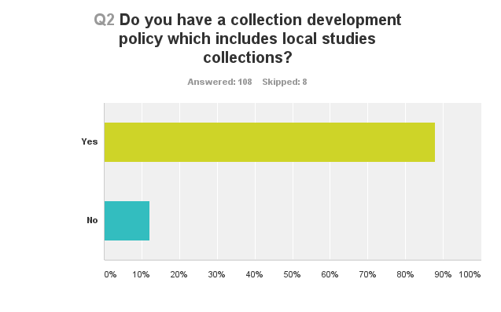
81.89% answered yes
11.2% answered no
6.8% did not answer

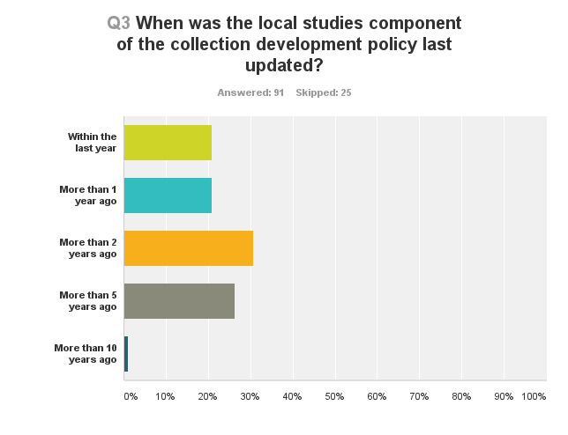
Of the councils replying to the survey, 32% had updated the relevant parts of their collection development policies less than two years ago. The remaining councils had not. This figure could be much higher because of the councils who did not complete the survey at all. Having current collection development policies which include local studies collection management is critical to the health and development of the local studies collection. Without documenting the information it can mean that critical collection areas are missed, or that assumptions are made about what is included, and what is not. This area should not depend on staff knowledge of the collection practices of the past as it needs to be open to new technologies and diverse ways of collecting and creating collection content.
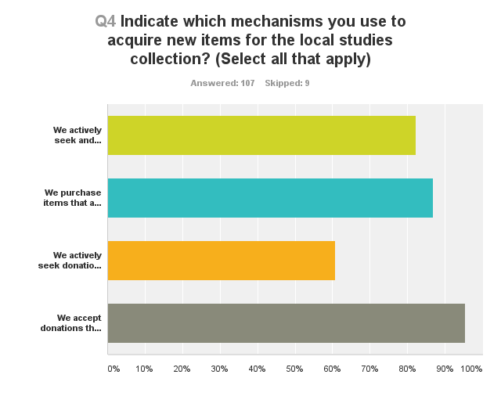To make this graph easier to understand, the phrases people responded to are shown below, in the same order as on the graph (top to bottom):
We actively seek and purchase local studies material
We purchase items that are suggested and are relevant to our local area
We actively seek donations that are relevant to our local area
We accept donations that are offered and relevant to our local area

Comments about the collection mechanisms included:
- Collecting from adjacent local government areas
- Transfer of archive material council
- Request Council to deposit reports into Local Studies Collection
- Natural accumulation of archives
- Copy material held in other institutions to include in our collection.
- Our local family history group sources relevant material and donates it to the collection
- Actively seeking free/ephemeral material currently available
- Copying relevant items - photocopying or digitally
- receive material from Council i.e. reports etc
- Transfer discarded items from lending collections if appropriate for LS
- We encourage deposit from our Council and other similar agencies

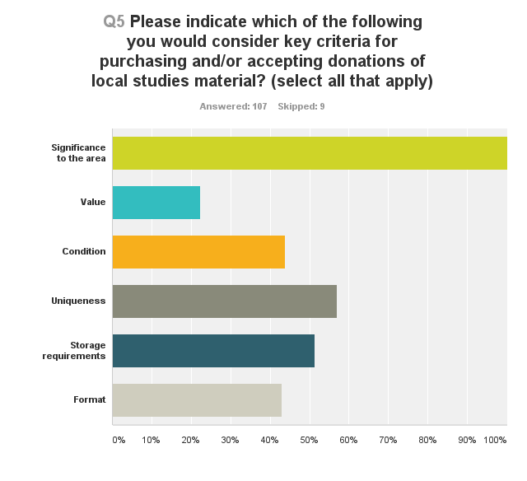Comments about this included:
- Local authors
- Unfortunately limited space also plays a part. Maps etc are forwarded to our Museum
- focus is on published books (not electronic format), govt reports, research notes,
- Provenance - i.e. does the donor have authority to donate the item/s. Would only be important occasionally.

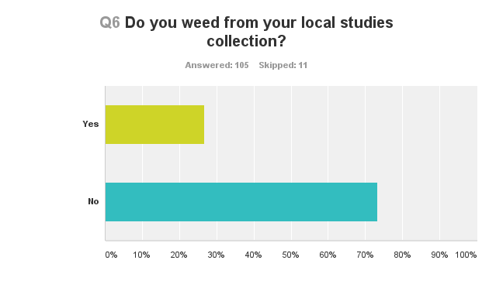

Q 7 Briefly describe how you dispose of weeded items? eg offer to other organisations, destroy
27 councils provided comments. Very limited weeding from local studies collections is to be expected, as it is important to collect a range of material for the future

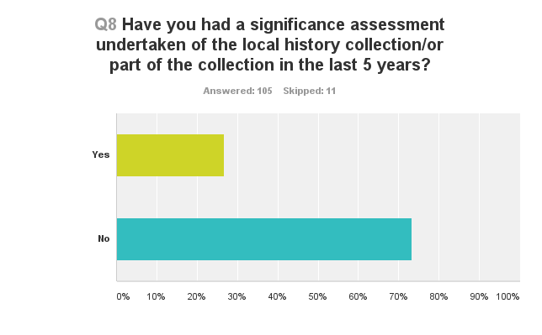
This means that only 26% of the libraries responding had a recent significance assessment for their collection. This would be a useful tool for all libraries to have access to for their collections, and would be of assistance for planning collection priorities.

Q 9 Does the library have an annual budget for local studies collections and services?
46 libraries responded yes
52 libraries responded no

This should be seen as indicative data as more libraries provide budget information, in the following question, than responded ‘yes’ in this question. It may also highlight that, for some libraries, the local studies budget is integrated into the budget as a whole.

Q 10 Provide an estimate of your annual budget (voted or actual expenditure) for the local studies functions below
Staffing
47 libraries provided budget amounts or descriptions in their responses. The library with the most local studies staff appears to have 3.2 EFT including 0.6 EFT archivist. The other end of the spectrum are the libraries with no local studies collections and no staff. Several libraries commented that local studies was part of everyone’s job, or part of a designated position like reference.

The average salary costs for the 42 libraries who provided dollar amounts is $81 680. This is an indicative number only, and does not clearly describe the number of people in each library, as several libraries have more than one staff member, and others part time staff. It would not be correct to see this as an actual salary figure.

Collection acquisition
54 libraries provided budget amounts, or approximations in their responses. This is a contrast to the previous yes/no responses in question 9. Several other libraries explained that local studies was funded as part of reference or non-fiction, with no amounts provided.

If the 54 responses, the largest annual collection budget for local studies was $21 000, and the smallest $100. The average budget was $3320, and the median is $2000.

Conservation (including preservation, restoration, examination)
26 libraries provided budget amounts for this area. Several other libraries commented that they had money “as needed” but gave no examples of how much this might actually be, or if there was a planned program receiving regular funding. One of the budget lines included conservation and programming with another part of council, so this is not being included in the following calculations. The budgets for conservation ranges from $100 to $48 375. The average is $4 505, and the median is $1 600.

Digitisation
28 libraries responded to this question. For several of these libraries they have used grant funding including Local Priority Grant funding, and various other budgets within the library, without specifying dollar amounts. One library commented that it had completed all digitisation, but this may not take into account new acquisitions.

19 libraries provided annual budget amounts. These ranged from $200 to $60 000. The average is $10 017, and the median is $4 000. One of the libraries included their hosting fees in this area.

Technology (including online hosting fees, software, IT support)
38 libraries responded in this area. Several libraries mentioned that there was no separate budget and it was part of the general IT budget for the library.

Of the 25 libraries who provided actual funding, the highest budget amount was $26 000 for new website development and the smallest was $100. The average is $4 090, and the median is $1000.

Other, please specify
17 libraries responded to this section, and most of the budget areas described are programs, outreach, museum and archive expenses and some additional technology including some one off purchases. 14 libraries provided budget amounts and these ranged from $1700 to $40000.

The average is $12 417, and the median is $10425.

Combining the total amounts for each of these categories provides a conservative figure of $4,009,676.95 for local studies spending in public libraries across NSW.

Q 11 Please provide details of any local studies initiatives you have applied for grant funding for in the last 5 years? (include grant funding body, project name, funding requested and indicate if application was successful)

68 libraries responded to this question. 21 libraries indicated they had not applied for any funding. The majority of grants applied for were the Community Heritage Grants from the National Library of Australia or Library Development Grants/County Library Funding from the Library Council of NSW. There had also been grant applications to the NSW Department of Sustainability, Environment, Water, Population & Communities/Your Community Heritage Project, Archives in the bush from NSW State Records, Department of Veterans Affairs/Saluting their Service Grant Project, Office of Communities - ANZAC Community Grant and Maritime Museums of Australia Project Support Scheme. Some councils seemed very effective at locating alternative sources of funding to apply for.

A couple of libraries had received funding from local historical societies, in one instance to add local newspapers to Trove. Bendigo Bank provide sponsorship for the printing of a newsletter for one library.

Grants covered significance assessments, exhibitions, microform reader printers/scanners, microfilm, scanning and digitisation equipment, digitising, genealogical resources, digitising (newspapers, photographs, negatives, maps, oral histories, videos, rates and minutes books, other local studies material), restoration of honour rolls, creating video histories, preservation and rehousing for specific formats of materials, projects to create content, discover and connect content, furniture for local studies areas, apps, and touch screen systems.

Not all libraries provided dollar information about their grant applications. Of those that did, there were $271 656 of unsuccessful grant applications, and $1 035 068 in success grant applications from various programs.

Q 12 Please indicate the size of each of the following local studies collections
The responses in this section showed some interesting subtleties of interpretation. The data will include a note about which figures are exact numbers, and which are estimates.

91 libraries provided collection data, and the percentages are based on this total. The total numbers of libraries for each category include libraries who provide a response of nil.

Photographs (including slides and negatives)
91.21% or 83 libraries responded
50 libraries provided exact counts and held a total of 603,340 items in this category
15 libraries provided estimates of a total of about 120,000 items in this category, and 10 linear metres of unprocessed content

Born digital pictures (acquired as digital images)
87.91% or 80 libraries responded
32 libraries provided exact counts and held a total of 63,969 items in this category
6 libraries provided estimates of about 2 200 items in this category

Digital copies (copy made from physical original)
89.01% or 81 libraries responded
44 libraries provided exact counts and held a total of 200 167 items in this category
7 libraries provided estimates of about 9700 items in this category
This category had photographic data as well as digitised volumes such as rate and minute books.

Postcards
83.52% or 76 libraries responded
34 libraries provided exact counts and held a total of 6 764 items in this category
3 libraries provided estimates of about 300 items in this category

Prints and posters
81.32% or 74 libraries responded
29 libraries provided exact counts and held a total of 3038 items in this category
4 libraries provided estimates of about 500 items in this category

Paintings and drawings
83.52% or 76 libraries responded
38 libraries provided exact counts and held a total of 4947 items in this category
2 libraries provided estimates of about 200 items in this category

Subdivision or development plans
82.42% or 75 libraries responded
36 libraries provided exact counts and held a total of 19 983 items in this category, plus 54 volumes of small bound plans
3 libraries provided estimates of about 350 items in this category

Maps
89.01% or 81 libraries responded
61 libraries provided exact counts and held a total of 25 325 items in this category
6 libraries provided estimates of about 770 items in this category and over 4 linear metres of unprocessed maps

Architectural plans
80.22% or 73 libraries responded
29 libraries provided exact counts and held a total of 28 648 items in this category
4 libraries provided estimates of about 970 items in this category

Published printed books
86.81% or 79 libraries responded
74 libraries provided exact counts and held a total of 148 098 items in this category
3 libraries provided estimates of about 3 640 items in this category

Published E books
79.12% or 72 libraries responded
6 libraries provided exact counts and held a total of 31 items in this category
There are also 35 CD-ROM which were included in this category.

Newspapers and periodicals
82.42% or 75 libraries responded
33 libraries provided exact counts and held a total of 57 431 items in this category

As well as the above count there are 457 newspaper titles, 1390 periodical titles, and a file of 5000 newspaper clippings, and 125 linear metres of newspapers

Microform (including fiche and film)
85.71% or 78 libraries responded
46 libraries provided exact counts and held a total of 39 868 reels in this category
As well as the count of the microfilm reels, there are 683 microfiche titles and 2 304 microfilm titles. Some other data, including the size of a storage cabinet was also provided.

Bound manuscripts
72.53% or 66 libraries responded
20 libraries reported holdings in this category and held a total of 873 items in this category

Minute and rate books
81.32% or 74 libraries responded
28 libraries provided exact counts and held a total of 12 936 volumes in this category
9 libraries provided estimates of about 1215 items in this category as well as the equivalent of 50 digital volumes, 150 reels of 35mm and 51 linear shelf metres

Unbound manuscripts (in linear meters)
69.23% or 63 libraries responded
11 libraries provided exact counts and held a total of 354.7 linear metres in this category

Analog sound recordings
80.22% or 73 libraries responded
37 libraries hold a total of 3335 items in this category

Digital sound recordings
82.42% or 75 libraries responded
33 libraries provided exact counts and held a total of 3312 items in this category
3 libraries provided estimates of about 35 items in this category

Moving images (film and/or video)
82.42% or 75 libraries responded
49 libraries provided exact counts and held a total of 5402 items in this category
5 libraries provided estimates of about 570 items in this category

Scrapbooks/cutting books
79.12% or 72 libraries responded
38 libraries provided exact counts and held a total of 1883 volumes or folders and 13 linear metres in this category
3 libraries provided estimates of about 27 items in this category

Subject based compilations
72.53% or 66 libraries responded
23 libraries provided exact counts and held a total of 18 345 files plus 50 linear metres in this category
2 libraries provided estimates of about 3 filing cabinets in this category

Personal and community papers
73.63% or 67 libraries responded
30 libraries provided exact counts and held a total of 15 463 linear metres in this category
As well 4 libraries have 673 series or collections (no sizes provided), and there are additional quantities of 18 archives boxes and three filing cabinets

Archives in linear metres
78.02% or 71 libraries responded
29 libraries provided counts and held a total of 5243.3 linear metres in this category

Artefacts/objects/realia
76.92% or 70 libraries responded
29 libraries provided exact counts and held a total of 6624 items in this category
2 library have 7 linear shelf metres of objects

Ephemera
73.63% or 67 libraries responded
21 libraries provided exact counts and held a total of 62 946 items in this category
9 libraries had 21 archives boxes, 8 linear metres, 12 folders, 8 three drawer filing cabinets, and 4 260 vertical files and an ‘unknown number stored in several boxes’

Handwritten and card indexes
78.02% or 71 libraries responded
24 libraries held 6069 items in this category. From some of the numbers provided it appears unlikely that a library holds 5000 indexes, so it may be more accurate to see this as 269 separate indexes. As well there were indexes comprising 5 metres (two libraries) and two sets of drawers (two libraries)

Electronic indexes
73.63% or 67 libraries responded
Many libraries mentioned their library catalogues as their indexes, although not all did.
33 libraries mentioned 561 electronic indexes in a range of formats.

Other
46.15% or 42 libraries responded, many with zero holdings.
17 libraries provided estimates of about:
- 11 pamphlets
- Archaeological material: 70
- 75 Zines
- Over 3000 Council reports
- 34 linear metres of files and 10 4 drawer filing cabinets
- 8000 electronic file-notes
- Women’s clothing from the 1800s
- 402 CD-ROM
- 12 council registers
- Council reports, community organisation reports including annual reports, print format council electoral rolls, print commonwealth electoral rolls, souvenir booklets from various community facility openings, lots of environmental studies for the local area either done by council or commissioned by council.
- + many other uncatalogued materials

Format | Collection size 2013/14 | Collection size 2003
Photographs | 723 340 + 10 linear metres of unprocessed content | 635 701
Born digital pictures (acquired as digital images) | 66 169 | 11 218
Digital copies (copy made from physical original) | 209 867 | 209 805
Postcards | 7 064 | 4 515
Prints and posters | 3538 | 5710 prints
Paintings and drawings | 5147 | 1021 other images
Subdivision or development plans | 20 333 plans, plus 54 volumes of small bound plans | 7586 plans  13 digital plans
Maps | 26 095 maps and over 4 linear metres of unprocessed maps | 25 158 maps
Architectural plans | 29 618 | 12 994 architectural plans
Published printed books | 151 738 volumes | 149 331 volumes  1332 other published
Published E books | 31 volumes and 35 CD-ROM | No data
Newspapers and periodicals | 57 431 items in this category + 457 newspaper titles, 1390 periodical titles, and a file of 5000 newspaper clippings, and 125 linear metres of newspapers | 56 494 newspapers
Microform (including fiche and film) | 39 868 reels + 683 microfiche titles and 2 304 microfilm titles | 64 924 microform
Bound manuscripts | 873 volumes | 9354 bound manuscripts
Minute and rate books | 14 151volumes + 50 digital volumes, 150 reels of 35mm and 51 linear shelf metres | 12 831 minute books  16 360 rate books
Unbound manuscripts (in linear meters) | 354.7 linear metres | 1938 unbound manuscripts
Analog sound recordings | 3335 items | 5 014 analog oral history sound recordings
Digital sound recordings | 3347 items | 759 digital oral history  719 sound recordings
Moving images (film and/or video) | 5972 items | 1693 analog  79 digital moving image
Scrapbooks/cutting books | 2000 volumes or folders and 13 linear metres | 3308 scrapbooks
Subject based compilations | 18 345 files plus 50 linear metres and 3 filing cabinets | 2242 subject compilations  141 other compilations  191 card indexes  150 electronic indexes
Personal and community papers | 15 463 linear metres in this category and 673 series or collections, 18 archives boxes and three filing cabinets | No data
Archives in linear metres | 5243.3 linear metres in this category | No data
Artefacts/objects/realia | 6624 items and 7 linear shelf metres of objects | 1390 artefacts  993 other
Ephemera | 62 946 items, 21 archives boxes, 8 linear metres, 12 folders, 8 three drawer filing cabinets, and 4 260 vertical file | 25 934 ephemera

All of these different collection figures makes the collection size for local studies across the state, over 2.9 million items and over 21 329 metres. These numbers combine to provide the collection size. It is a conservative calculation

The many estimates of collection size included in the survey make planning for individual collections complicated because the exact extent of the situation is hard to gauge. It makes it hard to plan for change when very approximate numbers are being used. Some responses were ‘many” and “lots” which are not possible to quantify without seeing the actual collection, and these were not included in the totals.

Photograph collections have grown significantly faster than born digital content. Despite the amount of digitisation which is described in other questions, the digital copies show only a very small change in their number. There has been a significant increase in the number of subdivision plans which are held, yet little change in the maps. The books are also increasing very slowly. The number of analog sound recordings has decreased, this may because of digitisation, or through the deterioration of the recording.

Archives and papers were not counted in the first survey, and for other content areas, the method of counting varied more than expected, with some councils reporting volumes, other metres, some provided dimensions of storage cabinets which it was not possible to extrapolate the collection numbers from with any certainty.

The low number of ebooks is also of interest as it is a format which it would appear possible for local historians to provide, at least in the form of pdf or word, documents of their research. The number of bound manuscripts has declined dramatically, this may be because of them being counted in different categories. Digital sound recordings have increased more rapidly than ebooks. There has also been a significant increase in object and ephemera.

Q 13 Please indicate the overall condition of each of the following collections

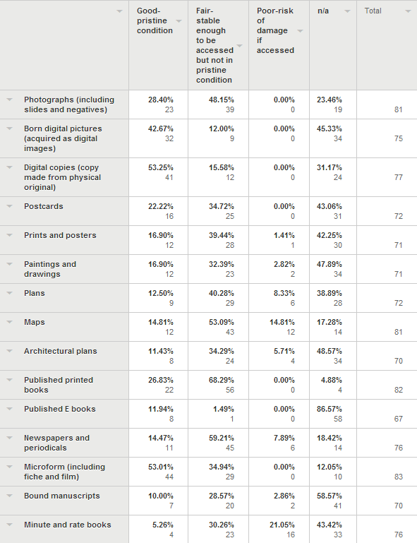

It is interesting to note that already 12 % of the born digital images are not in pristine condition. This could be because of the file format chosen for storage not being optimal.

Good Fair-stable Poor n/a Total
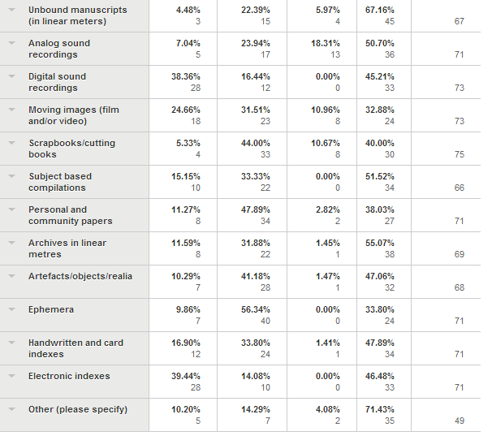

The collections with the highest risk of loss because of the percentage of items in poor conditions are maps at 14.81%, minute and rate books at 21.05%, analog sound recordings at 18.31%, moving images at 10.96% and scrapbooks/cutting books at 10.67%. This shows a high need for conservation, in some cases, and for others stabilisation and digitisation for access.

Q 14 Indicate which of the following you are collecting from your local area
84 libraries responded
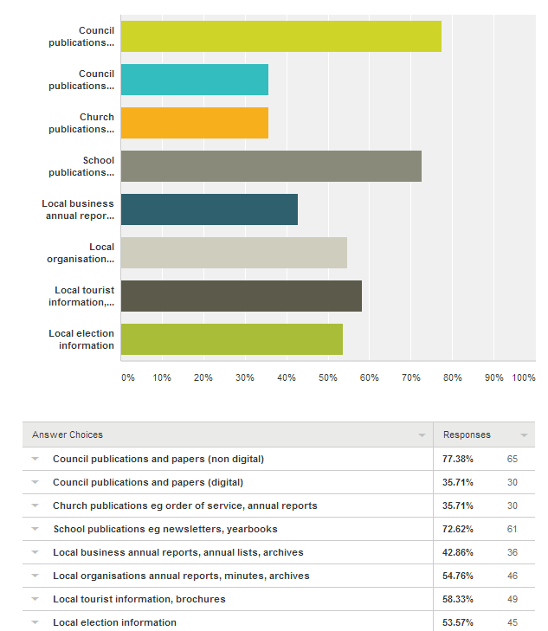

Council publications are not being collected by every local government area.
.

Q15
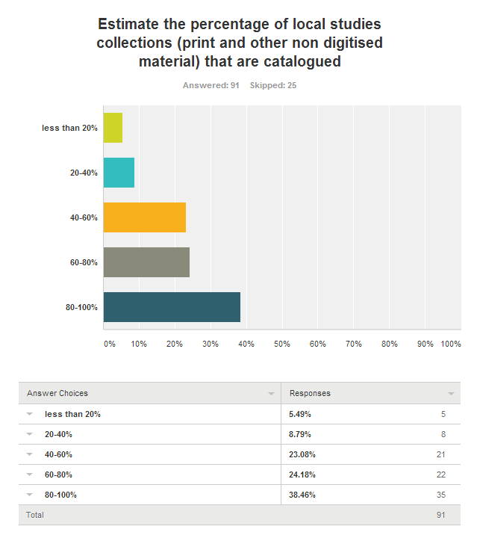
It is encouraging to see that 35 libraries have 80 to 100% of their local studies material catalogued. The other data is a cause for concern. Looking at the 116 councils who completed the survey that leaves 81 libraries/councils with less than 80% of their local studies collection catalogued, including 5 with less than 20% of the collection catalogued.

Q16 What standards are you using to catalogue local history collections (eg Dublin Core, RDA, Australian Pictorial Thesaurus, LCSH)?
81 libraries answered

The answers included RDA, Marc 21, LCSH, ISAD-G images (archives) Powerhouse Museum Object Thesaurus Library collections, Vernon, Small museums standards, Mosaic and some indexing of some titles in the catalogues or some councils. Two libraries use in house standards.

Name of standard | Number of libraries using standard
RDA | 46
LCSH | 46
APT | 16
AACR2 | 10
DDC | 10
Dublin Core | 9
MARC | 5
Vernon | 1
ISAD-G | 1
Mosaic | 1
Powerhouse Museum Object Thesaurus Library | 1
Small museum standards | 1

Some of the libraries used more than one standard, for example using RDA, LSCH, APT and Dublin Core.
.

Q17 Describe the key fields you use to catalogue your local studies (print and non digitised) material. Please note any significant variations across different collections.

65 libraries answered. The detail in cataloguing varied considerably. From author, title, publication, extent, contents, subject headings, notes where applicable to ISBN, author, title, edition, publication, physical description, frequency, series, general notes, contents notes, summary, subject headings including personal/corporate/topical & geographic and added entries including personal/corporate/meeting & conference name, any electronic reference and call number. Some libraries put in more detailed tags for some fields to enable more specific searching.

Q 18 Please describe the method of recording and sharing information about copyright ownership and access conditions for local studies material?

71 libraries responded

LMS/CMS/DMS information recorded in notes field, copyright status and access conditions | 44
Not sure /na | 10
In library signage | 5
Recorded, not on catalogue | 5
LMS – no specific details | 2
Staff provided with information from the Australian Copyright Council | 2
Copyright recorded on website | 1
Word of mouth | 1
Separate registration required to use local studies collection | 1

Many of these libraries are recoding information in a way which staff can see, some of the information recorded on the LMS/CMS/DMS is publicly viewable, but not all.

Some of the comments include:
- 541 tag we enter details of who donated the item - this is not for public viewing. We don't generally record details of who donated an item unless it is a photograph - for those we get them to fill in a donation form which includes a license agreement. 500 tag we enter copyright details for post 1955 images as: Copyright licence/assignment held by [name of council]. 540 tag is where we enter what access conditions and restrictions there are for an item.
- Included in General notes Access defined and limited through LMS and /or location of material
- If known it is entered in the marc record. Customers are advised verbally about copyright and access conditions.
- No copyright information is included in the records online. There is general copyright and disclaimer information on each webpage which outlines council's copyright policy for all information and images contained on the website.
- For our digital photograph collection, as we are borrowing the originals from the community we have copyright permission forms, along with forms describing the material they loan. On our LMS, we record the source of the photograph and the creator, if known. The majority of our photographs were created prior to 1955. For photographs since 1955, if we do not have copyright permission, the catalogue record will describe the image but the image will not be shown online.
- Copyright disclaimer is added to catalogue record for images.
- Note kept with accession register for all formats. Note made on cataloguing record to indicate status, this information is available to all users. Note on web accessible databases
- donation forms - librarian knowledge
- Recorded in catalogue record where known. All requests for permission to reproduce or publish assessed on a case-by-case basis.
- These fields are mandatory if available and a default statement is used.
- Copyright information and access conditions are included in the entry on the catalogue which is accessible through the staff computers.
- published items standard copyright notice on photocopier and inside books verbal on use of family files
- Paper based detailed accession register as well as signed release forms in hard copy. Basic copyright and permission details entered on to online image database.
- A note is made on the notes field in the catalogue. A written note is included with archive material.
- New donors are required to complete a form clearly identifying their donation and intentions re copyright, ie donation of item without transfer of copyright, or with full transfer to the Library. This documentation is recorded via the Council's records management system, however it can be difficult to relate this back to collection items and keep the intentions clear for later users. Staff memory is a poor substitute! Most items in this situation are photographs, and are uncatalogued. Some unpublished works are held, but no copyright or access information is evident from the time of donation.
- Copyright notices in Local Studies Room. Some rare material requires a library card and use of cotton gloves. Access is usually supplied by staff member on the Reference Desk.
- Forms are filled out, digitised and saved on Councils records management system. On our DMS (website software) we add details to the records in addition to saving a copy to Councils records system. On our website we own copyright on all material and freely share this with the community - the exception is if material is used for commercial purposes, we require acknowledgement.

Where possible this information should be entered in the catalogue, at least some of this information (not individual copyright owner details) should be viewable by the public.

Q19 Describe how the public can search for non digitised local studies items in your collection (eg via LMS, card catalogues, Trove, other online systems)

86 libraries responded
LMS only | 32
LMS and Trove | 17 | For 2 Trove is partial
LMS, Trove and something else | 15
LMS and something else | 11
No LMS access, but other tools available | 7

The other tools include:
- Library staff, and local studies staff
- Folder with collection subjects in alphabetical order
- Card catalogues and indexes in various formats including, for newspaper indexes 1980s and 1990s
- series listing
- correspondence file
- shelf listing
- CD-ROM
- Flickr and Search tech
- Tabularium and other archival inventories or indexes
- printed index of clippings file
- Onsite photograph database
- Spreadsheets and subject listings/indexes
- Library website or blog
- In house databases including in Access and Excel
- File drawers in alphabetical/subject order
- Sands directory

Q20
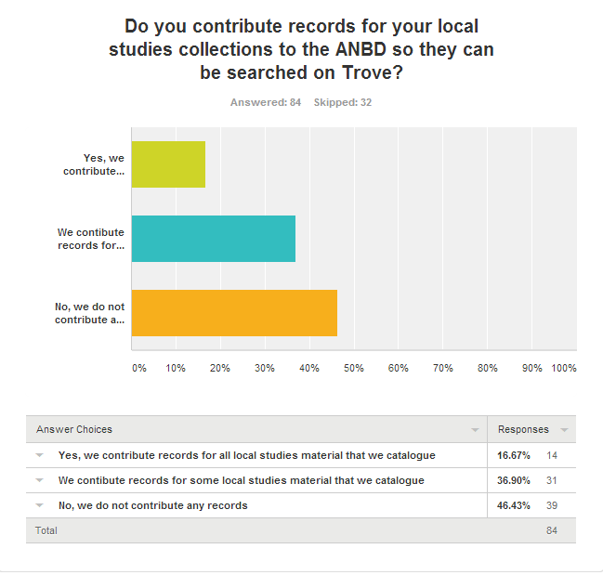

14 councils contribute records to Trove for all local studies material which they catalogue. These council are to be commended for making their material searchable as part of the national database. Thirty two councils skipped this question, and thirty nine councils responded that they do not contribute any local studies material to the ANBD, while thirty one contribute ‘some’ records to the ANBD. This means that for over one hundred councils in New South Wales little or no local studies material can be searched online in one place.

Q21
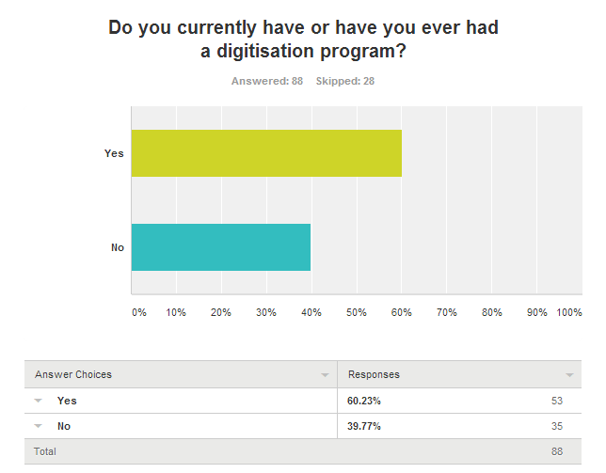

The comments provided additional data to indicate that four councils had stalled digitisation programs, and two had such occasional digitisation that it could not be called a program.

Q22 Approximately how many items have you digitised in the last 12 months?
Answered by 53 libraries

73 903 items plus 3.8 TB of content. From the descriptions the majority of the digitisation is of photographs, but it also includes newspapers, books, plans, postcards, rate, minute and valuation books, and building application registers.

Q23
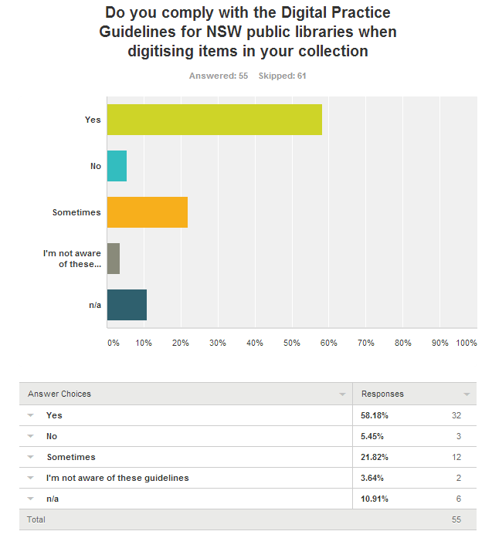

Q24 Thinking about digital local studies collections in your library only, provide a brief description of
Methods used to create metadata/catalogue
43 responses to this question

21 libraries catalogue using their library management systems using LSCH or APT. Comments about this include:
- MARC fields for digital print items
- Copy cataloguing using Libraries Australia
- Cataloguing as per AACR2/ Australian Pictorial Thesaurus and now RDA
- Catalogues on Library management system then data uploaded to Search Tech/Perfect
15 libraries catalogue to digital assets databases, image databases, and online service providers using a range of standards including:
- LSCH
- Modified Dublin Core, with crosswalk to MARC
- Dublin Core
- APT
- Dbtext
- fields created based on NLA fields; using customized categories

The remaining libraries to complete this question had either no content, or were preparing to start creating metadata.

Levels of detail in item records
42 responses to this question

Full or detailed | 27
Medium | 2
Basic | 6
Varies | 1
No answer or not sure | 6

Comments about this include:
- As much as is available with each individual item.
- as detailed as possible, 3+ subjects required for each item, 10+ required fields to catalogue
- Captions, date, photograph image number, physical description, archive series number if required, subject headings, copyright and reproduction rights statement, photographer, scope notes and additional notes if required, donor,
- File number (image number), title, date, description (i.e. format of original image), subjects (using Australian Pictorial Thesaurus), provenance, author, copyright, call number, access
- Resource designation, title, author, publication date, biographical/historical data, subjects (topical, geographical, personal, corporate).
- Detailed on library website with simpler descriptions on Historypin.
- Basic except extensive notes field
- Accession Number; date; locality; description; format; cataloguer; donor details; access restrictions; subjects
- Title, subject, dates, detail of original item (eg size/format). Keywords important - for speed of cataloguing and allowing public to find materials.
- moderate detail, average 12 Dublin Core elements used.
- Title, date, Creator, multiple topical subjects, LCSH format geographic subject, Rights,
- As much as possible even if it doesn't follow all the cataloguing rules (more in tune with RDA)

How the public can search for digitised items
45 responses to this question

LMS | 18
LMS and Trove | 8
Online photographic or heritage database/website | 8
LMS, Trove and photographic database | 2
No search access for public | 2
Flickr and local database | 1
LMS and picture database | 1
Card catalogue | 1 | This seems an anomaly
LMS and Flickr | 1
Images digitised but not accessible for the public | 1

While the low level of online searching is of concern, it is also interesting that some libraries have digitised material which the public cannot search. They have done a lot of the hard work towards access, but have not completed all the steps for public access.

If the public can add content to digital collection records/items
44 responses to this question

No | 37
Yes | 3
Partial | 4

Most of the methods of adding content are mediated by library staff and include:
- adding a comment to the LMS which may be incorporated into the record, once details verified
- comments on blog, or facebook, by email or in person, and the information is used to add to/ improve catalogue records

Direct methods include:
- can add tags and comments
- can add information to Flickr or Historypin

It is interesting, that even with the success of the text correction on Trove, as well as the capacity to tag and add information on some library management systems, that there are still concerns about content from the community being contributed to digital collection records.

Access restrictions or charges
43 responses to this question
20 libraries have no charges or access restrictions

Charges include:
- 15 libraries charging for high resolution copies or prints – wide range of prices from a couple of dollars to over $25, per image (including tiff and jpeg).
- At least two libraries charge for commercial use of material (in or out or copyright)
- Research
- Photocopying

Access restrictions include:
- Oral history can only be listened to at the library other than the tracks which have been made available online
- where do not have copyright permission, in which case a catalogue record is prepared but the image is not displayed online.
- Maybe some restrictions for commercial use for material still in copyright as per agreement with donor
- Copyright
- Access to fragile items, records which have personal information such as recent church records
- items not yet catalogued
- Family History material is not allowed to be borrowed except by Family History Group members.
- The digital collection on Flickr is blocked to the public
- Postcard collection

It is of concern that in some libraries high resolution digital copies are only available for a fee. Depending on the quality of the copies available online, it may be interpreted as an access fee as it may be the only way to view a reasonable version of the image. This is further restricting access to material.

Methods of recording and sharing information about copyright ownership and access conditions
43 responses to this question

22 libraries include copyright information at an individual record level on their catalogue or image database. This information is sourced from donation/accession forms which are stored securely. The donation information may be entered online, but will not be visible to the public. The catalogue record may also include any access conditions. A few libraries indicate on their catalogue who can give permission for copying material within copyright. One library includes pop-up copyright information prior to viewing digitised images. Another library notes that original donor forms are manually updated as conditions changes, and the challenges of tracking down copyright owners once the original donor/owner has died.

Two libraries used the settings on Flickr to record this information.

Eleven libraries uses a more general approach to copyright information, for example providing it on each page of the website, providing a disclaimer, rather than precise information, with each item, printed handouts, a link on the catalogue to general information about copyright and access conditions. One libraries requires customers to fill out forms in regard to purposes of their enquiries. Copyright notices provided in the library and copyright holders recorded. Restrictions may only be for commercial publications

The remaining libraries did not describe a consistent method of recording and sharing information about copyright ownership and access conditions.

Q 25 Can clients access your digitised material from outside the library? Please describe systems used to provide access
55 responses to this question

8 libraries answered no, one answered yes but provided no detail

LMS | 15
Website | 7
Flickr | 6
LMS and Trove | 4
CMS or DMS | 2
Image database | 2
Trove | 2
Flickr and website | 1
Trove and website | 1
Image database and Trove | 1
LMS/website/image database/wiki | 1
LMS/website/blog | 1
LMS/website/image database/Trove | 1
LMS/image database/Trove/facebook | 1
LMS and image database | 1
LMS and website | 1

Several libraries commented that a small part of the digitised collection was available this way, and not the entire digitised collection. A range of formats including images, maps, oral histories and newspapers were included.

Q26
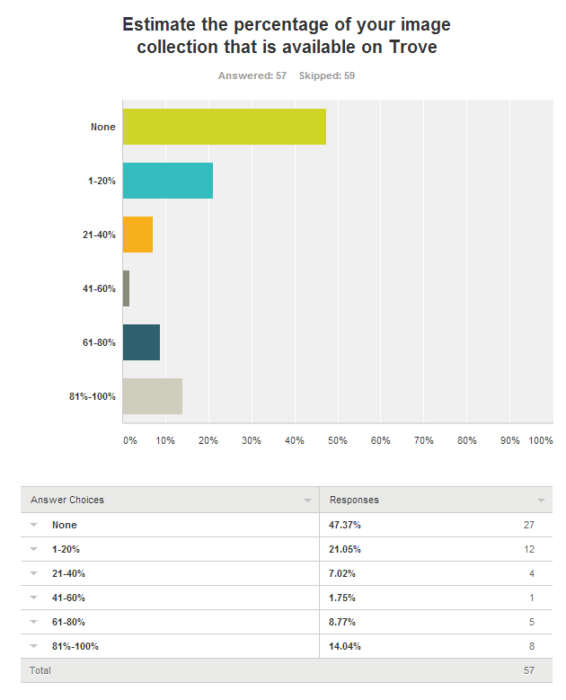

Fifty nine councils skipped this question, and twenty seven councils responded that they do not contribute any images to Trove, while sixteen contribute less than 40% of their image collection. This means that for about one hundred councils in New South Wales few or no images can be searched online in one place. This is a similar to the responses to questions 19 and 20, highlighting the difficulty of searching nationally for local studies material. To find images, people have to know which library they have to contact to ask for information, or where to search online.

Q27 Please describe
Software used for creating digital content
45 responses

Some libraries outsourced all or most of their digitisation and digital content creation to contractors, and did not comment on the methods used for creating original digital content.

The responses to this varied and included:
- Different library management systems
- Flickr
- ABBYY
- Adobe Photoshop
- Arcsoft photo studio
- Audacity; scanning software
- CanonScan 5.0
- ContentDM
- Cumulus from Canto
- EasyThumbnails
- Emu (DMS)
- Epson V700 Photo scanning software
- Filezilla
- Flickr
- Gimp
- HP Scanning software,
- Inmagic - dbtext database
- Irfanview for image modification
- Jpeg or TIFF scans
- Kodak Scandirect
- Media wiki
- Microsoft Office Picture Manager
- Microtek scanner
- Omeka
- Paintshop Pro
- PDF scanner
- Perfect Pictures
- Photorama
- Photoscape
- Photoscope v3.6.5
- Picassa
- Silverlight for slides and negatives
- Trim for original
- Various proprietary products sold with ad hoc collection of scanners

Most used a range of library management or content management systems. Specific software which was used more widely includes Adobe Photoshop, Microsoft Office Picture Manager, and Epson V700 Photo scanning software

Hardware used for creating digital content
44 responses
Several of the responses to this were of a general nature, and the equipment (of unspecified brands) includes council computers and scanners, digital still and moving camera, digital audio recorders, microform scanners, USB digitisers and digital screens. With the scanners which had brand provided, there were 12 Epsons (a mix of flat bed and page scanners), 5 Cannon, 4 HP, three MicroTek, and one each of Digi frame, Toshiba, Kodak and Plustek (for slides and negatives). Of the cameras which were specified there was one Panasonic and one Canon.

The responses to this question, and the previous one, seem to indicate that the majority of the digital content which is created is done by digitising content in other formats. Only a few libraries listed cameras and audio recorders which could be used for creating original local studies content. Some of the mentions of computers may include current content creation and recording rather than format shifting, but that is not clear from the information provided. This reflects the responses to the previous question which also showed a focus on digitisation as format shifting for access, rather than recording current local studies in digital form. Digital recording, whether of photographs, videos or audio is not new technology. Libraries being involved in content creation is not a new idea either as some libraries have been photographing their areas for their collections. There are issues to be considered for access and preservation, but not creating the content at all is actually a bigger issue.

Ownership of equipment and software that supports digitisation
47 responses
One of the responses was from a library with no digitisation. Thirty eight councils or libraries own the equipment and software which supports digitisation. Three councils mentioned all material was outsourced, and the remaining five were a combination of council/library owned and contractor owned.

File formats / types used for creating digital images
45 responses
tiff/jpeg | 15
jpeg | 11
tiff/jpeg/pdf | 7
jpeg/pdf | 2
tiff/pdf | 1
pdf | 1
tiff/jpeg/pdf/mp3 | 1
tiff/png/jpeg | 1
tiff | 1
tiff or jpeg | 1
Tiff/jpeg/pdf/png/gifs | 1
NA | 3
This shows 27 council consistently using tiff, which is a lossless file format for their digital images.

Size of storage required for images
39 responses
20 councils provided details of their amounts of storage for images which adds up to a total of 26.88 tb. Four councils had storage of one tb or more. 5 councils provide NA responses, 14 provided no amounts but indicated that they had storage.

Backup system/strategy/storage
42 responses
Council server | 26
Offsite hosted or cloud storage | 6
Library server | 4
External hard drive | 3
na | 3

Q28
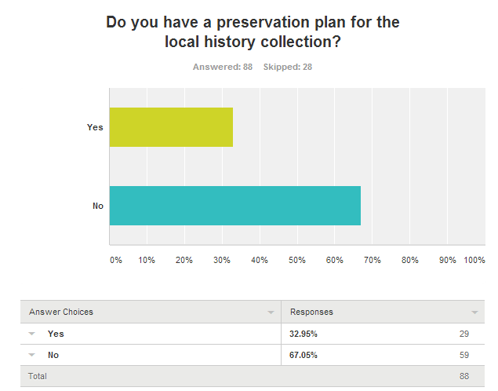
The responses to question 28 and 29 indicate that the local studies collection could be vulnerable.

Q29
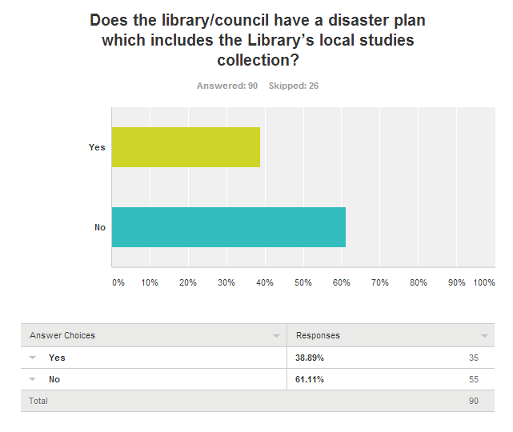
Q30
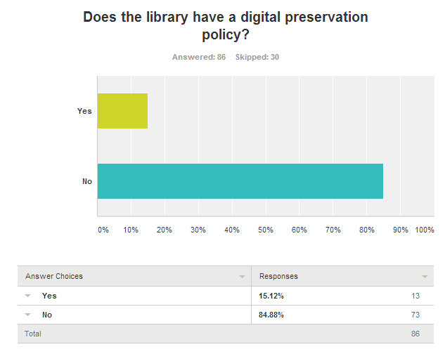
Q31
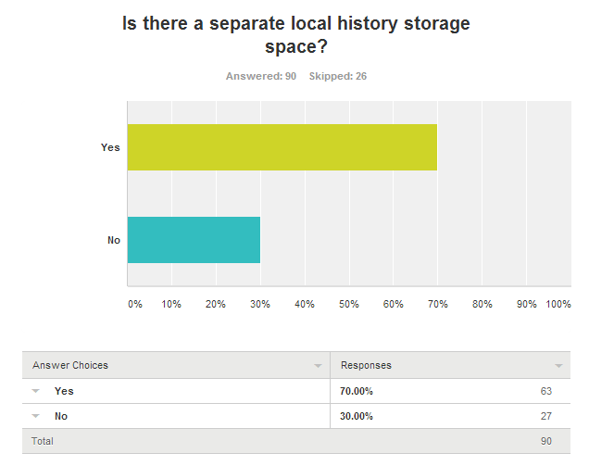

Q32 Briefly describe how different local history (non digitised) collections are stored/housed any special conditions. eg temperature moderation
Storage conditions | councils
a Temperature/humidity controlled conditions and fire rated or with fire suppressant / fire alarmed and stored in preservation safe casings/enclosures | 5
b Fire rated compactus – not temperature/humidity controlled (combined with in library storage) | 1
c Temperature/humidly controlled conditions and stored in preservation safe casings/enclosures | 5
d Temperature controlled conditions – optimised for preservation, mostly stored in preservation safe casings/enclosures | 10
e Stored in air-conditioned public access space , stored in preservation safe casings/enclosures where needed | 9
f stack or lockable storage/compactus - stored in preservation safe casings/enclosures but no details of temperature and humidity management | 10
g stored on open shelves in library | 17
h stack/compactus and open shelves in library | 15

Q33
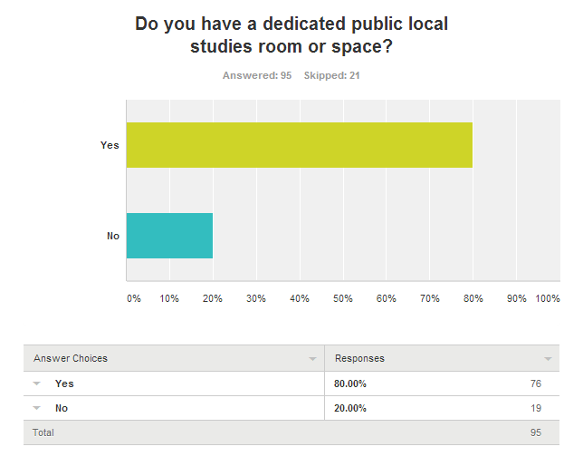
Q34
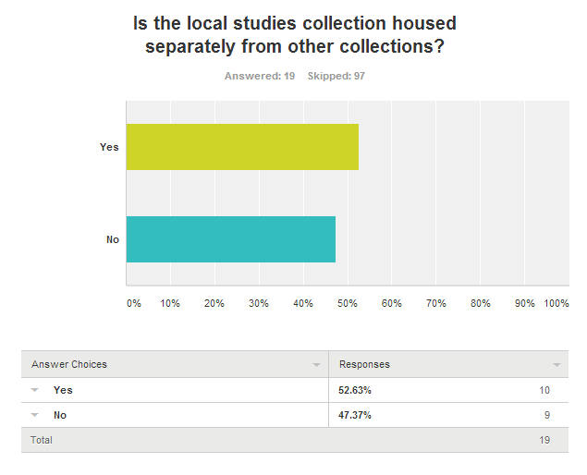
Q35
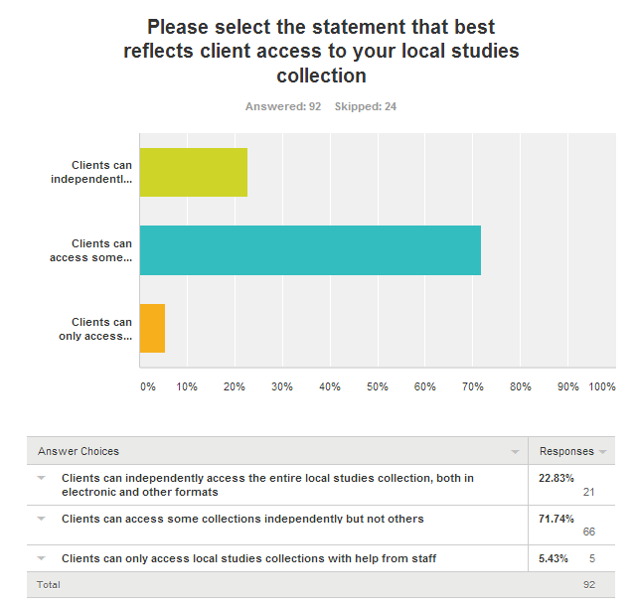

Comments about this include:
- The room is kept closed as we do not have a dedicated Local Studies person. It is opened whenever customers wish to access something they have found on the catalogue or have a general subject they are researching.
- Clients can independently access the entire local studies collection in print formats
- Our photo collection is held in locked cabinets, clients have to ask for them to be unlocked.
- The bulk of the collection is available at the Central Library. There is a stack storage area where lesser used items are stored. All of these items (except community archives) have been included on the library catalogue and can be retrieved at a day's notice.
- The only collection not publicly accessible are community archives and the pamphlet file which is locked.
- Photograph and scanned books online permit access to these collections.
- The archives kept under lock and key and are available on request
- Clients can independently access the entire collection
- Staff have to help sometimes.
- Local Studies Room is opened during the day, but shut at 3.30pm on weekdays, with a sign asking patrons to see Reference Desk staff for access to the room.

Q36
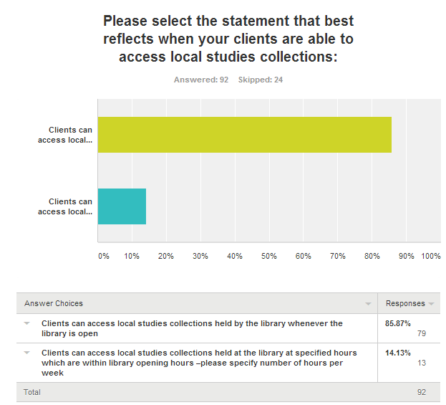

Comments about this include:
- The Local Historical Society stores some of their materials at [name of library deleted] Library in locked cupboards which are only accessible when the Groups members are available for consultation (3.5 hours per week)
- They ask staff for assistance to open the room.
- LS books, genealogy book collection, databases are available whenever the Library is open. Other Local Studies items are available Tuesday, Thurs. 10-5:00pm and Saturday morning 9:00am to midday when Local Studies enquiry desk is manned. Other times are possible with a prior appointment.
- Tue to Friday 2 to 5pm (12 hours per week) those using microfilm can access at other time as well
- Only some are available whenever the library is open, others parts of the collection, clients need an appointment.
- 7 hours on every Wednesday and any other time by appointment
- Part of collection accessible when Library open. Archival material by arrangement with Local Studies Staff
- The collections which are publicly accessible are available whenever the [name of library deleted] is open.
- Strong advocate of the LS collection being available at all times

Both the comments and the answers show a contrast between a mediated approach to the majority of the collection and a much more open access version.

Q37
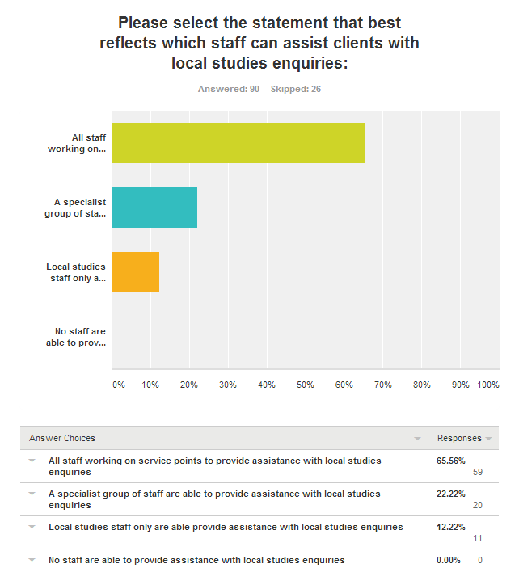
Comments about this include:
- Anyone working on the reference desk is expected to be able to locate LS material listed on the catalogue but specific detailed LS questions are referred to someone else.
- All staff are expected to be able to conduct a reference Interview to assess a client's requirements. If they then need to refer the client there are specialist staff onsite.
- There are a few other staff with some basic local studies training who are used to man the desk when the main Local Studies staff are on leave or not available
- Books on catalogue can be requested from all staff anytime
- The Local Studies collection is available any time the library is open therefore all staff need to be able to provide assistance in accessing the collection. However, if a researcher's enquiries are not satisfied they are advised to make an appointment with the Local Studies Librarian who can provide more in-depth assistance. Another librarian who was previously a Local Studies Librarian can also provide in depth assistance.
- We encourage the public who coming long distances with specific requirements to phone ahead, so that we can ensure that we have the information they are seeking.
- All desk staff have had overview awareness and training in Local Studies enquiries. However, specialist staff are available Monday to Friday 10am to 5pm for help.
- Only librarians are permitted to answer reference queries

Q38
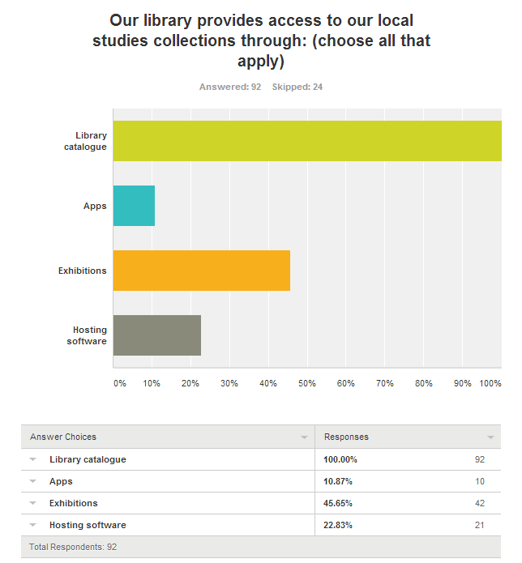
Comments and clarifications include:
- Some material is available online through the Local Studies webpage.
- Card indexes
- Webpage
- Printed and digitised indexes and listings, card catalogues
- Fact sheets on various subjects
- Web access to selected resources. Local Studies staff available mostly by appointment.
- Talks/tours for schools and community groups about the collection and service
- alphabetical files and USB and Microfilm.
- Flickr, Facebook
- Pamphlet file subject index and old card index

Q39 Tell us about any local studies programs, events, presentations or workshops your library has coordinated in the last 12 months
The areas covered general covered research methods, tie in with local, state and national events, showcasing local collections, showcasing research of display tool.

