Readers Advisory Services in NSW public libraries

Background
Rewarding reading training has been taking place in NSW public libraries for ten years. It was started as a result of a South East Zone cooperative Library Development Grant, with later training paid for by the State Library of NSW. This training has taken place in each zone and region of NSW.
The State Library conducted a survey to determine the current state of readers advisory services in NSW public libraries. The survey was based on one developed by Library Journal with NoveList and the RUSA/CODES Readers’ Advisory Research and Trends Committee. We have obtained their permission to do this.

Objectives
- To explore the current role of libraries in providing readers’ advisory services
- To identify the range of readers’ advisory services across the state
- To identify current service models for readers’ advisory services in libraries
- Develop good practice guidelines for readers’ advisory services in libraries

Results of research in USA libraries are available: The State of Readers' Advisory, Library Journal

The NSW research showed that in the ten years of training being provided in readers’ advisory services, that
- Readers advisory services are provided in many libraries
- While most of the training has been effective, there are issues in some local implementation of the training
- Some organisations still have restrictions on the use of social media, including requiring everything to have preapproval.
- Almost 40% of the responses showed the provision of some roving as part of readers’ advisory services
- Some libraries are making their catalogue work very effectively as part of the readers’ advisory service.

Outcomes
The results of the survey will be discussed with the Readers’ Advisory Working Group. The working group will develop a paper with ideas for the development of Readers’ Advisory Services in NSW public libraries.

Overview of results

There were some very encouraging responses to the survey about readers’ advisory services.

Libraries provided readers’ advisory services at many places within their buildings. 37% percent of respondents provided readers’ advisory services through roving, 52% provided these services at the reference desk, 4% have a dedicated readers’ advisory desk, and 83% provided them at the circulation desk. Included in the above figures, 3% provided readers’ advisory services both at the reference desk and by roving, 12.9% provided these services by roving and at the circulation desk, and 20.2% provided the same services by roving, at the reference desk and the circulation desk.

It would seem that over time this percentage will to shift towards more roving as the increase in the provision of self check for clients removes the circulation desk, making staff available for the provision of roving services. I would expect that even in a short time that these percentages would be reversed, and that we will be at the stage of the below comment
- All staff should be able to provide a basic level of RA.

For self directed readers’ advisory services most libraries have displays. Shelf talkers (small on shelf information) appear an underappreciated tool. One library used
- shelf talkers for databases and ebooks only
This is an excellent way to make information about online resources available in the library.

Reading discussions, author talks and facilitation or provisions of materials to community reading groups were all wide spread, as were resources on websites and reading suggestions provided through social media.
- The [ ] Library offers the opportunity for patrons to rank books in the catalogue, but few patrons are aware of this feature, and it is not well used.

Readers’ advisory services were wide ranging, although some libraries are not able to use social media as part of their service delivery while others are using a diverse range of social media tools.

Readers’ advisory services were provided to all client groups with many staff talking about the range of tools they use including the catalogue (and the depth of cataloguing was important), LibraryThing, Novelist, Goodreads, genre specific resources, ‘who writes like’ tools and other relevant resources and databases. Other staff relied on personal reading preferences which is not as effective.

Most respondents thought that readers’ advisory services had increased in importance in the last three years, and it would continue to do so over the next three years.

Library staff were asked how effective they were in providing suggestions to clients. The vast majority of respondents were divided between effectively and somewhat effectively. This is a solid start and can be worked on with more training.

Staff were more confident in providing readers’ advisory services to adults than to children, and more confident in providing the services to children than to young adults.
- It depends on the interests of the reader. If we have similar interests eg humorous fantasy then I'm all over it, but if I have an adult ask me for romance recommendations I start having trouble after Danielle Steel and Nora Roberts
- Lots of teen books are fantasy based, which I don’t read and find hard to recommend
These two comment are of concern as they show a lack of understanding of both the tools and the techniques. The references to “recommendations” goes against the basic principles of effective readers’ advisory work which includes making non-judgemental suggestions to readers. Suggestions carry less emotional weight and so if a reader does not like a staff member’s suggestion, they are more likely to talk about it when they are back in the library. If it was given as a recommendation they may feel it is a moral judgement on them when they don’t enjoy it.
However the following comment shows a better understanding of techniques.
- I have personal problems with genres that I don't read myself, such as westerns and romances, but can still use the databases etc. to help someone.

Another perspective is shown by the following comment:
- We have just launched this year a new RA program and we're still in the early stages. This is an area we've flagged for significant improvement and I'm confident that in 3 years I would be able to answer these questions more positively :-)

Big challenges for staff were keeping current with books, authors and genres across all age groups. This shows the value of knowing the readers’ advisory tools, and using them regularly. Time for training and confidence in skills were also an issue.

Just over half the respondents said their libraries were marketed as places to discover books and obtain reading suggestions, amongst many other services provided by libraries. Book suggestion databases like Novelist, library catalogues, and word of mouth were the main methods used to help readers. These were strongly followed by professional journals, social networking and consumer media. The readers’ advisory wiki, meetings and seminars as well as the twitter reader group all played a smaller role, but they did all play a role. There were comments about staff relying too much on personal experience and not enough on resources.

The Rewarding reading training played a significant role as did on site staff training, which may have been derived from the Rewarding reading training. Almost half the respondents included self directed training, whilst almost 14% said they had no readers’ advisory training or support provided by their library.

Detailed results of survey

163 responses were received from staff at 74 libraries.

At what points of service does your library currently provide Readers’ Advisory?

Question 1
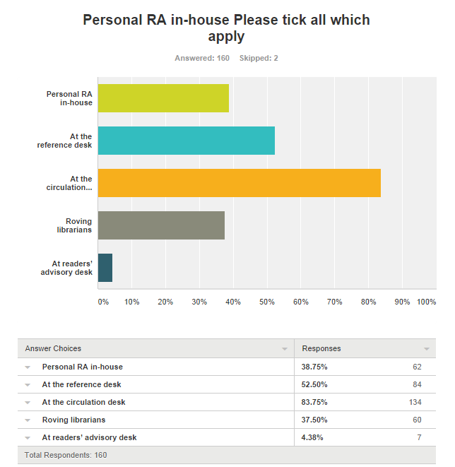

Comments included:
- Reference and circulation desk are combined
- Via mobile library van service to 8 schools Telephone Email
- also on call service.
- We have one Customer Service Desk where all inquiries are attended to. Whilst shelving or walking around the library.
- By telephone and online email requests.
- Also if a parent of a teen comes in I usually get called by the desk staff, as few staff are comfortable performing RA for the 12-18 age group.
- Home Library Service
- Website
- Staff have all been trained on RA based on the Rewarding Reading Training.
- Mobile Library
- Reference and circulation are all in a continuous wagon-train formation
- Library newsletter
- Not that I really know what the "Personal RA in-house" option is ...... Small single-staffed library so wherever they find me ...
- Referred to me by other staff. Questions via Ask-a-Librarian service.
- Currently participating in book selection for library
- I guess that's me. I'm not really sure about Readers’ Advisory. Although I do assist people to select books
- All staff should be able to provide a basic level of RA.
- Library contains a single service counter.

Question 2
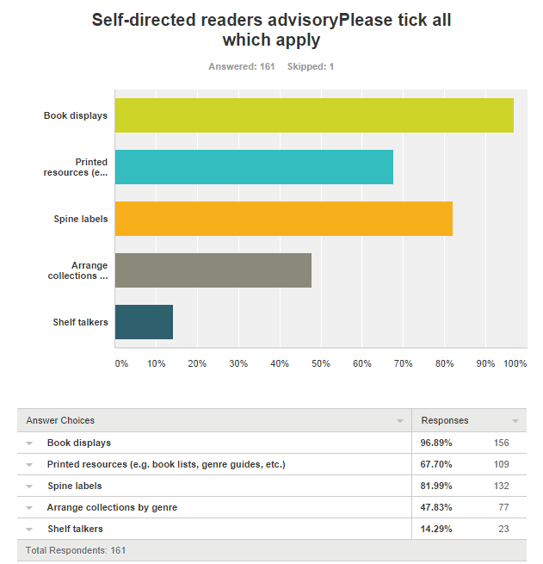

Comments include:
- shelf talkers for databases and ebooks only
- Via website Databases eg: Who Writes Like
- Digital displays on electronic noticeboards
- Merchandising
- ANF, some are in subject zones.
- Website
- Sometimes we have displays with simple display titles such, "Have you read these...." or "Did you know..."for not so popular authors and subjects.
- We also have online reviews. For YA there are no spine category stickers (and especially no PRC stickers) to pre-empt any potential bullying issues.
- Staff picks - which is the most popular
- Specialised collections, such as Red Hot Reads, Hidden Gems
- Genre meaning "type" applies here, not that we've created living rooms or abandoned Dewey for non-fiction
- We have just recently began upgrading our book lists, and have started being more pro-active with book displays. I am trying to implement shelf talkers. We have some genres that have spine labels with stickers to indicate genres.
- Paperbacks only arranged by genres NB Shelf talkers to promote eCollections
- Via Catalogue
- Links on website, articles on Facebook, reviews on OPAC.
- Blog posts, Tumblr and Pinterest posts
- Recommended reading lists in the catalogue

Question 3
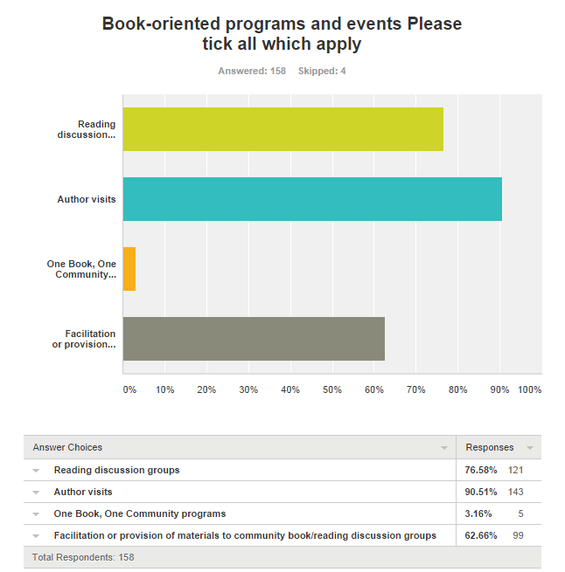

Comments include:
- Story Time sessions.
- Topical issues talks
- Displays
- Reading competitions, such as for Juniors/Young Adults "Mystery Titles - Undercover" whereby books are put in brown paper bags with just the barcode on it for issuing, and "Take a book to bed tonight" for adults on Valentine/Library Lovers Day. Reviews on books read will get a prize in the form of book vouchers, etc.
- Writing groups.
- … also runs an Adult Summer reading program and a Junior Summer Reading program that encourages reading and provides lists of suggested titles
- Writing/self publishing workshops, children's book weeks, […] Young Writers' Award
- Monthly newsletter for Friends of the Library, mounted on website for all after distribution to Friends
- Have just started a book group
- Author visits and reading groups are done at our main branch
- Literary talks focusing on a particular author or theme
- About to launch Book Group Kits, an idea pinched from [another library]
Question 4
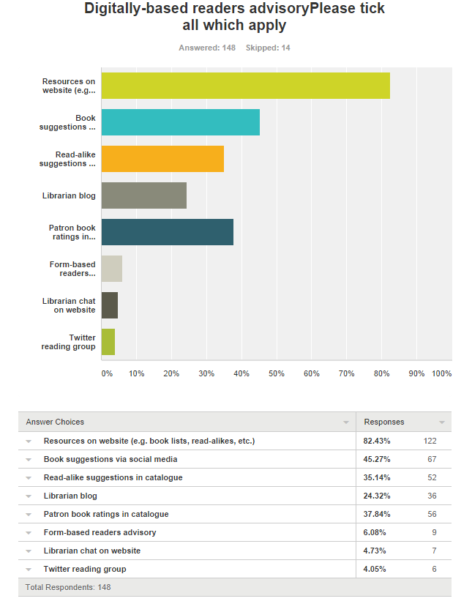
Comments include:
- Weekly book review by staff member in council newsletter
- On line book club. eBook provider provides 'if you like this then..." suggestions
- We would really like to improve the reader rating feature in the catalogue, at the moment it's hidden and not well utilised.
- Facebook.
- e newsletter
- The [ ] Library offers the opportunity for patrons to rank books in the catalogue, but few patrons are aware of this feature, and it is not well used.
- We have a special websiste for book discussions…
- More online RA will be provided through the library website and OPAC once the new LMS is implemented later this year (2014)
- Goodreads book group
- We do have the facility for patrons to rate and comment on materials in catalogue - but this feature has not been widely promoted as the small amount of promotion that was done at one stage did not result in any take up
- Online book selection

Question 5
Describe some of the readers’ advisory services you provide in the library
- already covered in above, 4 monthly event interviewing authors in the evening for adults
- All of the above
- Very limited. We response to direct questions at circulation, direct patrons to our database subscriptions, post a tired and repetitive 'bestsellers' list on our website/in branches.
- Genre displays, printed resources, displays, roving reference, use of Novelist, printed read-alike resources
- book displays, book lists, author visits
- Face-to-face on desk.
- reading lists, personal one-on-one advise with readers, website, facebook, newsletters etc.
- We are currently in the middle of a staff training RA activity where a different staff members talks about and writes a review of a book they have enjoyed, then other staff members recommend a book for them using RA tools.
- The "who else writes like" books are left around the Fiction section. The catalogue gives suggestions of other titles & tags for searchers to follow. We display Fiction books - genre, subject, & make up book lists & often make up displays non-fiction books about that subject.
- Book Clubs, Book Club Kits, Bookmark booklists, Library Thing, author visits, storytime - talk to mothers about resources, books displays, radio review spot on the local ABC radio, weekly column in local newspapers includes book reviews, Good Reading magazine online.
- 5 Books we are obsessed with this month Classic reads Book discussion groups Roving reference Themed displays
- Assisting readers to find books on particular genres, authors who write similar material. Assisting new readers find books based on their preferences.
- Display Board of new fiction
- We also provide an Ra service through our Home Library Service where customers fill out a form to describe what reading materials they prefer. Staff then go out onto the floor and select items for these customers.
- They are listed above. On line book Club. Themed talks, one on one conversations, genre labels and collections, merchandising principles, TV
- Book Clubs, Genres lists, Cross promotion of collections
- Personal chats to library users, newsletter, facebook
- Genre lists, who else writes like lists, genre spots, new items display, new covers on display with reading list of synopses, new items list on catalogue & website.
- We've run in house training for all staff is use of online and physical resources. We offer summer reading guides (for adults) and have a quick picks sections for key NF genres (cooking, computers, etc). We have a library blog, lots of face-out display shelving and slatwall displays. We also provide "recently returned" trolleys.
- At point of service only
- we get enquiries by email, 2 per month probably
- RA Books, reviews, show patrons how to access the online and hardcopy resources.
- Assisting in selection of audio books for those with low vision.
- availability, series, reservations + ILL, favorite authors/genre, read-alike, LP editions, genealogy and local studies, promoting e services - ebooks, eaudio and emagazines
- Book groups, Seasonal/subject suggestion lists/brochures, RA training for staff, hardcopies of RA reference books in central location.
- staff picks display
- Story time and baby rhyme time discussions
- Over the counter RA, recommended reads on display
- Dedicated PC to access Novelist.
- Genre labels
- How to use the catalogue. How to place a reserve on a book, DVD, CD,etc. How to access Book Clubs in the area.
- Mostly informal "chats" with library patrons - "I notice you're borrowing this, you might also like"..."This is a wonderful book, have you read..." provokes some great conversations and tips from readers, that you can pass on to others. Novelist, Librarything suggestions on our Catalogue, who else writes like type books, Booklovers webpage with links to other Readers’ advisory websites, Author talks.
- Very enthusiastic staff talking ears off random patrons they see in an area (eg Graphic Novels).
- Recommendation stickers from local readers placed on books Discussion notes for book clubs Staff recommendations placed inside book giving rating.
- Who else writes like...? I'm interested in...what do you have?
- themed bookmarks, personal assistance using "who else writes like' style publications and online databases, staff pick stickers, reviews in e newsletters, one on one conversations
- displays, genre grouping, genre stickers, one on one RA with patrons, general service desk conversations with customers.
- We provide genre/suggested reads bookmarks. We used to provide genre brochures but these have been phased out. Borrowers are encouraged to speak to staff at the Information/Reference desk. In-house book clubs and loan of book kits to community book clubs.
- Often take the customer to the shelves and help them find genre stickers
- Roving reference, hand outs
- Displays- new books, themed reading lists on our landing page readers groups meetings - in library and social setting
- We have a newsletter which is available in print and electronic formats; regular displays such as Author of the Week or changing displays with different genre, subject matter or seasonal topics.
- book lists in our monthly "what's on" looking to develop staff picks
- training of staff to help themselves and customer. Electronic and print resources, including genre lists, displays, and author talks
- author events, inhouse staff help, displays, conversation via facebook, book clubs run by staff.
- book club, 1-1 RA with customers,
- database assistance eg novelist
- The library offers book displays of new items, face out shelving to promote the collection, a display of 'staff picks' items that is very successful, some 'if you like/try' shelf talkers, and staff will offer reading suggestions, if requested. Our large Book Club service …regularly contact staff involved with the service to ask for in-depth advice about their next reading choice.
- We have staff rostered to provide RA assistance every morning and to top up the Book Displays throughout the Library.
- Author talks, book groups, book lists on website, Twitter reading group
- Face to face RA service to customers
- One-on-one at the help desks; RA books & guides; various displays often correlating with particular events or holidays eg Library Lovers Day; RA links in the catalogue with the provision of customer ratings & reviews; Recommended reads etc on OPAC (new)...
- Covered above plus, BookChat (subject or individual book discussion) Reading programs - Winter reading for adults and Summer Reading for children and youth. Storytime for children under 5, Annual Children's Book Festival, targeted Home Library selection.
- Displays poster, e-books download training
- Displays Poster promotions
- All those ticked above plus QR codes on shelves linking to author websites etc.
- Help anyone who asks, and we ask them if they're looking lost or wandering lonely as a cloud
- book lists, genre labels
- Read-alike suggestions leaflets/pamphlets available in the library for readers to take. Book displays by genre. Genre guides, spine labels.
- Only have the newsletter and small display
- hard copy RA collection. Use RA tools online eg Literature Map, Library catalogue.
- Book - Who writes Like , OPAC
- Monthly author talks for adults and reading events for children together with promotion of RA based databases are the cornerstone of our RA services
- Being a small branch library we are very patron oriented and know our clientele well. A lot of our RA is suggesting readalikes based on reading preferences. this is mostly done in a one on one sense. We also do a regular book review for the local paper
- Informal recommendations. Printed book reviews in local newspaper written by Summer Reading Club members. Weekly display of new stock. Genre spine labels and some genre shelving (large print and paperbacks). "Who else writes like" available at circulation desk.
- Read-alike book guides, fiction shelved by genre & genre/theme spine stickers, display stands for new books/recently published books, staff at hand at circulation & reference desks or roving.
- Assistance with finding the customer's next great book; suggesting book titles for book groups
- Personal assistance on request. Genre bookmarks which are regularly updated with new trends and linked to popular TV series etc. Author visits. Themed displays linked to events e.g. 100 years since commencement of WWI including fiction and non-fiction, film etc.
- At present we do not offer a great many, we assist with enquiries at the desk, we have genre lists, displays and a bookclub. Have a Top 10 Fiction poster every month. We also promote Read, Watch Play
- Other than the above, none
- Bookmarks, themed lists, displays
- book marks with author lists Display ends
- 'The Good, The Bad and The Ugly' book-review book for patrons to fill in.
- Use Novelist and book displays
- Recently started having displays. Apart from this very ad hoc.
- Podcasts of local authors
- Author of the week, book groups within the library
- Book marks, genre labels, list of websites near catalogue, copy of who writes like at the circ desk, websites in favourites at circ desk
- New book lists both through the catalogue or in the library. Newsletters with new titles. Book displays, new book displays. Book group. Traditional behind the desk reader's advisory and general conversational at the shelves reader's advisory.
- Generally we only provide RA services when asked other than providing access to "Who read likes.."and genre spine labels. Special genre displays are sometimes organised but not regularly.
- Displays Lists Guides
- Apart from displays, bookgroups, author talks borrowers are able to engage with staff one on one
- quarterly Reading Newsletter; eBooks info drop in sessions; eReader lending program; ANF subject zones arrangement; Adult summer reading program and awards; Personal RA when required
- Mainly, just new book displays and monthly new items lists - printed copies as well as e-lists through our LMS
- General readers’ advisory advice both as requested by a borrower, or through observation that a borrower may be looking 'lost'. We hold many authors talks and have 13 book clubs spread over 4 branches, including a subject specific one on travel. Recently we have moved reference RA materials to within close sight of the fiction collection to highlight these resources.
- book lists, displays, personal RA at reference desk
- We have librarians to help at our front desk during the day and we provide roving librarians in the peak periods. We have RA tools at our service desks for staff to use along with website links.
- Offer new genre based books to groups that meet in the library. e.g. Knitting group, Baby Rhymetime parents. New books collected for Bus to Library patrons for first borrowing. New children's books put aside for children's groups e.g. school holiday craft Book Week Short list out for borrowing or reservation
- Who writes like book book lists in folder at Info desk
- Special interest reading lists; one-on-one assistance; face out book displays
- Book reviews, staff recommendations, book lists, new book displays, themed book displays,
- We ask patrons to vote on a selection of items for purchase by the library
- Genre/theme based book displays (Rural Lit, Travel, Gentle Reads, Award Winners, Christmas etc) Resources (both print & online) for staff & customers to utilise. Pro-active staff who are eager to have a chat with customers. Author events.

Question 6

Describe some of the readers’ advisory services you provide online? What social media is used? Please provide account names and links

Account names and other identifying details have been removed from the comments.
- facebook, twitter
- Twitter
- Facebook and library website
- Facebook
- The library is currently prohibited from using social media - Council policy.
- subscribe to "online book clubs"
- Council does not allow us to use social media.
- website, facebook
- The e-newsletter usually lists of 10 or so books - e.g. best-sellers, topical subjects & often fiction authors of series about similar topics.
- Facebook and Twitter
- Library specific hashtag
- Facebook
- Facebook, Pinterest-staff picks, Twitter, Flickr, blogs and our website
- facebook, twitter, eNewsletter
- facebook
- facebook
- Facebook to highlight specific collections and events.
- Mainly the library blog and … Facebook (like us on Facebook!). We also have a youtube account which we use to upload our author talks.
- We have an underused Facebook page for the library service
- library email account
- Access to NoveList Plus, Good Readings Magazine (online), Who Else Writes Like...? (online), Library blog.
- Facebook
- Facebook… Pinterest, Twitter, Reading Blog…
- Novellist
- Facebook and Twitter just listing what has been recommended recently
- Internet
- Our website…Facebook
- I'm responsible for posting to the library's facebook page once a week, and focus on books/collections/reading. Posts sometimes around reading awards/shortlists, but mostly try to do book suggestions - in form of "one of our 7yr old borrowers shared her favourite titles" or "great new cozy crime in the library" and point to resources.
- We are only allowed to use Pinterest, so social media is VERY light.
- Library blog, book reviews in local newspaper
- We only provide links via the Library website.
- blog and collection highlights on library website.
- Facebook
- We have a facebook account which is popular. We did try a library blog but it was not read despite advertising, links from Facebook etc.
- Facebook Twitter
- Facebook and Twitter, more talking about events at this stage
- databases, promotions via FaceBook, Twitter
- facebook
- Limited social media is used at this time, as the library is still negotiating council approval to use its own social channels. A Pinterest account is used for the book club service where boards are created to help with typical RA queries eg Australian fiction, Literary prize winners, feel-good books. The Book Club service also uses a Goodreads.com account to maintain a list of titles under consideration - both customer suggestions and staff selections
- We use Twitter, Facebook, …[blog] and we have a teen blog [and] Pinterest
- Facebook, [library and youth pages], Twitter, Instagram
- Facebook
- Facebook page [and youth facebook page]
- Library Facebook Page. Considering Pinterest.
- [library] Pinterest, Facebook (Council) Eventbrite
- [library] Blog, Facebook, Twitter, Instagram Library Website
- Limited
- New book recommendations on website, library facebook, twitters, pinterest, vimeo., patrons book ratings in catalogue
- Databases: Novelist, Literacy reference Centre, Good Reads
- Library provides access to 16 RA based online resources such as Novelist Plus, Goodreads etc Council policy precludes the use of social media
- Facebook, Shelfies, have you tried...posts, posts by Bookgroups.
- Links from library website to book guide sites, e.g. Novelist Plus, Library blog; New Title Lists on the library catalogue; Library facebook account
- Pinterest
- Council does not allow material to be posted without prior approval, and so spontaneity is so lacking in our social media that it is impossible to imagine using it for RA!
- Facebook. We also have set up a Twitter account, but need to get official permission for this from Council before going public.
- Facebook, Pinterest Twitter
- Facebook
- Facebook, twitter, youtube, Flickr
- Facebook, Flickr, Pinterest, Twitter, Youtube.
- Facebook
- Podcast interviews and book reviews:
- Facebook,
- Do not have access to social media for RA
- No social media but through the OPAC we are able to display covers of new titles
- Library blog focussed on reading, Pinterest; Podcast
- Facebook, Twitter
- Good Reads account for library
- A webpage dedicated to readers’ advisory, plus links from children's and youth webpages to recommended reading.
- Facebook, blog
- Facebook, blog, pinterest
- Facebook, pinterest and Twitter
- reading lists in catalogue, Blog
- Library website, Council Facebook page
- blog … and twitter has just commenced.
- Facebook Webpage
- Facebook
- Facebook, blog
- Goodreads, WordPress blog, Facebook, Twitter
- Facebook and Twitter
- No social media used for this purpose. Council comms has final say over online content.
- Council Facebook

Question 7
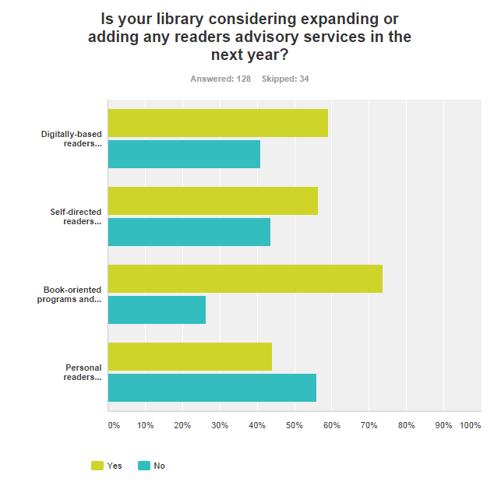

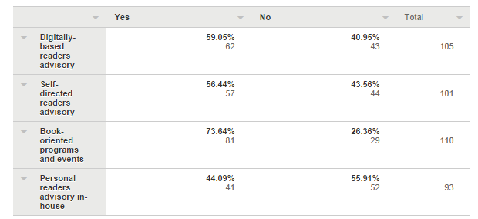

Comments include:
- All services are being reviewed at the moment.
- Form-based RA
- further develop on line book club
- Not sure
- I am not sure what plans are in place for the future.
- Personalised reading suggestions by staff for borrowers to be started within the next few months. creation of a pop-up library to promote all services.
- Shelf talkers
- Plans to gain a grant to buy loanable eReader devices.
- We are currently in the process of taking applications for a new position of Readers’ Advisory Librarian
- unsure
- Not sure - haven't been told of anything new
- No definite plans but all of the above have been discussed and may well be taken up.
- Form based and shelf talkers
- already doing these
- Proposals have been submitted to run 4 author events, to improve the Readers’ Advice offered on the library website by flagging staff picks and reviews, to improve the layout and display of library material to make it more accessible, to promote and participate in the RWP twitter discussions and associated resources, to create a Youth Blog featuring RA content, a film discussion group, and to trial form-based RA.
- Social media book groups
- Children's and YA continuing to expand existing services
- As we will be in a temporary location (whilst our library is being refurbished), public access to browse collections will be severely impacted, this will require that we enhance our readers’ advisory skills and activities.

Question 8
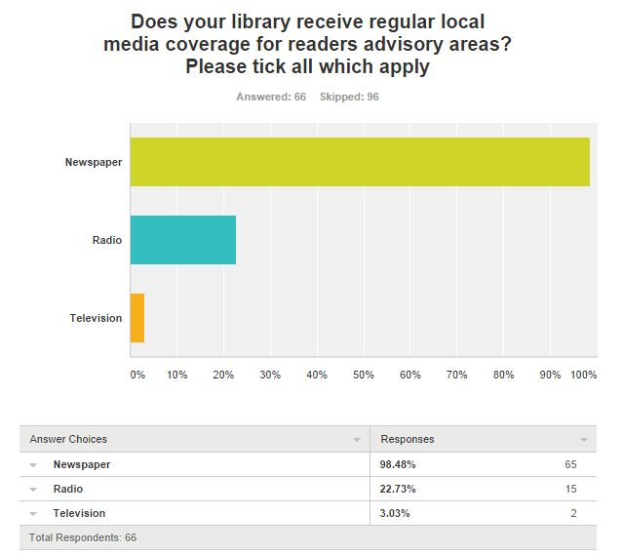
Comments include:
- Council webpage
- Council's publications, paper based and digital Library newsletter
- Not that I know of
- The branches are responsible for getting the information regarding events out to the media, a reasonably time consuming task
- Local writers centre , local newspaper
- Local Community newsletters
- Only for author talks.
- Regular newspaper coverage of our children's programmes
- Not really, media coverage tends to be events based.
- occasionally
- We have received coverage for our Read, Review & Win Program
- Targeted events
- Fortnightly library column covers a wide range of topics and includes reader advisory-type columns
- library leaflets, local government newsletters
- Our author visits are usually previewed in the local papers.
- During the Year of Reading our local newspaper published a weekly column in our free newspaper. They do not publish many of our media releases of late.
- We don't get regular media coverage although we regular provide content, it is not picked up.
- Sometimes TV
Importance of readers’ advisory
Question 9
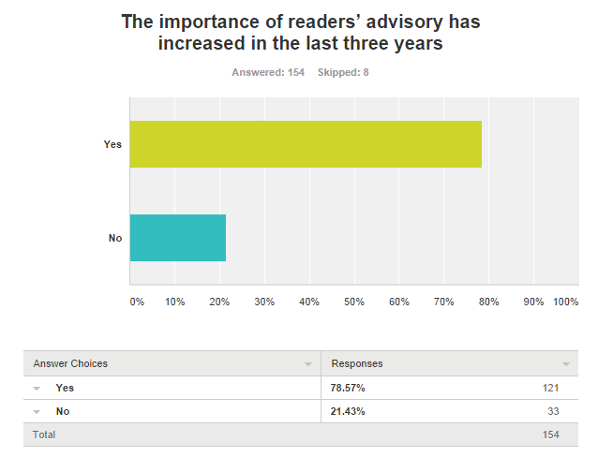

Question 10
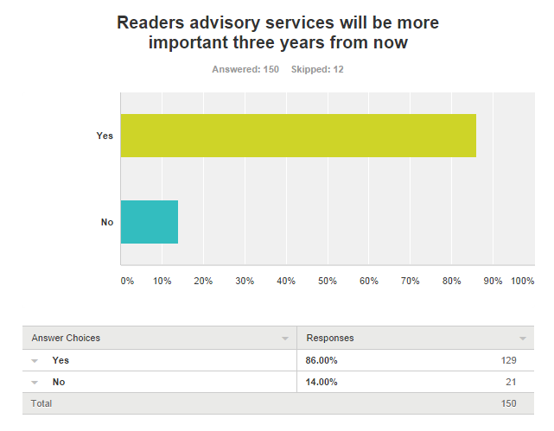
Question 11
How effectively would you say your library currently provides materials recommendations to users?
Note, we usually use the term suggestions, but are using 'recommendations' so that this data can be used by Library Journal

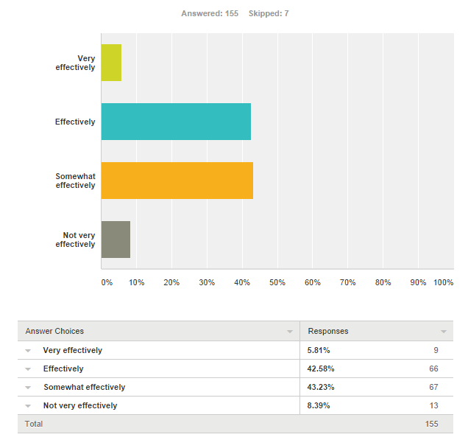

Question 12
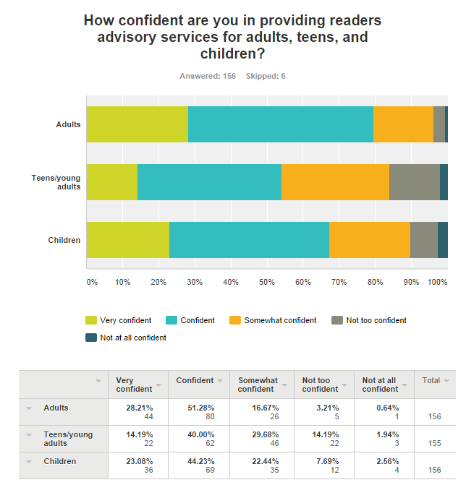

Comments include:
- We have just launched this year a new RA program and we're still in the early stages. This is an area we've flagged for significant improvement and I'm confident that in 3 years I would be able to answer these questions more positively :-)
- Hard to find resources for adult non fiction readers’ advisory.
- Our literacy based activities, events, etc have double since the last financial year. We have plans to further build on that by collaborating with other organisations in partnership.
- It depends on the interests of the reader. If we have similar interests eg humorous fantasy then I'm all over it, but if I have an adult ask me for romance recommendations I start having trouble after Danielle Steel and Nora Roberts.
- Find it hard to keep up with Teen material
- I have personal problems with genres that I don't read myself, such as westerns and romances, but can still use the databases etc. to help someone.
- Librarian book recommendations will be added to our enewsletters
- The children's team are relied on to provide this service
- Ongoing small update/refresher courses offered online would keep skills up to date
- Focus group feedback last year indicated some parents wanted more advice on children’s reading- in response a number of events and web-based/print guides have been created.
- This is mainly because I read a lot myself and keep up to date with new releases via FB, Twitter, Prizewinner RSS feeds, blogs etc. I also have young children - hence I'm very aware of their interests and what is available - less so for teens/YA, although I try and keep knowledge in this area up to date also.
- Adult customers are often referred to me. I facilitate two book groups and have selected adult collections in the past. I have good, broad knowledge of reading trends (fiction and non-fiction) and can also provide assistance with recommendations from our DVD collections. My weakness is really in the teen area - ok with fiction, but quite at sea if the question is about manga!
- I am the only staff member who is extremely confident in Readers' advisory work at all levels; the other staff consult me if they fill they aren't meeting the reader's needs adequately. They are undertaking in-service training, and have also undertaken RA courses to assist their professional development
- This is my personal rating, but many staff have little interest in the collection so the RA area is quite variable in our library
- As a librarian and team leader, I am confident personally, however I know that many of the library assistants who work on the desk are not confident - hesitant and apprehensive about providing suggestions to members of the public.
- I think the most important tool with RA is to know the collection, know whats new and what is trending so you can make recommendations even when it is not something you yourself read. But I think this is something that takes a lot of time and reading/researching that would have to be done outside of work hours and that is just not possible for a lot of people.
- Use databases for adults, collection is divided into approx. reading levels for young children but teenagers are grouped together except for Manga
- Workload at circulation often precludes provision of an effective service.
- Children & young adults are diffident about asking unless they have specific titles in mind. It's usually parents who ask for help for their children, so we don't usually get to hear whether or not our recommendations have had success.
- training was provided to all staff and now they have become more confident
- Lots of teen books are fantasy based, which I don’t read and find hard to recommend

Question 13
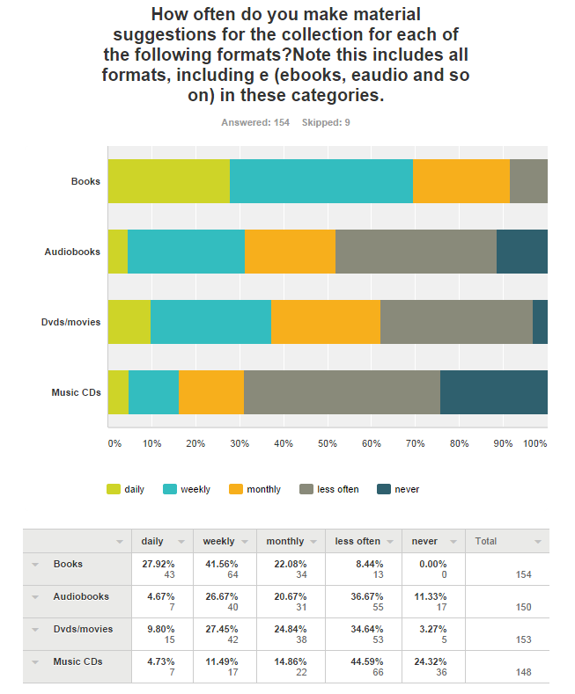

Question 14
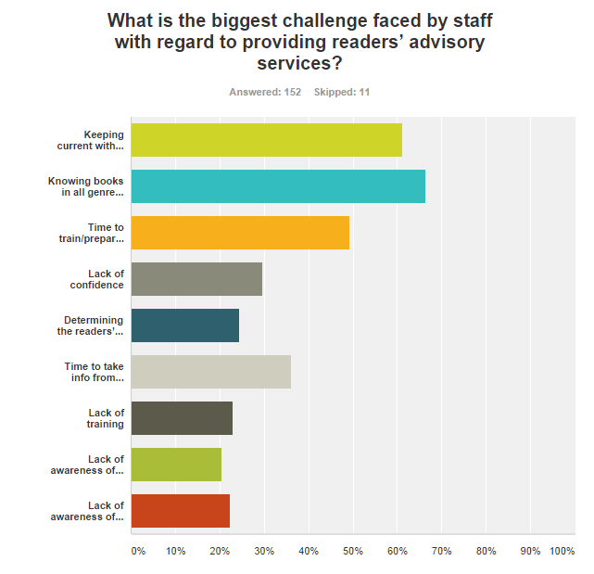
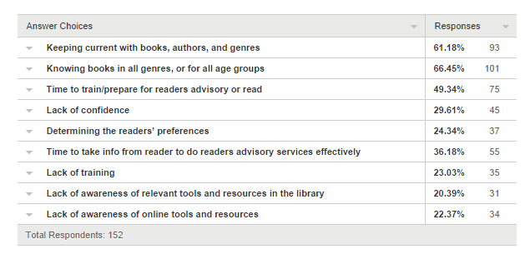

Comments include:
- Different staff have different challenges, including lack of knowledge, inadequate communication skills, lack of wish to provide service.
- lack of time and staff resources to be able to concentrate on reader's advisory
- lack of time and pressure on circ desk in general
- More than half of the staff are not readers themselves. This is a massive challenge. Most of the staff are of NESB and don't read for leisure in their first languages either.
- understaffed library
- lack of support for readers’ advisory - managers talk about it, but nothing happens. Keen staff (who've undertaken training in their own time/at own expense) are informed their input is not required, or that they are "irrelevant" and responsibility passed to others.
- Getting customers to ask! The desk is often clogged with people wanting 'less interesting' things!
- Lack of recognition of the value of RA means that it is not encouraged or recognized in any Position Descriptions
- Time in an already busy work day lots of competing demands
- Staff have to multitask, managing the transactions at circulation, phones and shelving etc. whilst attempting RA.
- Staff have had on-training for RA resources.
- yes to all of the above which makes the tackling of the process so hard
- I have no formal training nor any direction. I assume that "readers’ advisory services" is giving clients recommendations. Most of this is based on my own experience, reading and observation (eg requests, returns etc).
- I've ticked many of these when thinking about my colleagues. It's been a while since we've done RA training and it's probably time to do it again, both refreshers and training for new staff. We have a lot of competing demands though (doesn't everyone?)

Question 15
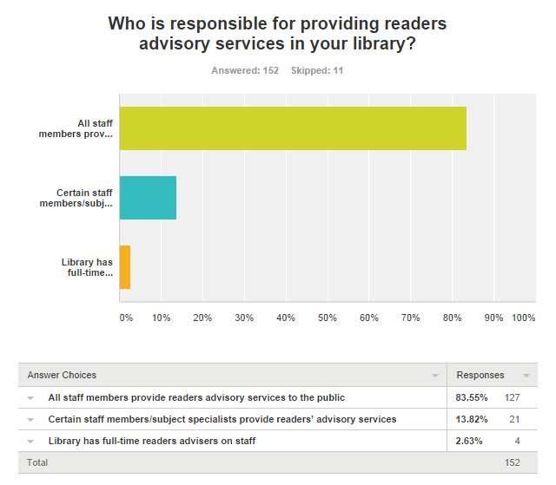
Comments include:
- all staff provide assistance at circulation. Main branch has specialist reference staff too.
- mostly on an ad-hoc basis
- All staff have different reading preferences, so we confer about different types of books that might suit particular people if we can.
- All staff members are responsible for providing readers’ advisory to customers when on desk shifts however we do have an in house RA team that is responsible for displays, producing readers’ advisory material and training for staff.
- Circulation and Home library Staff
- We have one staff member who fits it in alongside their main role. This isn't formalised and there is an understanding that there is a need for someone to take this on formally, at least one day per week. We're undergoing a service review at present and it is expected that this may be an outcome.
- in addition we have a staff specialising in training staff in readers’ advisory
- those staff motivated provide to customers, but no systematic training/support of all staff
- Everyone performs RA but some people tend to perform nearly all of the RA for some age groups eg very few staff provide RA to teens.
- However please note we have a part time Readers’ Advisory Librarian-24 hours per week
- some are more willing/knowledgeable than others, believe we need to encourage staff to be more up to date with genres/authors
- From their own knowledge and using RA based web tools
- some staff are more knowledgeable in a given area than others. Staff discuss, reflect, refer to each others interests/knowledge where possible.
- In theory. In fact, many staff are not readers and find it difficult to discuss reading interests, or get stuck if it is an area they don't find personally interesting.
- I recently attended Rewarding Reading training and made the suggestion in time for our appraisals that ALL staff are responsible.
- Branch Librarians? - not sure really.
- However staff ignore that responsibility
- RA is not considered a core role for any staff
- All staff members have responsibilities for providing RA services to public. Specialists are called when demand is high.
- We have more than one staff member stationed at the front service desk, so if one person is not confident to answer a question another staff member can help and we phone through to staff sections when needed.

Question 16
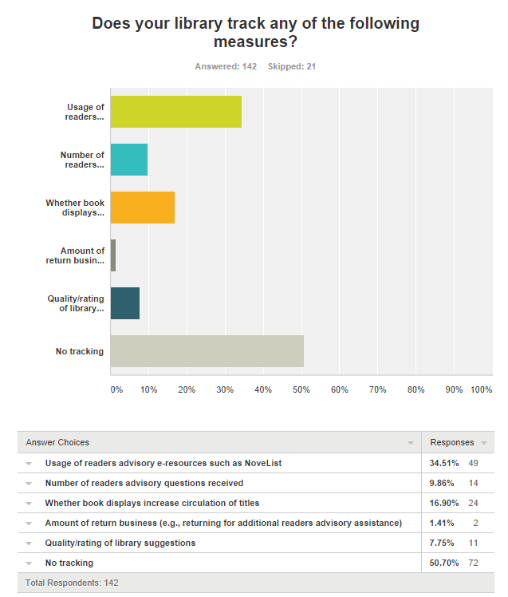

Comments include:
- Not sure
- I am not sure how my library tracks those measures.
- electronic resources tracked as part of database usage statistics, but no specific other measures
- Unless they do but I haven't been made aware of it
- The library is able to track the use of electronic resources such as Novelist, but no further measures are made.
- Tracking is anecdotal, sporadic and engaged all at the same time
- unknown
- don't know
- Regular surveying and focus groups
- Tracked informally by Senior Library staff.
- During PLEG week, all patron enquiries are tracked/recorded, including readers’ advisory services
- We keep a record of how many suggestion are made and how many completed.
- Feel that items on display are borrowed very quickly. Not many staff maintain the displays.
- don't know
- None that I know of but there may be some done at the main branch
- We don't officially track return business but individually we note it.
- There are a lot ways to measure this, eg. Circulation stats and display books that disappear quickly provide some rough ideas about reading, as well as onsite reading without borrowing. Therefore subject zones have been established recently in providing easier access for readers.
- Tracking is informal and based on observation eg. staff notice by having to replenish displays, by returns, by observation what works and what doesn't

Question 17
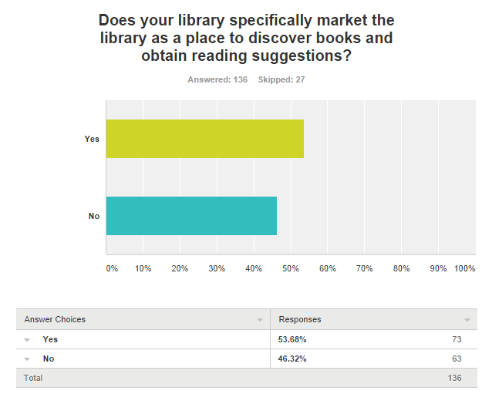
Comments include:
- It should!
- Sort of
- but limited
- To school students through book week activity each year
- This year "Your next great read" campaign
- Not as such but I would hope the experience of clients assures them that such enquiries are welcome and (hopefully!!) fruitful.
- That said both of these are promoted in brochures and on website individually.
- Not sure
- It's marketed for many thing, more than just books
- Knowledge Centre - books take a lesser role
- new books and titles mentioned weekly in newspaper column Library Lines
- But we should!!

Question 18
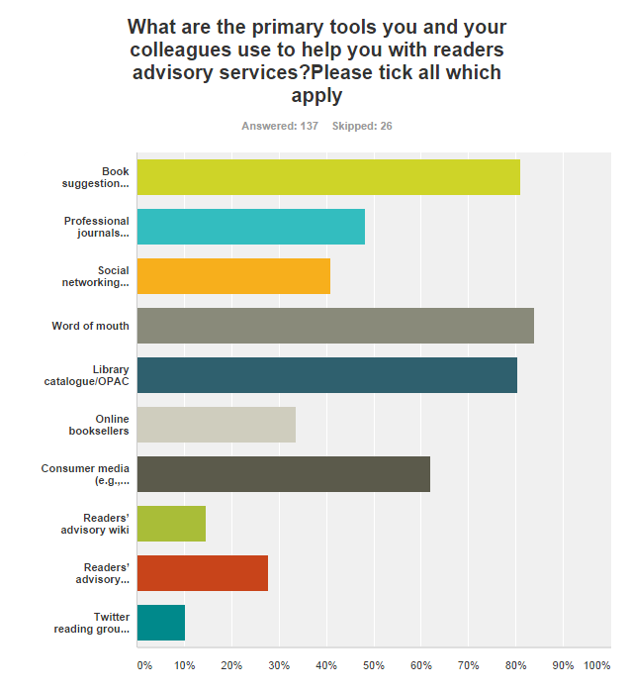

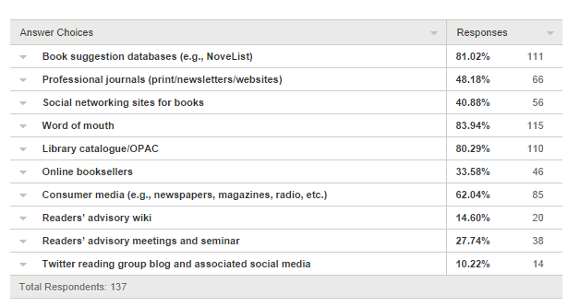

Comments include:
- many staff only rely on personal experience and do not research actively.
- I try to encourage staff to use these resources!
- good reading magazine, reading.com website , fantastic fiction website
- 'Who Writes Like' books
- Each other
- RA collection
- My own wide reading and the reading habits/suggestion of patrons.
- Google
- The book "Who Else Writes Like"
- publishers catalogues, book reviews
- Internet
- Extensive reading resulting in knowledge of individual titles and authors

Question 19
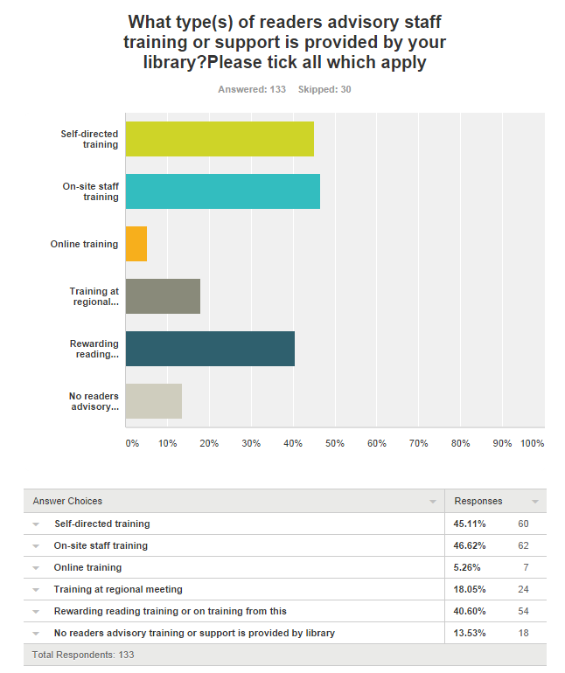

Comments include:
- Presentations on use of Novelist at General staff meetings
- Due to budgetary constraints, training is often in-house.
- Staff who have completed rewarding reading training are not permitted to train others
- many types over the years not recently
- Library provides weekly "Short and snappy" staff development sessions including use of RA tools
- A staff member attended one of the first lots of training but she has left, I attended training in June and am hoping to increase training.
- No continual training
- RA training has been provided
- Some staff have attended RA training at SL NSW
- Informal training where possible
- All staff have been trained previously via train the trainer model and then rolled out to all staff.
- Last Rewarding Reading training would have been done over 3 years ago, if not longer

Question 20
